Community Pub Ownership bulletin – April

17/04/2025 by WB Reporter

Campaign

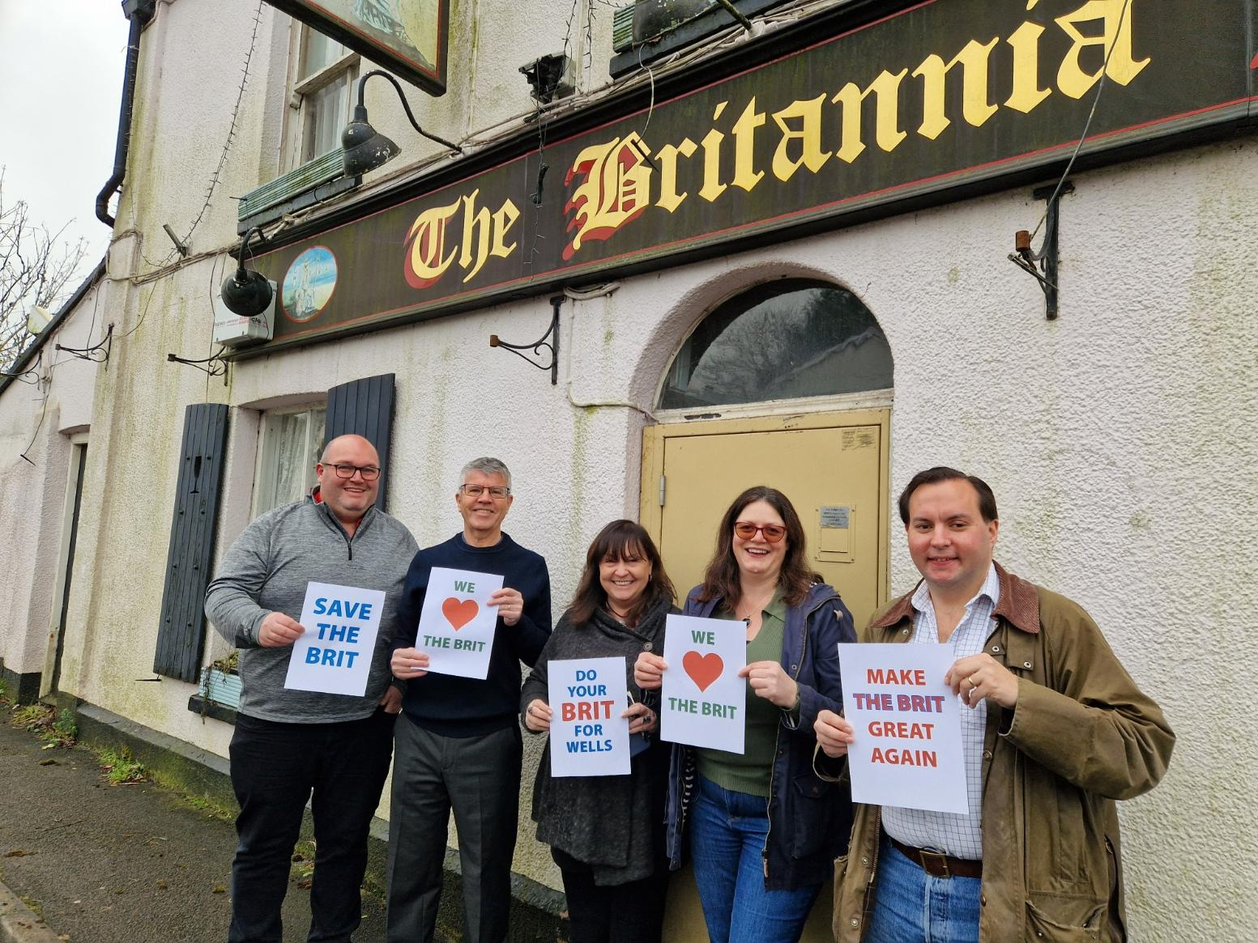

This is the first of a new quarterly bulletin about community owned pubs. For more information, the community pubs webpage of CAMRA’s website contains advice and guidance as well as regularly updated information about both existing and planned community pubs. Pubs are going through a tough time, and reports of them struggling or closing are all too common. However, there’s one area of the trade, where in recent years, the news has been mainly positive and that’s community owned pubs (COP). At the latest count, there are 217, with another 28 run by their local communities and 78 campaigns to take ownership. CAMRA is fully supportive of this model and is keen to assist communities interested in going down this road. On the CAMRA website, you can find an overview on both the history of the community ownership movement and where it presently stands here. There is lots of information, including details of the operating models for COPs. The most common is the Community Benefit Society (135), followed by Private Limited Companies (49) and Community Interest Companies (14). It also explores the reasons why the model has been so successful, regularly transforming pubs written off by previous owners as terminally unviable into thriving community hubs. Looking ahead, there’s both good and bad news. The government has announced the introduction of a community right to buy scheme which will replace the right to bid process associated with Assets of Community Value. In future, if an ACV-listed property is put up for sale, a community group can exercise this new right, and a price will be set by an independent valuer. The owner will then be required to sell to the group at the set price. This will be a game-changer, as currently owners are under no obligation to sell and can just ride out ACV moratorium periods. The government has promised legislation will be introduced later this year. On the downside, the government has scrapped the Community Ownership Fund that has enabled many community groups to reach the purchase and renovation costs of their pub. CAMRA is lobbying government to reintroduce the fund or a similar scheme, otherwise the community right to buy may be a damp squib. Britannia Inn, Wells, Somerset (pictured) The Britannia Inn was closed by the Wellington Pub Company in June 2021 and was put on the market for £300,000. The East Wells Community Benefit Society has been formed to bring the pub back to life and a share offer opened on 5 April. The group aims to raise £450,000 for the purchase, repair and refurbishment of the Britannia. The share offer closes on 30 May but will be extended a further month if the target isn’t met. More information can be found at savethebritanniainnwells.org Fox, Little Ryton, Shropshire At the end of March, campaigners announced the purchase of this village pub thanks to investment from more than 150 people and a Community Ownership Fund grant. The Fox had been shut by its previous owner in September 2022, but by the following February the community united to form a Community Benefit Society (CBS), reached a purchase agreement and launched a successful share offer. When it reopens, the pub will also serve as a community café and pop-up shop. Brockweir Inn, Wye Valley, Gloucestershire The Brockweir Inn CBS became official owner of the pub last December. There’s plenty of renovation work to be done before the first pint is pulled but the momentum is unstoppable. The Brockweir Inn is planned to become a community hub, with accessible spaces to facilitate meetings and activities as well as events that will bring locals together. Oakbank Community Inn, Sandbank, Argyll The Oakbank Community Inn Sandbank (OCIS) group should take ownership of the pub in the next couple of weeks. It has also raised the money necessary to carry out essential repairs, employ staff and stock the bar and kitchen. The venue will be, in its own words, a “gateway to the Scottish Highlands”. Elm Tree Inn, Langton Herring, Dorset The pub’s owner recently accepted an offer from the Friends of the Elm Tree to purchase the freehold. The group is now advertising for tenants. Crown Inn, Newcastle-on-Clun, Shropshire Through a mix of Community Ownership Fund grant, Public Works Loan Board loan and community fundraising, the Newcastle Parish Council raised funds to buy the pub in late February. Restoration work to the pub has now begun. If you have any information about community ownership developments in your area, particularly any new local campaigns, please send updates to info@communitypubs.camra.org.uk If your pub has closed or is threatened with closure, CAMRA's website has in-depth guides and resources, including those about community pub ownership, to help save your local here. Pictured: East Wells Community Benefit Society steering group members are fighting to reopen the Britannia Inn. Photo by Wells Voice.