Members’ Weekend 2025 round up
16/04/2025 by WB Reporter
Campaign

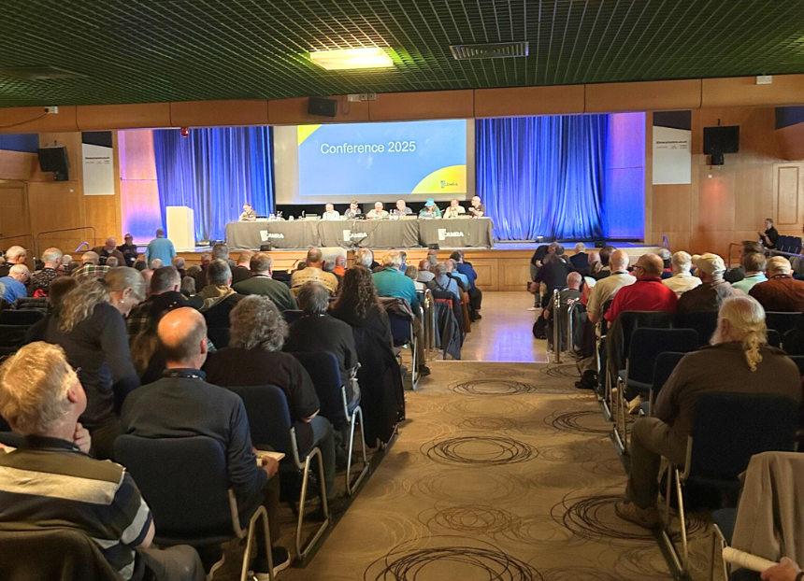

CAMRA’s Members’ Weekend took place in Torquay last weekend. Details of award winners and how the motions fared are below. AWARDS
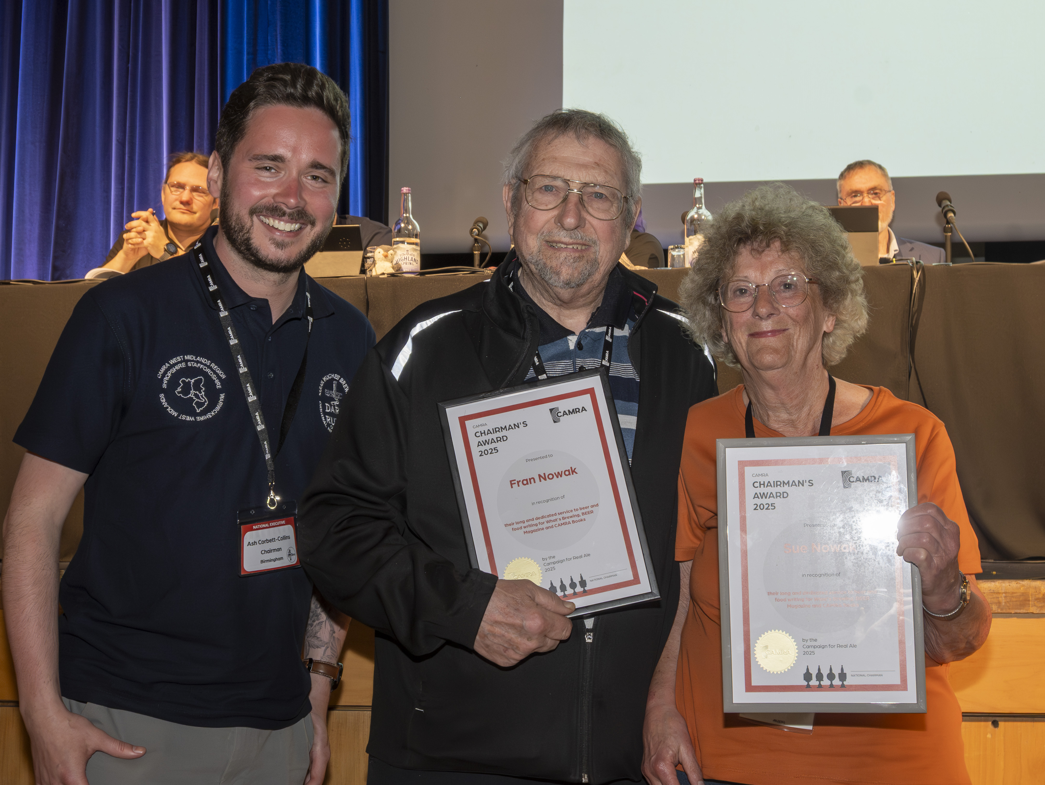
Chairman’s Award Winner: Sue and Fran Nowak Both have been members for 40 years and have spent that time tirelessly campaigning to improve the quality and choice of food in pubs. Sue's writing includes articles in What’s Brewing and BEER, as well as editing six editions of the CAMRA Good Pub Food Guide, plus writing for a range of national and local magazines and newspapers. Fran has been her partner in pub cuisine, accompanying her on an estimated 100,000 miles travelling the country seeking out the best food pubs, and providing photographs to go along with her copy. From left: Ash Corbett-Collins, Fran Nowak and Sue Nowak Magazine of the Year
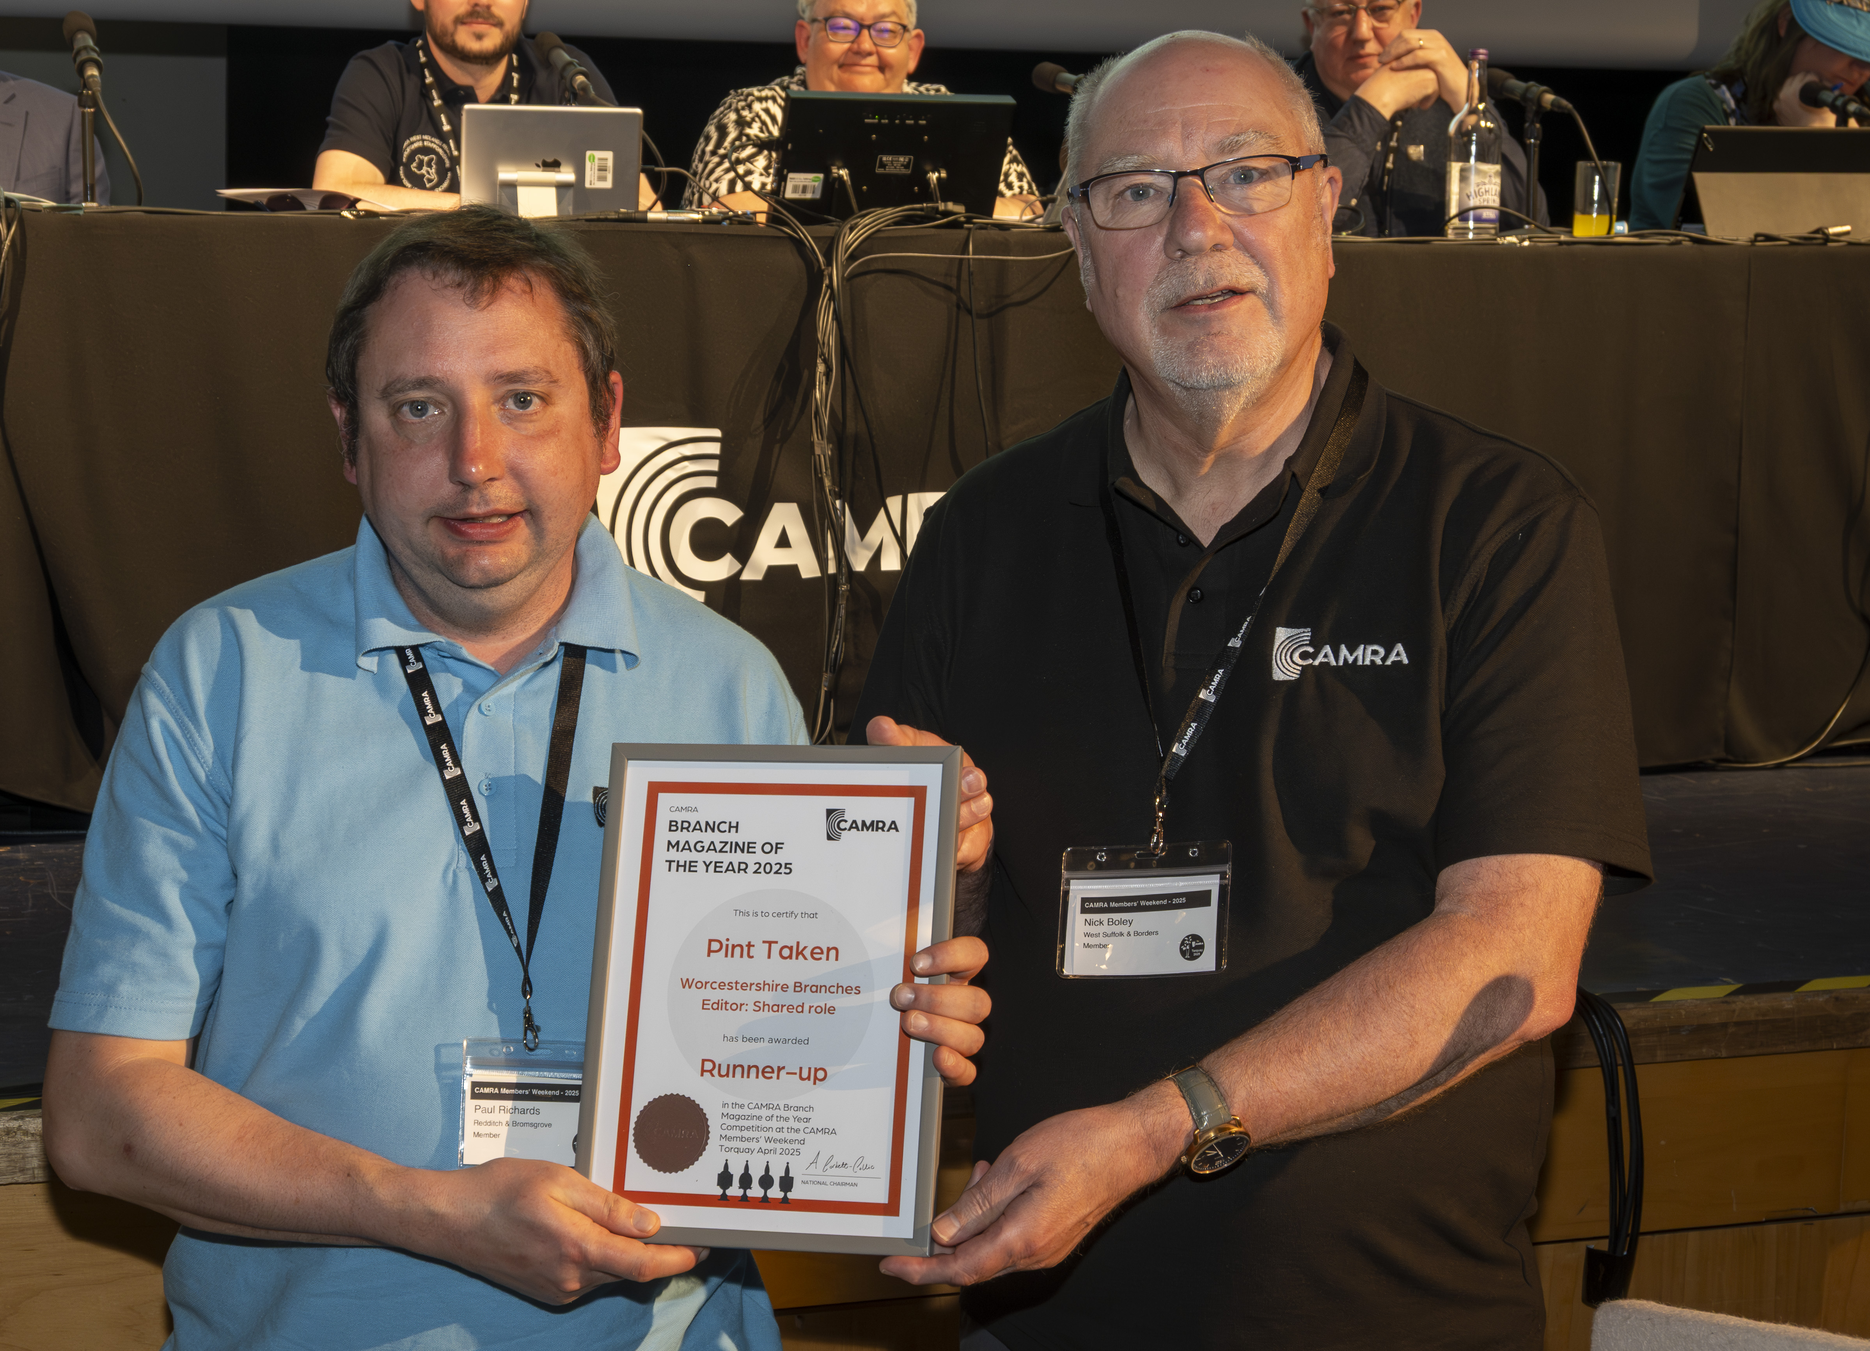
Runner up: Pint Taken, Worcestershire Branches A close contender for the Bronze award, judges commented that this magazine was of a high standard with especially strong campaigning messaging. Bright and colourful with a good mix of features, the judges thought the magazine was well illustrated. Pictured above: Paul Richards and Nick Boley
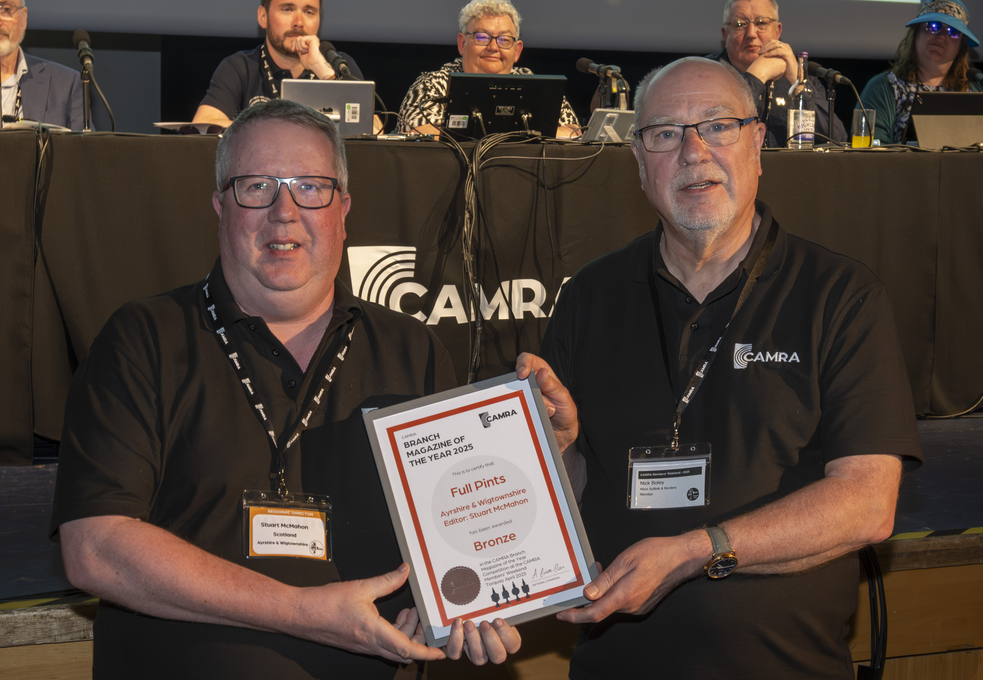
Bronze: Full Pints, Ayrshire and Wigtownshire Branch, edited by Stuart McMahon Judges loved the magazine’s bright and colourful layouts. The quality of local information and the efforts to cover wider campaigning issues in Scotland was commended. Pictured above: Stuart McMahon and Nick Boley
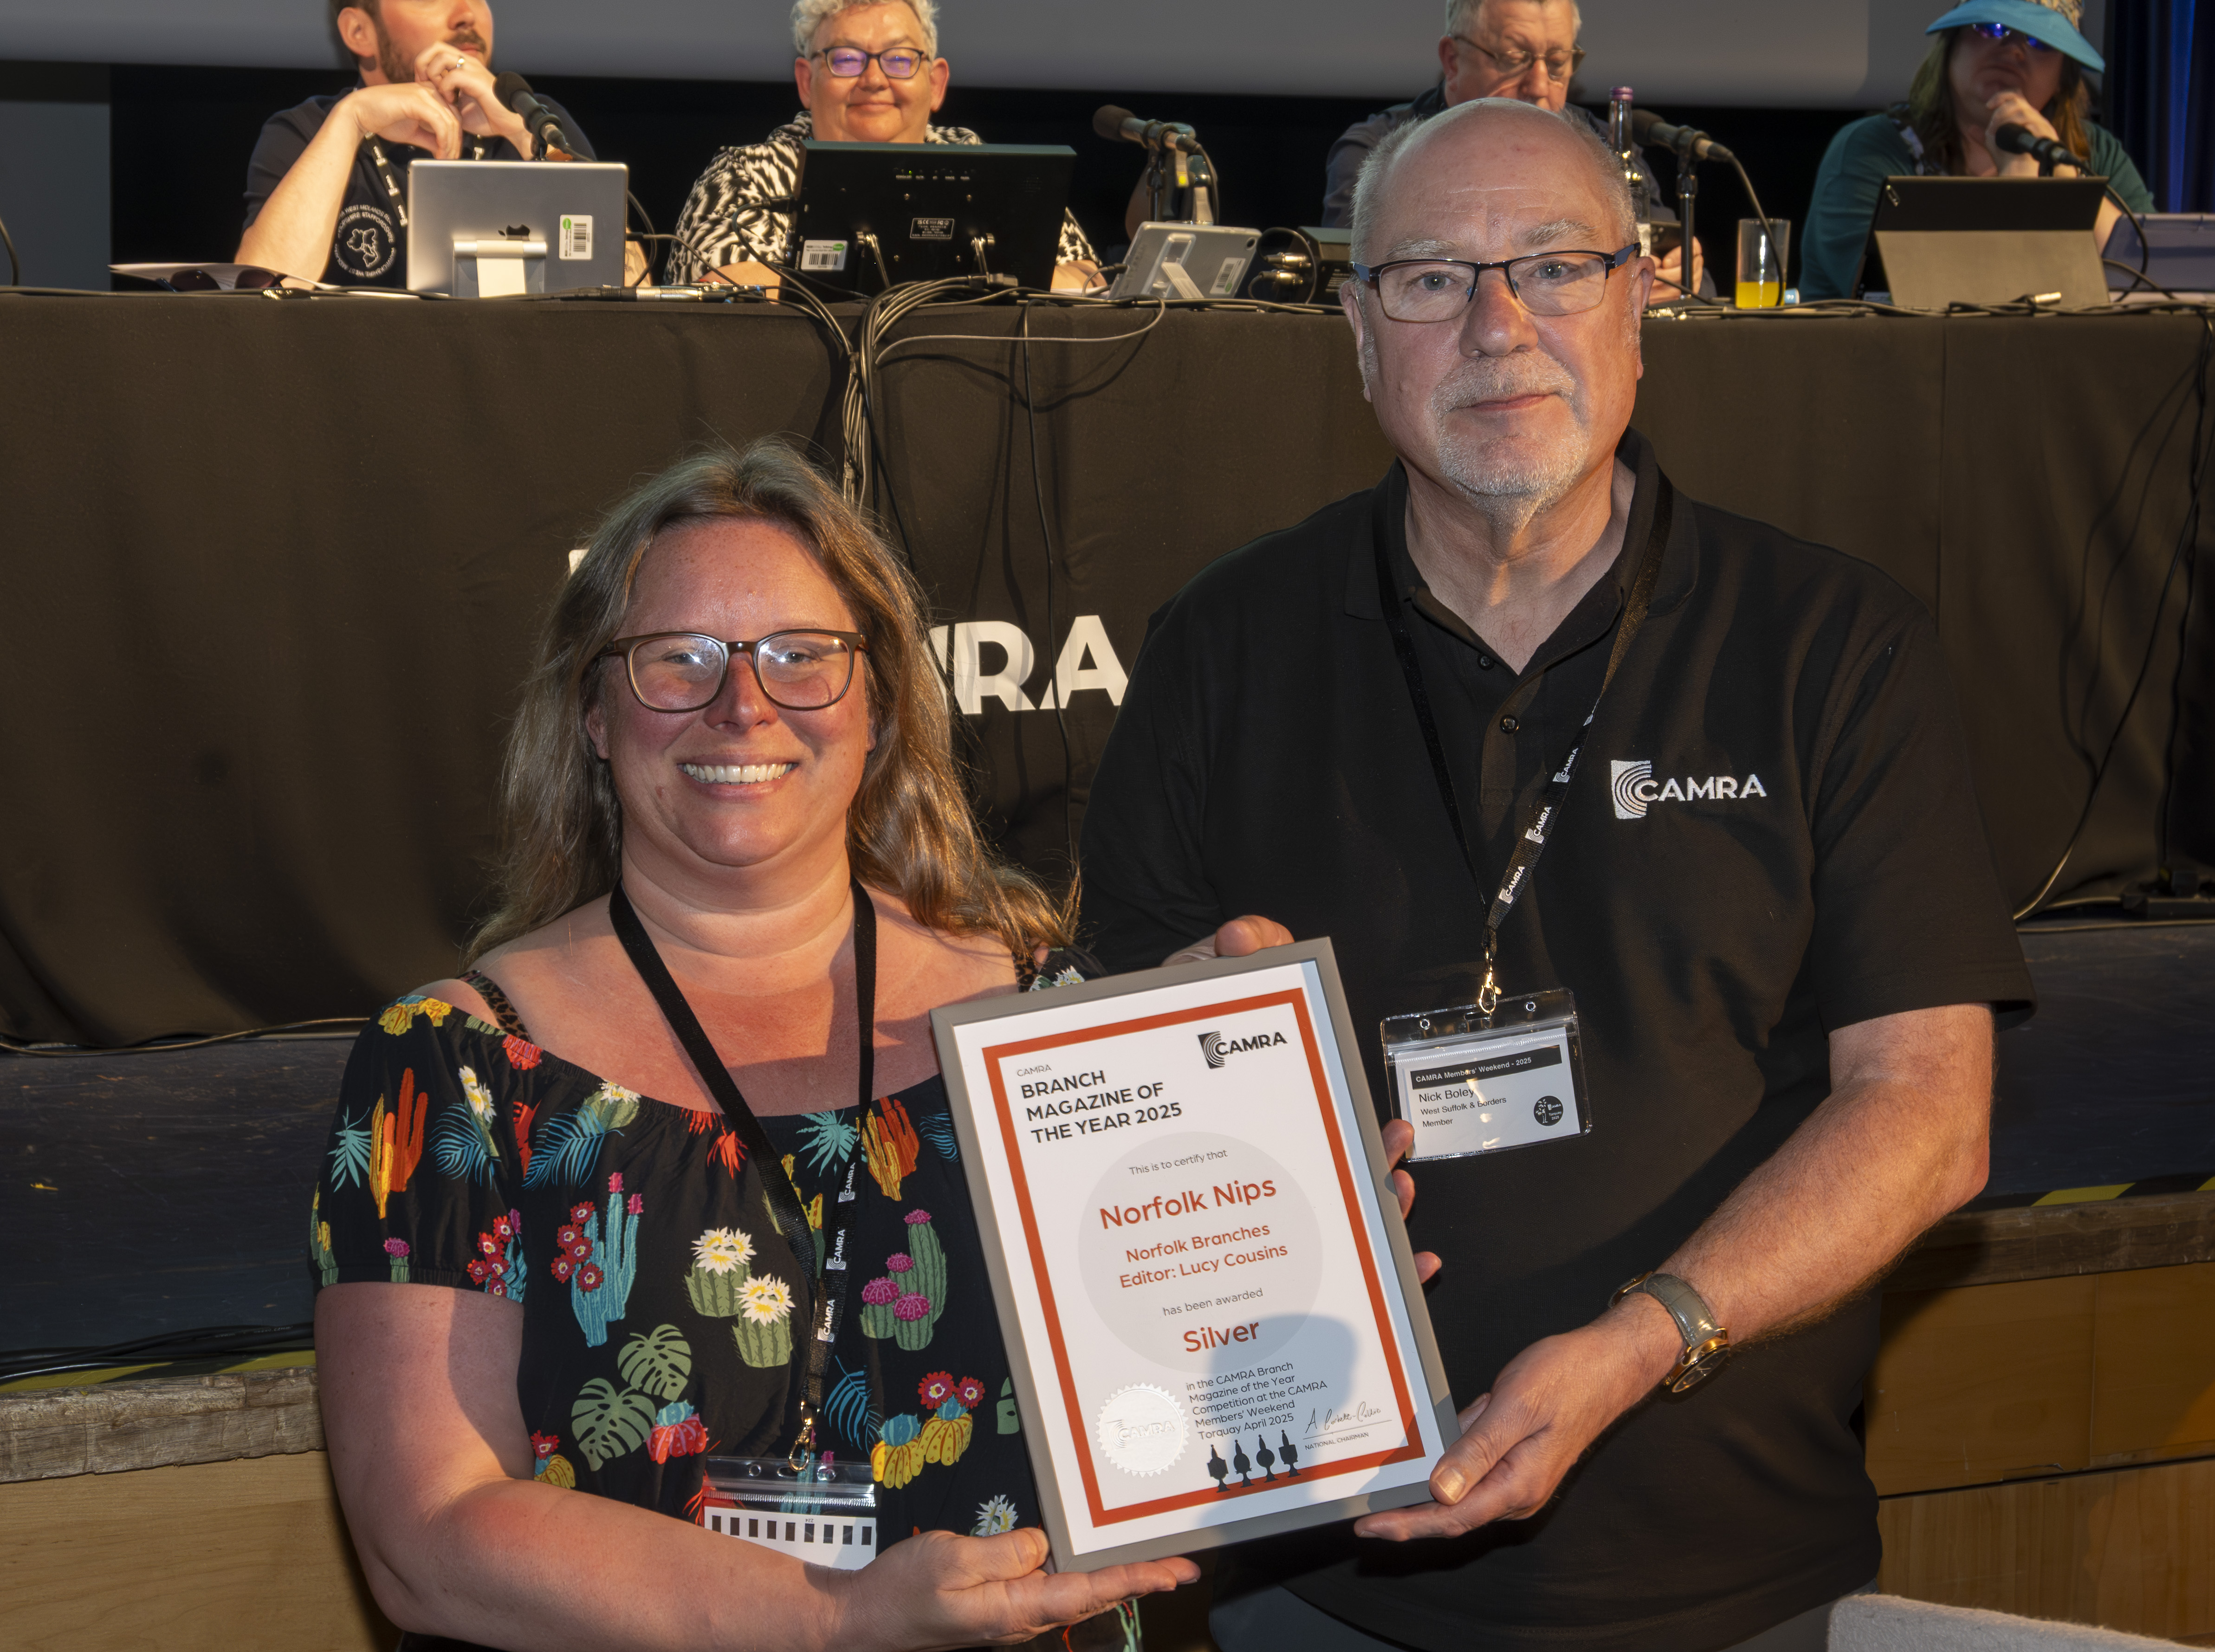
Silver: Norfolk Nips, Norfolk Branches, edited by Lucy Cousins Bright, colourful and very reader-friendly, judges praised the page layouts and design of this very modern-looking magazine. The judges noted that this magazine showcased local branch activities, highlighting a fun and sociable group of volunteers learning about all aspects of beer and cider. Pictured above: Lucy Cousins and Nick Boley
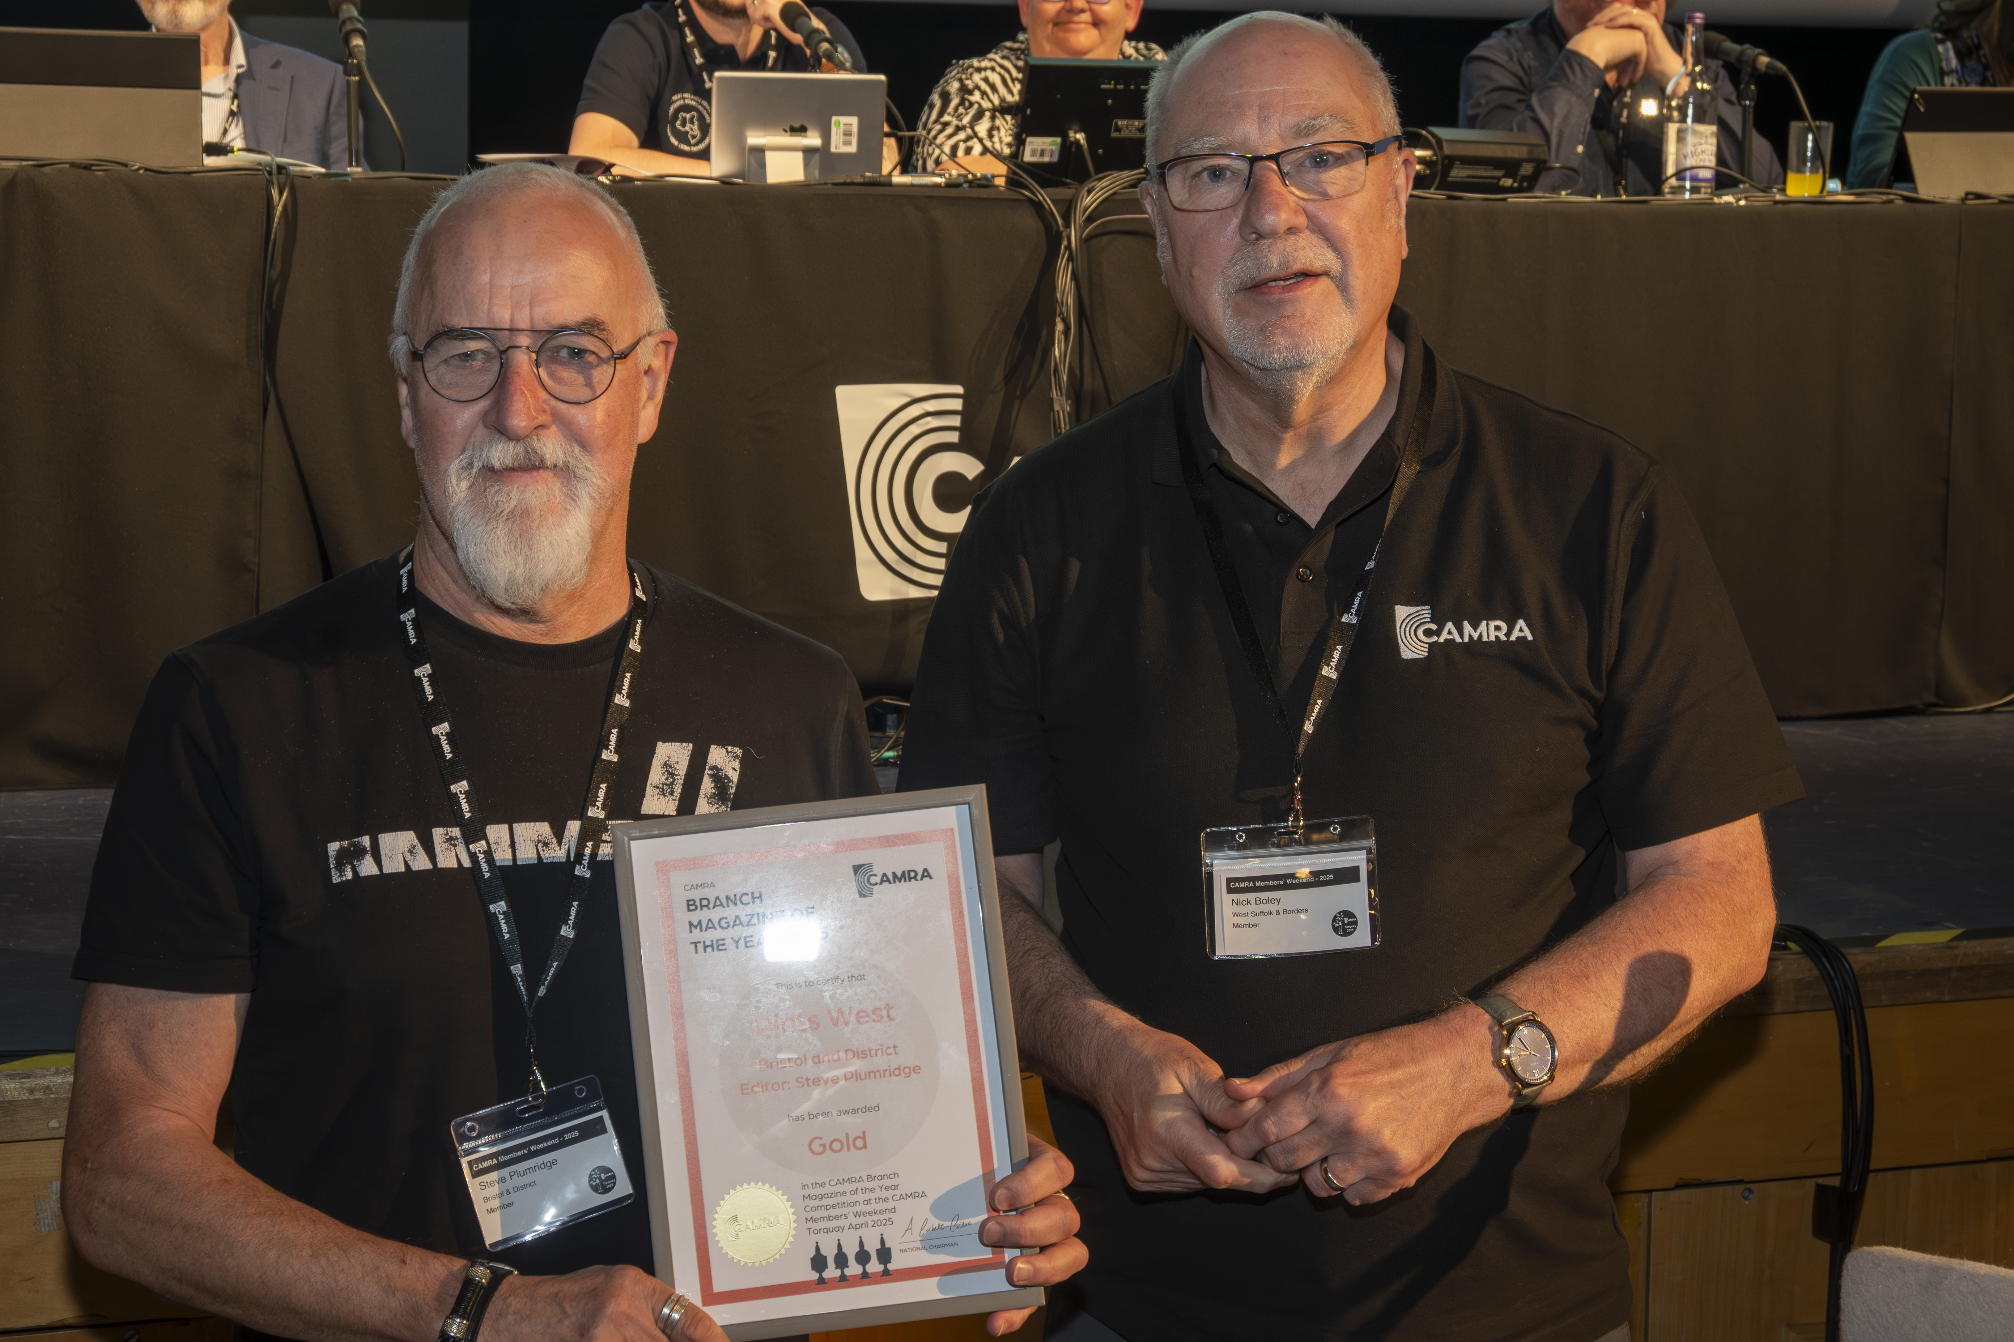
Gold: Pints West, Bristol and District Branch, edited by Steve Plumridge Judges commended the professional look of this magazine and the assuredness of its content, which included a large number of articles on unusual topics. The strong use of imagery was praised by judges, with photos of branch volunteers enjoying trips and socials. Pictured above: Steve Plumridge and Nick Boley Website of the Year
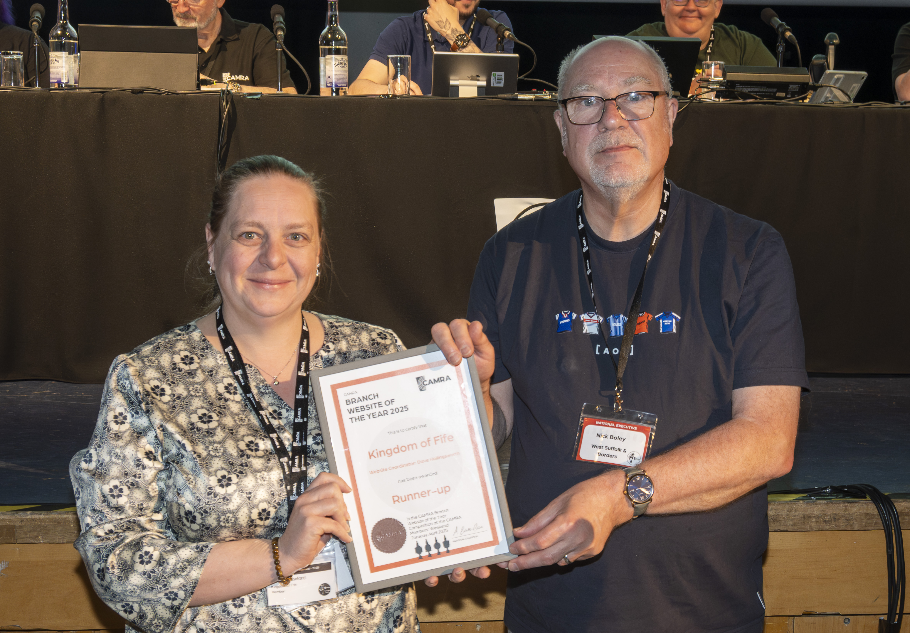
Runner up: Kingdom of Fife Branch, website coordinator Dave Hollingsworth Judges were impressed by the website’s attractive design, use of photos and clear layout. It was highlighted as a great example of how to use the BeerEngine template, with lots of useful content for both members and visitors to the area. Judges noted the clear branch map on the homepage as being especially helpful. Pictured above: Sarah Crawford and Nick Boley
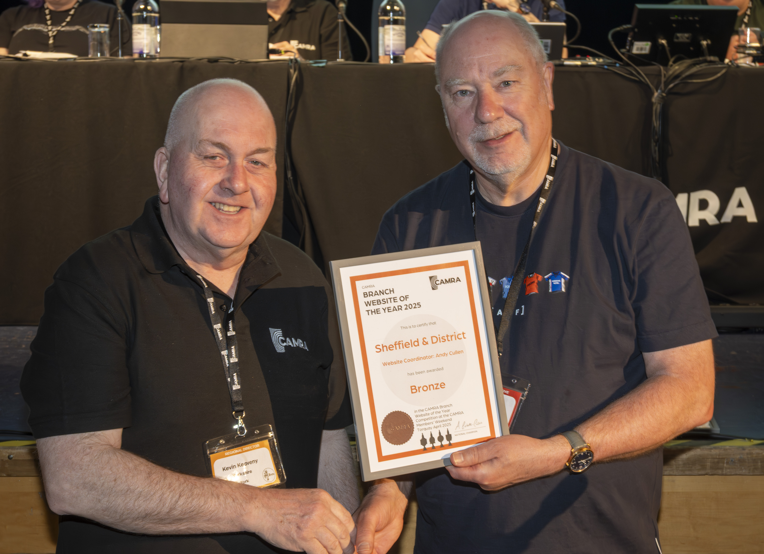
Bronze: Sheffield and District Branch, website coordinator Andrew Cullen Judges praised the website’s original design, with lots of information and great use of images. The website’s pub guide and pub heritage sections in particular were noted for being very comprehensive. Pictured above: Kevin Keavney and Nick Boley
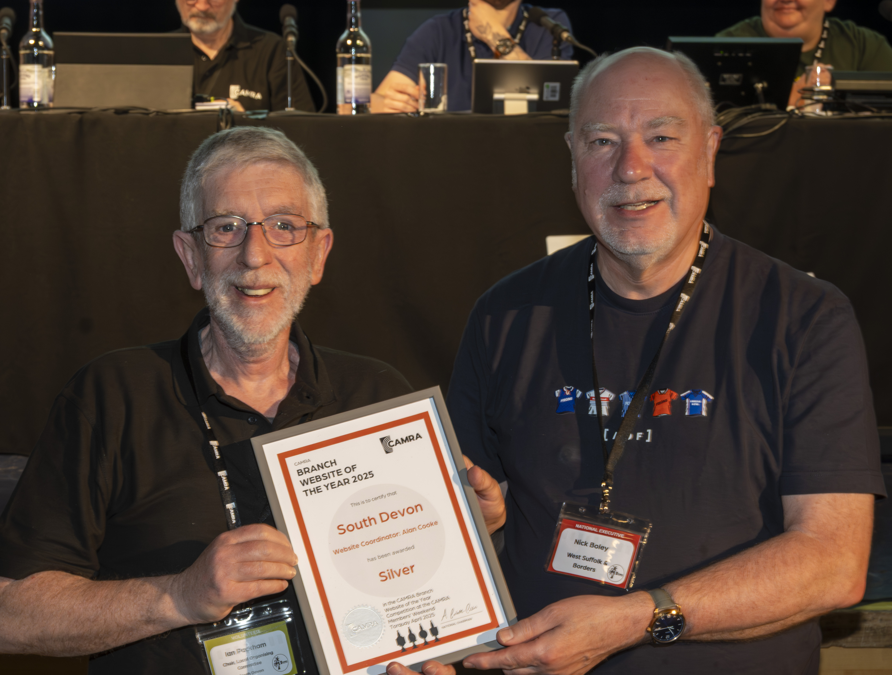
Silver: South Devon Branch, website coordinator Alan Cooke Judges were impressed with the variety of information provided by the website, including Good Beer Guide selection, National Beer Scoring and public transport links. The friendly welcome message from the branch chair was highlighted as a nice touch. Pictured above: Ian Packham and Nick Boley
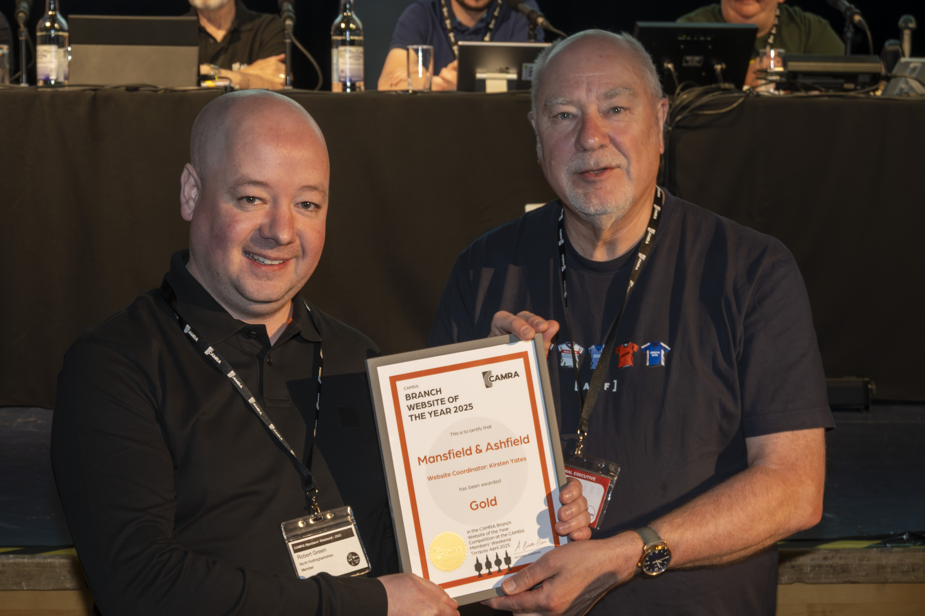
Gold: Mansfield and Ashfield Branch, website coordinator Kirsten Yates Judges commended both the quality and quantity of information displayed on the website, particularly the professional-looking promotion of beer festivals and a strong use of imagery. Judges highlighted the local transport map as one of the most detailed and useful they had seen. Pictured above: Robert Green and Nick Boley MOTIONS Motion 1 – passed Proposed by: National Executive This Conference agrees to adopt the Policy Documents presented for adoption at Conference 2025, subject to any amendments to policy decided at this Conference. Motion 2 – passed Proposed by: National Executive This Conference agrees the Annual Membership Subscription rates will increase by £3.50 from 1 July 2025 to the following: Single membership (British Isles and Overseas) Direct Debit £34 Non-Direct Debit £36 Single concessionary membership (British Isles) Direct Debit £25.50 Non-Direct Debit £27.50 Joint membership (British Isles and Overseas) Direct Debit £42 Non-Direct Debit £44 Joint concessionary membership (British Isles) Direct Debit £33.50 Non-Direct Debit £35.50. Motion 3 – passed Proposed by: Real Ale, Cider and Perry Campaigns Committee This Conference agrees that UK beer lovers have been badly let down by the lack of leadership and imagination shown by the multinational brewers and large property firms that, between them, control the UK beer trade. Conference therefore instructs the National Executive to ensure that all relevant CAMRA publications and communications pledge preferential support to beer producers and suppliers that are independent of the influence of the multinational brewers, and to make the case persistently for this stance. Motion 4 – passed Proposed by: Real Ale, Cider and Perry Campaigns Committee This Conference instructs the National Executive to establish a self-funding opt-in Beer Group for members, to study and discuss all aspects of beer, viewed from the consumer perspective. The group should be of interest to consumers and the wider beer and pub trade. Motion 5 – passed Proposed by: Real Ale, Cider and Perry Campaigns Committee This Conference instructs the National Executive to investigate the logistics and funding of a specialist training course about the nature of beer in all its forms, the structure and ownership of the UK brewing industry and retail beer trade, the nature of real cider, and an introduction to the UK club trade, viewed from the consumer perspective. This should be self-funding and open to all. Motion 6 – passed Proposed by: Commercial Committee This Conference instructs branches to use the National Beer Scoring System as a significant factor when determining which pubs are considered for inclusion in the Good Beer Guide, from the 2027 edition onwards. Motion 7 – failed Proposed by: Commercial Committee Amendments to the motion were accepted by the proposers, and it was debated and voted upon as: This Conference instructs the National Executive to reduce the number of pubs in the Good Beer Guide from the 2027 edition onwards. The original motion wording was: This Conference instructs the National Executive to reduce the number of pubs in the Good Beer Guide from the 2027 edition onwards, to ensure only quality pubs are featured. Motion 8 – remitted Proposed by: Bradford Amendments to the motion were accepted by the proposers, and it was debated and voted upon as: This Conference agrees the National Executive should take steps to ensure complaints and disciplinary processes and procedures, as well as the Code of Conduct, are clear and easily accessible to all members. The distinction between complaints and disciplinary matters must be clarified, particularly at what stage a complaint might become a disciplinary matter that needs escalating. Wherever possible, and in line with the Disciplinary Policy, Branches and Regions should deal with issues locally in the first instance. Branches and Regions shall be empowered to impose commensurate penalties within relevant guidelines at local level. Proceedings shall be recorded appropriately and shall be monitored by the Regional Director. The original motion wording was: This Conference agrees the National Executive should take steps to ensure complaints and disciplinary processes and procedures, as well as the Code of Conduct, are clear and easily accessible to all members. The distinction between complaints and disciplinary matters must be clarified, particularly at what stage a complaint might become a disciplinary matter that needs escalating. At all times Branches and Regions to have autonomy, with Regional Director guidance, to deal with issues locally in the first instance and determine whether and when a complaint needs to be escalated. Branches and Regions to be empowered to impose commensurate penalties at a local level, but within the relevant guidelines, and as agreed with the Regional Director. Motion 9 – remitted Proposed by: Bradford Branch This Conference instructs the National Executive to publish the final submissions for all National, Regional and Branch festival business plans, with confirmation as to whether these were approved or rejected (with reasons provided where appropriate), on an appropriate part of the CAMRA website accessible to members.

