Women On Tap launches Changemaker community

15/04/2025 by Timothy Hampson

Industry

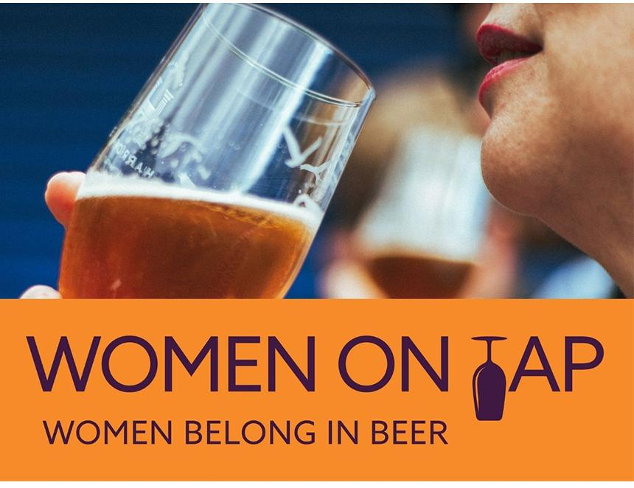

Change is brewing in the beer world, and now there’s a way for everyone to be part of it. Women On Tap, a social enterprise and leading advocate for gender equity in beer, has launched its BEER 50/50 campaign and Changemaker – a new community for those who want to help shape a more inclusive industry. For just £3.50 a month, Changemakers will fuel work by the social enterprise that connects and opens up new opportunities for women and supports the industry to evolve, improve, and be more inclusive. The beer and brewing industry thrives on craftsmanship, community, and culture, but it’s time to ensure those values reflect the diversity of the people who love beer and work within it. By becoming a Changemaker, supporters will help Women On Tap to: – Run campaigns that challenge bias and champion inclusion, including International Women’s Collaboration Brew Day (IWCBD). – Create new resources and development opportunities for women in beer. – Build toolkits and training programmes to support breweries in taking practical action. – Bring back WOTFEST and host other events that celebrate women and inspire industry-wide change. – Grow a consolidated movement of people committed to progress. Founder of Women On Tap CIC Rachel Auty said: “I’ve been working with our advisory board over six months to shape a new ambitious plan and develop a theory of change model to drive impact. BEER 50/50 is our umbrella campaign for this work. Fundamental to the next phase of Women On Tap is the need to create a community and a movement of people who want to see and be part of that change. “For less than the price of a pint, everyone can play an active role in changing the face of beer. Changemaker is about collective power, creating space for everyone to stand up for what they believe in and be a part of making the change happen.” Become a changemaker at womenontap.co.uk/join