PUBlic Affairs round up - April

13/04/2025 by Tori Wood

Campaign

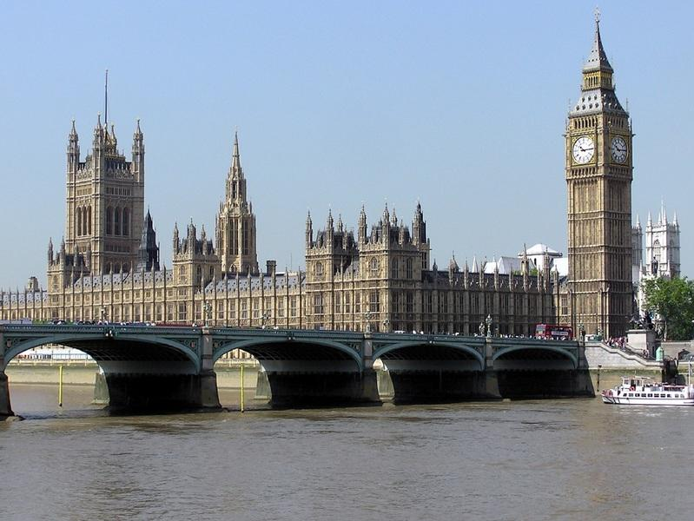

It’s that time again for the Campaigns and Communications team to bring you the latest updates on its campaigning efforts across Westminster, devolved parliaments and local government in this regular PUBlic Affairs round up series.   Westminster  The dreaded tax increases have arrived this month, meaning Employer National Insurance contributions have increased for businesses across the UK, and pubs in England face higher business rates due to cuts in relief from 75 per cent to 40 per cent.  In response, the team issued a press release discussing how both of these tax increases will affect pubs, along with alarming closure data urging the UK government to recognise the detrimental impact this decision will have on locals and to think again.  Planning protections [England only] In January 2025, a letter was sent to Alex Norris MP, minister of Housing, Communities and Local Government addressing the need for the return of the Community Ownership Fund and improved planning protections for pubs in England.  The minister recently wrote that he is keen to meet to discuss these issues, so the team is arranging for this to take place and to see how we can work together to improve planning protections for pubs.  Community Ownership [England only] The UK government closed the Community Ownership Fund in December 2024, with promises to replace it with its new Community Right to Bid.  Officials from the Ministry of Housing, Communities and Local Government have confirmed the legislation to introduce the new scheme will be included as part of the English Devolution Bill.  The bill is expected to come into force later this year.   All-Party Parliamentary Group on Pubs The team met with Charlotte Nichols MP, chair of the All-Party Parliamentary Group on Pubs to discuss issues facing pubs, consumers and breweries.          Deposit Return Scheme & Extended Producer Responsibility The Extended Producer Responsibility Scheme (EPR) was implemented on 1 April.  Along with other industry bodies, we wrote to the Environment secretary to raise issues of double payments for pubs and the wider hospitality sector.  One issue addressed that a majority of pubs and hospitality products sold in glass are classified as household waste, which means these venues are not exempt from EPR fees.   These businesses already pay private waste contracts to collect and recycle these products, which is against the intent of regulations.  The letter also emphasised that fees charged as part of the scheme, in many cases, are higher than the profit margins businesses will make on products sold.   Due to this, these costs are likely to be passed on to consumers, which we also raised to the Environmental secretary.   Scottish government and parliament   Scottish Pubs Code The first round of provisions in the Scottish Pubs Code that include a guest beer entitlement for tied pub tenants came into force on 1 April.  The team issued a press statement welcoming the introduction of the new Scottish Pubs Code.  The market rent only provisions are expected to follow in the summer.  Cross-Party Group on Beer and Pubs (secretariat service provided in part by CAMRA) The Cross-Party Group on Beer and Pubs brewery visit in Leith, for MSPs to take part in beer tastings and discussions on issues faced by Scotland’s independent brewers and consumers, is coming up on 25 April.  Welsh government and Senedd Cymru  Cross-Party Group on Beer and Pubs (secretariat service provided in part by CAMRA) The team recently met with Joel James MS, chair of the Cross-Party Group on Beer and Pubs to plan an activity programme over the coming months.   This will include a series of MS brewery visits across Welsh regions and an exhibition stand to engage with MSs in the Senedd.  Northern Ireland executive and assembly  Licensing Review The University of Sterling recently carried out an independent review of Northern Ireland’s alcohol licensing laws.   The team continues to work with local breweries and partner organisations to influence MLAs and political parties to get positive responses to the report and recommendations published as part of the review.   Non-parliamentary  One Voice for Pubs and One Voice for Beer CAMRA chief executive Tom Stainer continues to meet with the group to co-ordinate activity on issues of common concern with industry organisations, which includes the letter sent to the Environmental secretary on issues relating to the Extended Producer Responsibility scheme.