Mild Magic weaves its spell again

10/04/2025 by Timothy Hampson

Campaign

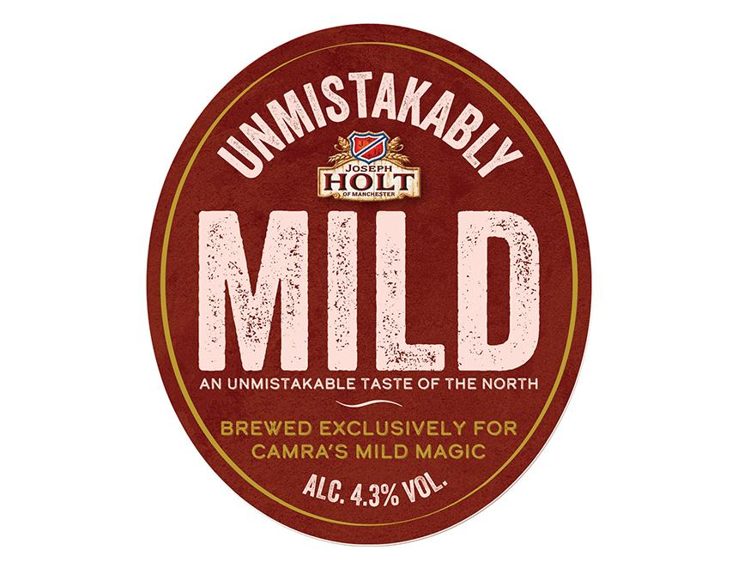

The UK’s longest-running and largest promotion of the mild beer style, Mild Magic, is back again for its 31st year with a record-breaking 102 pubs taking part. Covering a wide area in and around Greater Manchester, all the pubs, including the 16 taking part for the first time, will be stocking at least one cask mild for the five-week duration of the event.  Organised by volunteers from local CAMRA branches, the beer trail runs from Friday 11 April until Sunday 18 May. Participants only have to visit 12 pubs in different areas, and drink at least half a pint of cask mild beer in each, to start winning prizes. For 12 pubs you get a T-shirt with this year’s Mild Magic logo and beer vouchers for the Stockport Beer Festival in late June. You can upgrade prizes by visiting 24, 48 or all 102 pubs. All successful entrants will be included into a draw for a trip round Bollington brewery in September. Mild Magic is once again sponsored by Hydes brewery, which makes a dark and light mild all year round at its Salford brewery. As a limited edition, it has also recreated its Anvil Mild from many decades ago. Joseph Holt in Cheetham Hill is again brewing its award-winning Unmistakably Mild, previously released in 2023 for Mild Magic (pictured above). JW Lees Dark should also be available at various locations. As well as Manchester’s family brewers, many local independent producers will be offering milds. Last year, no less than 85 were on the trail. Bridge Beers of Stalybridge will be offering four milds, Dark Ruby, Marshmallow, Golden and Cherry, but this is the last time you will be able to sample them. The owner is retiring and closing the brewery shortly. Its bar in Stalybridge will feature the beers, and they will also be available in participating pubs, particularly in Tameside.  Last year, the trail was extended successfully to Macclesfield and pubs there will feature again. This year, Bollington will be brewing its Bollington Nights for the first time in many years, and it will be available at its Macclesfield brewery tap and at the Vale Inn in Bollington. For many years the trail has followed the A6 out to Chapel-en-le-Frith and it has now been extended to four pubs in Buxton, each allocated their own area. Organiser Darren Berry said: “I am very pleased that, once again, many local independent brewers and pubs have agreed to participate in our quest to find that rarest of heritage beer styles - mild. “Milds come in many varieties, from dark to golden, and from low to high strength. Sarah Hughes Dark Ruby, at six per cent, was the favourite of Mild Magicians last year, and I’m sure it will appear again this time. “With a great range of tastes, there will be something for everyone. More than 200 people enjoyed the trail experience last year and generated an estimated 4,000 pub visits. So have a lot of fun and, at the same time, you will be supporting local hospitality businesses, because if we don’t use them, we will lose them.”  Stockport and South Manchester CAMRA spokesman Chris Walkden said: “We have to run this starting a bit earlier than Mild Month in May to ensure we get all the prizes sorted and available for distribution at our beer festival in June.” Mild Magic is coordinated by Stockport and South Manchester CAMRA with input from Central Manchester, East Cheshire, High Peak, and Trafford and Hulme branches. Mild Magic started in April 1994 as the Stockport Mild Challenge. It was originally devised as a celebration of the town's position as one of the remaining strongholds of traditional cask mild. No fewer than 55 pubs took part and it’s a sign of the times that 24 of those pubs have subsequently closed and a further three no longer sell cask beer. In April 1999 it became the Stockport and Manchester Mild Challenge featuring 50 pubs over a wider area, including the city centre, Gorton, New Mills and Whaley Bridge. It was later further expanded, renamed Mild Magic, and has been held every year since, apart from during Covid. Full details of the trail, including rules, venues and a downloadable card for stickers can be found here.