Get Together Club doubles up

09/04/2025 by Timothy Hampson

Industry

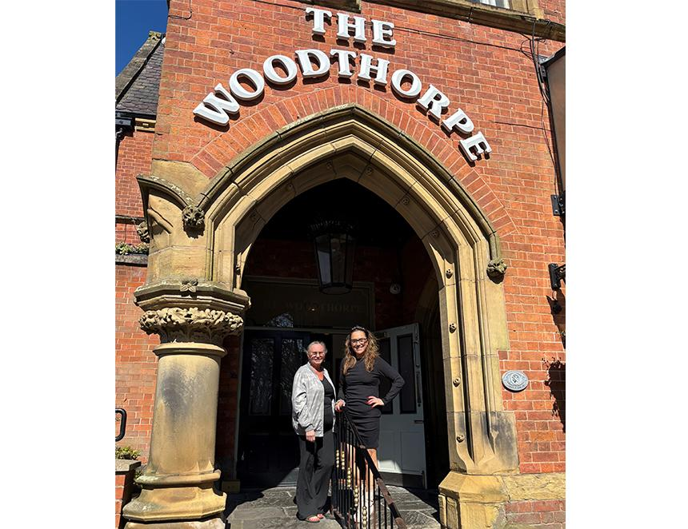

Looking after someone with dementia can be an incredibly lonely experience and a relaxing trip to the pub is, for many, out of reach. However a new free support group – the Get Together Club – has been set up at the Woodthorpe in Prestwich so carers and their affected loved ones can come together to socialise and enjoy some company over tea and biscuits. The group offers crafts and activities such as bingo, as well as music and singalong sessions for those living with dementia, and their family members. The Woodthorpe is owned by the North-West brewer Joseph Holt and is the second pub owned by the 175-year-old family business to provide such support. Last year a similar group was set up at the Goat’s Gate in Whitefield by then landlady Valerie Watts after her own mum was diagnosed with the condition three years earlier at 57 and who found there was a paucity of support for those caring for loved ones. Following its success, one of Val’s fellow organisers, Sonia Schofield, has decided the time had come to set up at a second venue. Sonia said: “Dementia affects so many people, and it can be so lonely, yet we saw at the Goat’s Gate what an impact our group had on those who would come along to the club. “Pubs are such warm, sociable and welcoming places – so meeting in the likes of the Goat’s Gate and now the Woodthorpe is deeply appreciated both by carers and those suffering with dementia. “My own grandma, who brought me up, used to go the group at the Goat’s Gate and it was such a great place for her to go. These groups are a place to laugh, cry, let off steam, share experiences or just enjoy the company. The most important thing is that people shouldn’t feel alone. “And being in a pub, the atmosphere is already one of warmth and welcome which really adds to what our club is trying to achieve.” The Woodthorpe group meets every Wednesday between 11am and 1pm and there is no need to book.  Pictured: Woodthorpe landlady Gaynor Hindley and the group’s founder Sonia Schofield