Pyoneer-ing spirit in Wye Valley

08/04/2025 by Timothy Hampson

Industry

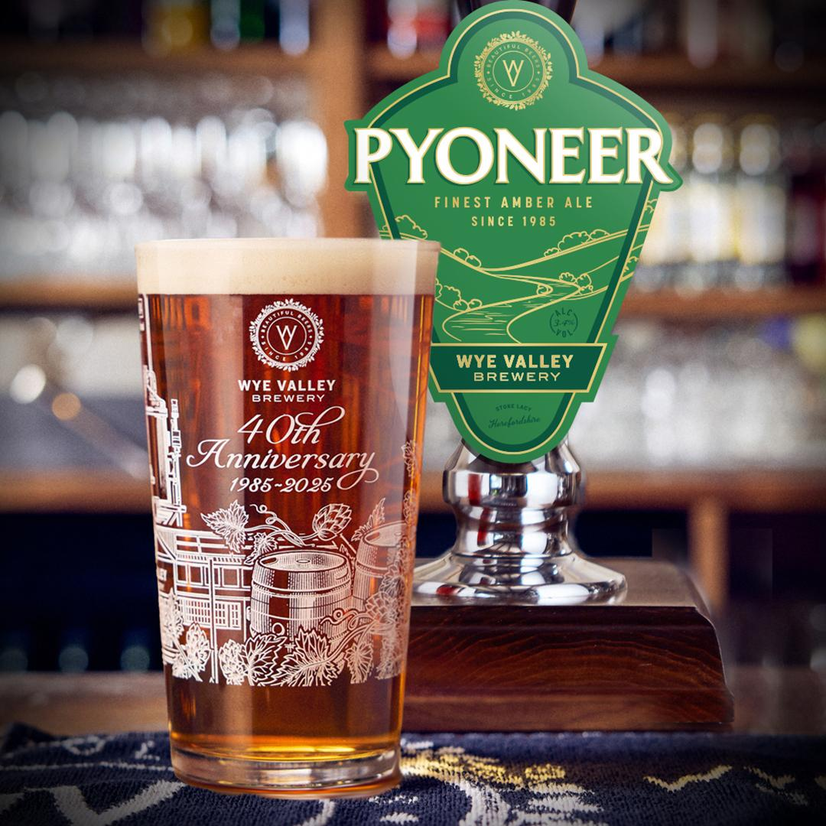

Wye Valley brewery has unveiled a rebrand of its first beer, Wye Valley Bitter, as part of its 40th anniversary celebrations, renaming it Pyoneer. Founded in 1985 in Herefordshire, England, Wye Valley brewery has grown from a small family operation into one of Britain's leading independent breweries. “We wanted a name that honoured our roots but also looked forward,” said Wye Valley MD Vernon Amor. “Pyoneer is exactly that – this was the beer that launched Wye Valley brewery, and it’s still as loved today as it was 40 years ago. The name gives a nod to Canon Pyon, where it all began, and to the pioneering values that continue to shape our brewery today.” While the name and branding have evolved, the award-winning taste remains unchanged. Pyoneer (3.4 per cent ABV) delivers the same balanced, full-bodied character that made it a favourite. The rebrand is just one of many events planned to mark Wye Valley brewery’s anniversary.