Otter moves into Exeter

07/04/2025 by Timothy Hampson

Industry

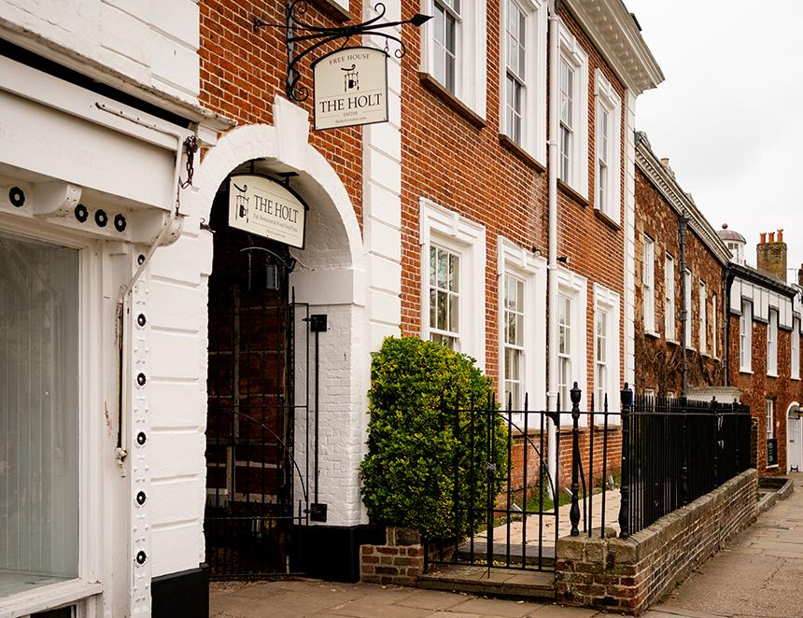

Otter brewery has opened its first pub and restaurant in the heart of Exeter. The venture sees Otter owners Patrick and Tor McCaig linking with Patrick’s brother Joe and wife Becks (current proprietors of the Holt – Honiton) to launch the new enterprise in a medieval building next to Exeter Cathedral. Patrick said: “For many years we have been waiting for the right location to give us the best opportunity to bring something new, exciting and, above all, independent to the centre of Exeter. “The Holt – Exeter is exactly that and precisely what we have been searching for. We are excited to open the doors and share our passion for locally produced beers and to deliver a menu that makes eating out easy! “The Holt – Exeter promises customers a wood-fired pizza menu, alongside a full range of locally sourced seasonal dishes. It will also be a showcase for the full range of Otter ales and lagers, including Amber Fresh, which has helped to bring a new, younger drinker to the cask ale category, and Otter Pale Ale.” Founded in 1990 from a farmhouse in the heart of Devon’s Blackdown Hills, Otter has grown to be one of the leading brewers in the South West.