CAMRA Pub Heritage Group update - March

06/04/2025 by Tom Chapman

Campaign

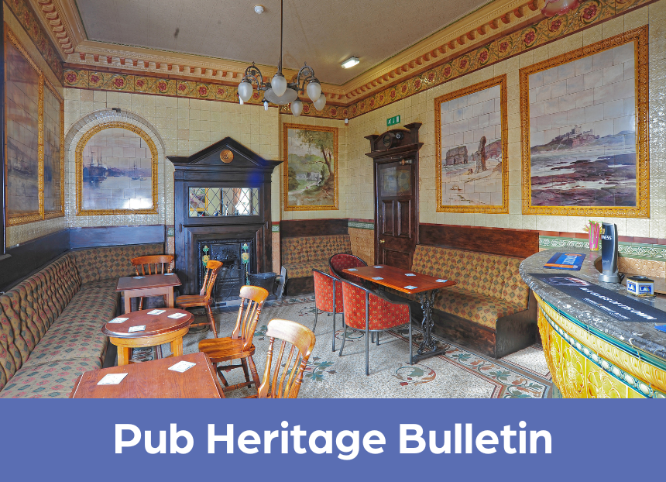

CAMRA’s Pub Heritage Group shares news and updates about pubs with historically significant interiors across the UK. For further news, see the Pub Heritage webpage here.   Three Star Heritage Pubs  Mountain Daisy, Sunderland, Tyne Wear The Mountain Daisy (above) has closed after being sold by Trust Inns to an undisclosed buyer, and its future is now in serious doubt, as the new owner has no intention of reopening it as a pub. The Pub Heritage Group anticipates a planning application will be lodged. Dating to the Edwardian era, the Mountain Daisy is a Grade II\*-listed pub, and its tiled Buffet Bar is recognised as being one of the most impressive historic pub rooms in the UK.  Find more information about the sudden closure on the Sunderland Echo website here. Read an interview with Sunderland & South Tyneside CAMRA’s pub protection officer Ian Monteith-Preston on BBC News here.

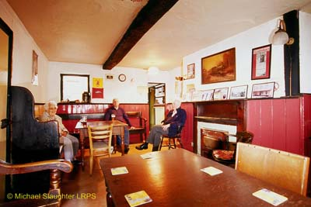

Red Lion, Llandovery, West Wales (above)  The Pub Heritage Group last reported on the sale of this classic time-warp pub in December 2023. After a long period of closure, the Red Lion is going to reopen as a pub! The new owner has submitted planning application which demonstrates a real commitment to conserving the internal layout and restoring historic features. There are proposed changes to ensure it is a viable business going forward which include installing a new bar, extending kitchen facilities and renovating the upstairs for B&B accommodation. The Red Lion has been restored to the National Inventory with a Three Star status.

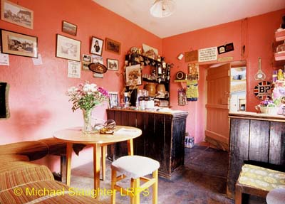

Luppitt Inn, Luppitt, Devon (above)  The Pub Heritage Group is happy to announce that this farmhouse pub reopened in early March. The group will visit to assess the changes that have been made to the pub’s layout.

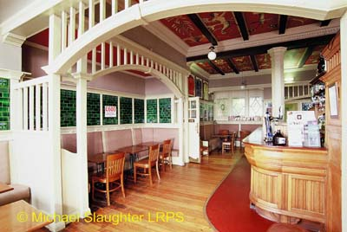

Prestoungrange Gothenburg, Prestonpans, Edinburgh & the Lothians (above)  Following a public consultation to discuss a possible alternative use for the pub, as reported in last month’s bulletin, an overwhelming response from the community has ensured that the Goth will remain a pub. A new operator has already come forward to take the lease of this fantastic arts-and-crafts-style pub. Find more information about the consultation on the East Lorian Courier website here.

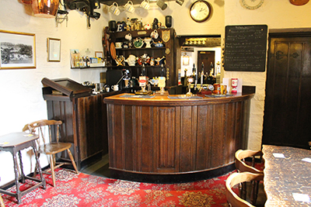

Eyre Arms, Hassop, Derbyshire (above)  Shut since lockdown, the lease of the Eyre Arms was taken on by restauranteur Alaistair Myers in February with the pub reopening 23 March. The impressive creeper-covered Eyre Arms was originally built as a farmhouse in 1632 and was being run as a pub by 1753. It is included on the National Inventory for its high quality 1950s interior refit. Find more information about the pub on the Derby Telegraph website here.

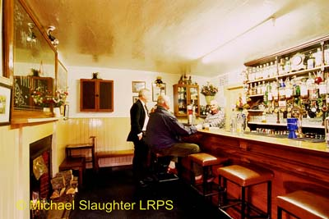

Fiddichside Inn, Craigellachie, Aberdeen and Grampian (above)  This classic one-room pub is up for sale with an asking price of £425,000. It was bought by the current owner in 2022 to ensure its preservation, but as they are based in London, they have decided to find a more local custodian to take it on. Read more about the sale on the Forres Gazette here.

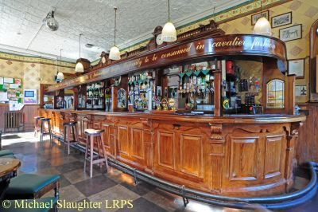

White Swan, Birmingham, West Midlands (above)  The Pub Heritage Group detailed the unexpected closure of the White Swan in last month’s bulletin. However, since writing, the pub has been reported as being open with somewhat irregular opening hours recently.  Two Star Heritage Pubs

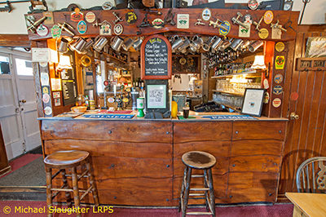

Horseshoe, Ebbesbourne Wake, Wiltshire (above)  The Horseshoe was awarded Pub of the Year by Salisbury and South Wiltshire CAMRA branch. It is a lovely village pub which has been run by the Bath family for more than 50 years. Read more about the pub’s triumph on the Salisbury & Avon Gazette here.

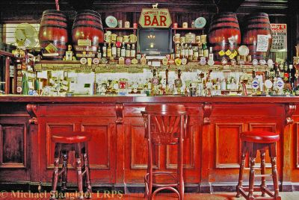

Volunteer Arms (Staggs), Musselburgh, Edinburgh and the Lothians (above)  The Volunteer Arms (Staggs) has been awarded Pub of the Year by Edinburgh & South East Scotland CAMRA branch. This superb pub has been run by the same family since it was built in 1858. The well-preserved public bar has a surviving Victorian back gantry with four large spirit casks that are a rare survivor from the late 19th century.  One Star Heritage Pubs

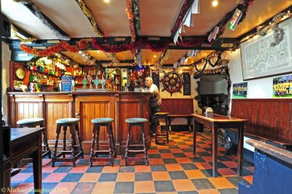

Ship Inn, Porlock (Top Ship), Somerset (above)  Another Pub of the Year winner, the Ship Inn has won Somerset CAMRA branch's award. It is known as the Top Ship to distinguish it from the nearby Ship Inn at Porlock Weir which is known as Bottom Ship. Dating to the 16th/17th century, the very characterful small snug bar is the star heritage feature of the pub.  Horns Tavern, West Norwood, London South East A recent refurbishment has removed all surviving historic features, so the pub has been removed from the National Inventory.  Other news  BEER BEER is available here. (CAMRA membership login required). In the spring edition of BEER, Pub Heritage Group chairman Paul Ainsworth explores pubs with fascinating histories in Inn-Side Stories.  If you have any news for CAMRA’s Heritage Pubs team, send to: info@pubheritage.camra.org.uk . If you wish to receive the bulletins directly, sign up by sending an email to bulletin@pubheritage.camra.org.uk with “subscribe” as the subject or “unsubscribe” if you wish to stop receiving bulletins.   Photos: Michael Slaughter