More pubs will close following tax hike double whammy

02/04/2025 by WB Reporter

Campaign

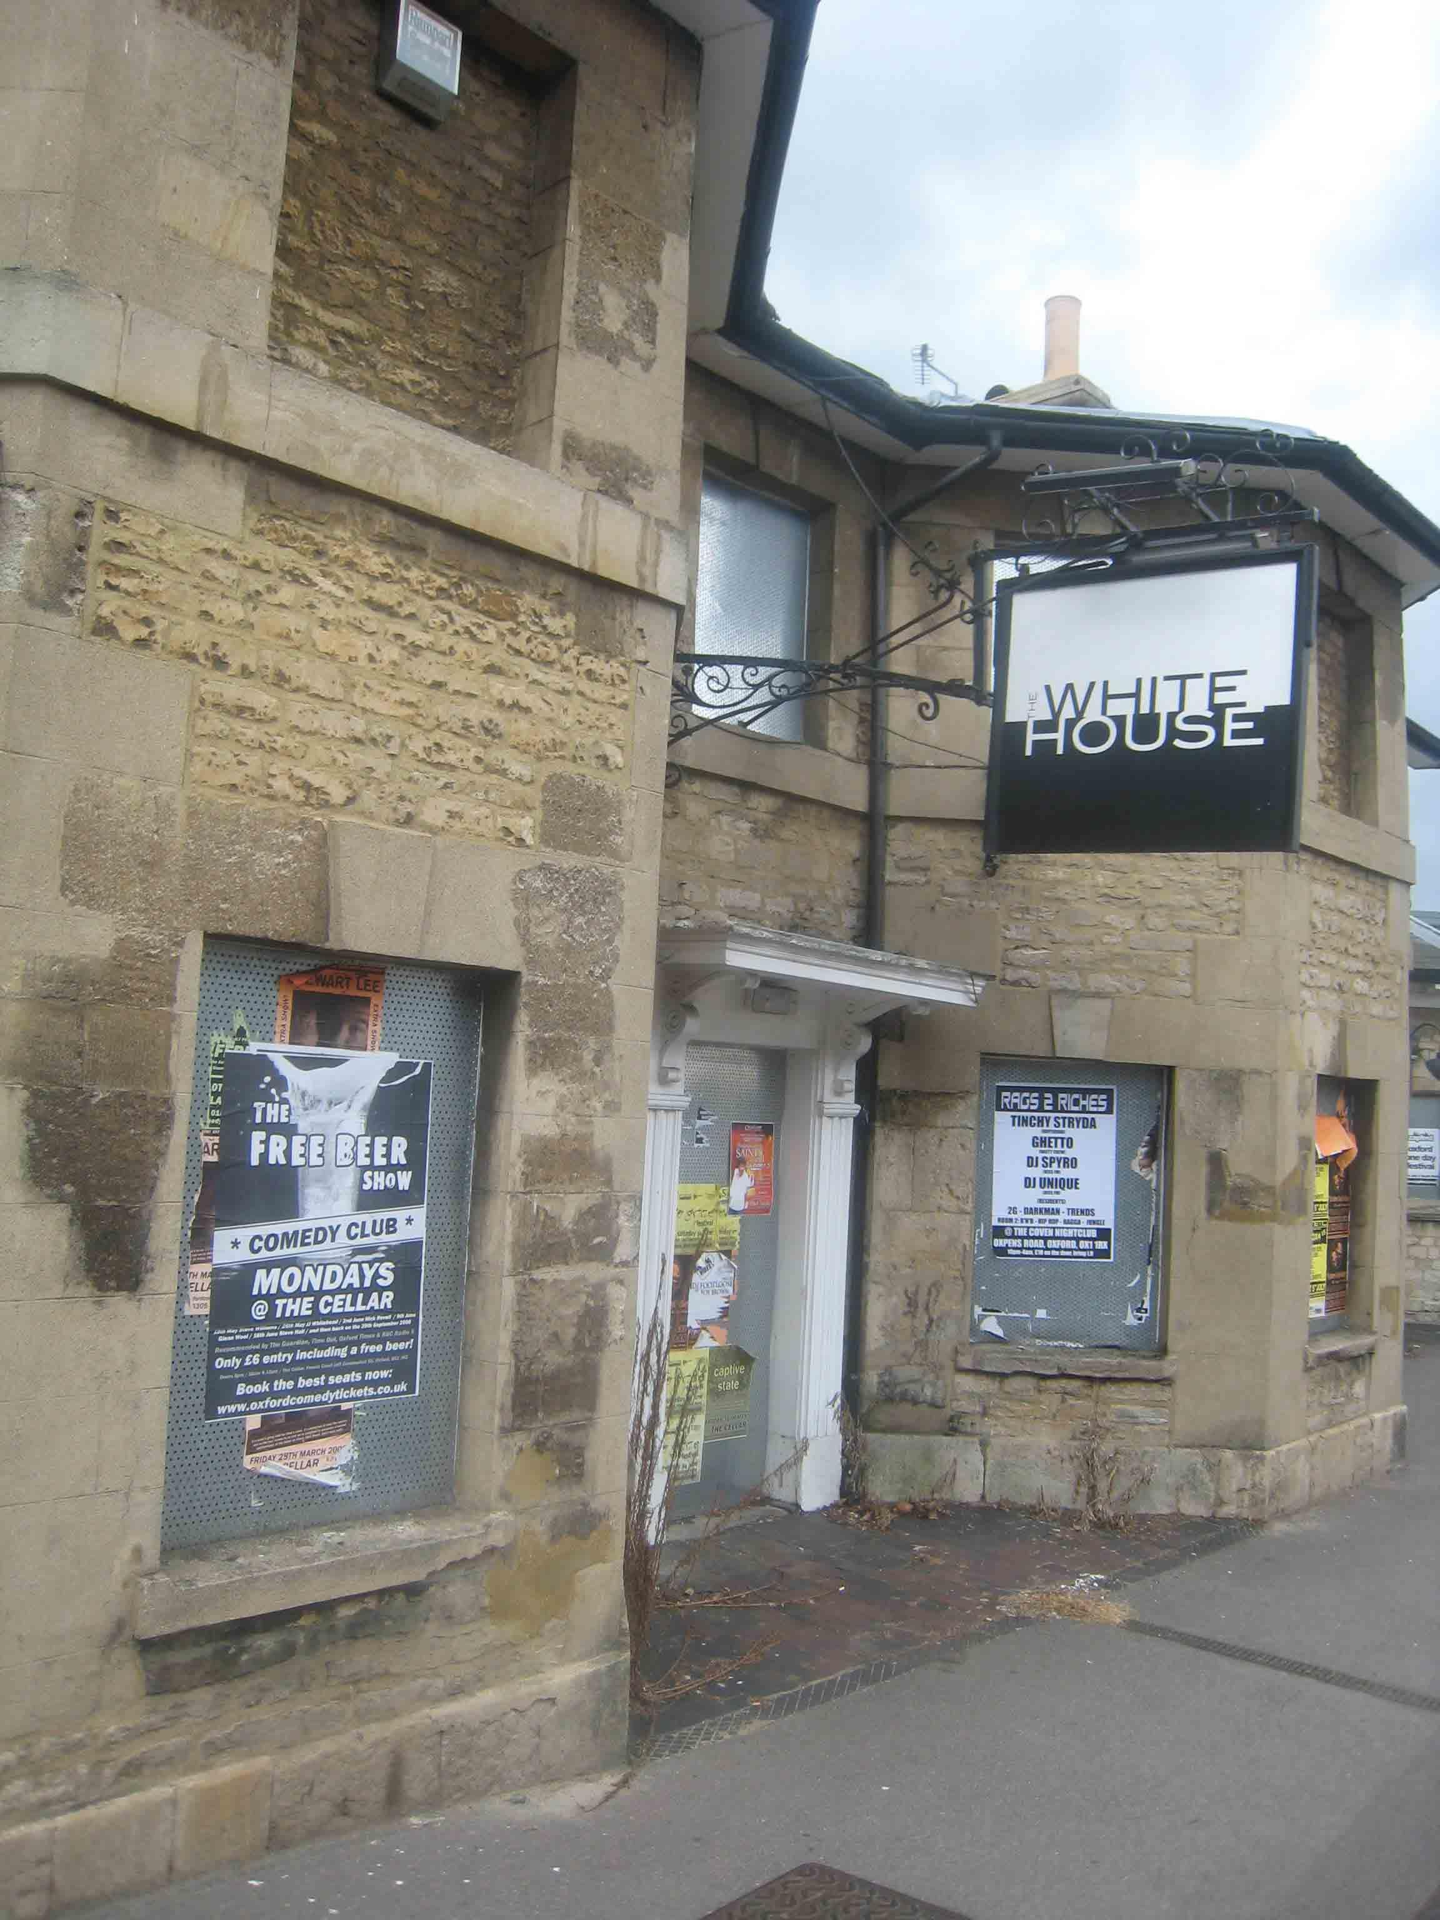

CAMRA is warning pub closures and conversions could rise as licensees face increases in Employer National Insurance from 6 April.   Pubs in England will also see an increase in the cost of their business rates bills this week, as the government-provided relief is reduced from 75 per cent to 40 from 1 April. Some pubs in Scotland and Wales will also receive 40 per cent relief on rates bills. CAMRA is calling on governments in all UK nations to introduce revised business rates that are fairer to pubs.  CAMRA’s pub data shows that in 2024, 1,062 pub businesses across Great Britain were no longer operating, with buildings standing empty. A further 210 pub buildings have been converted into other uses like shops or housing.  In the first three months of 2025, 303 pub businesses across England, Scotland and Wales closed while a further 46 pubs have been converted into other uses.  CAMRA chairman Ash Corbett-Collins said: “Hundreds of pubs have already stopped trading this year. How many more need to shut before the government takes notice? With big increases in costs from higher National Insurance contributions starting this week, and hikes in business rates bills for pubs in England too, it’s important for customers to remember that price hikes at the bar are the fault of the government, not hard-working publicans.  “Pubgoers are calling on the chancellor to look closely at the rate of pub closures between now and the Budget in the autumn, to think again on the Employer National Insurance hike for pubs and to cut rates of VAT and duty charged on beer and cider served in pubs.  “Without action from governments in all four nations, we risk losing more pubs which are a vital part of our social fabric and are at the heart of community life up and down the UK.”