Hunt for cider and perry heroes returns

01/04/2025 by WB Reporter

Campaign

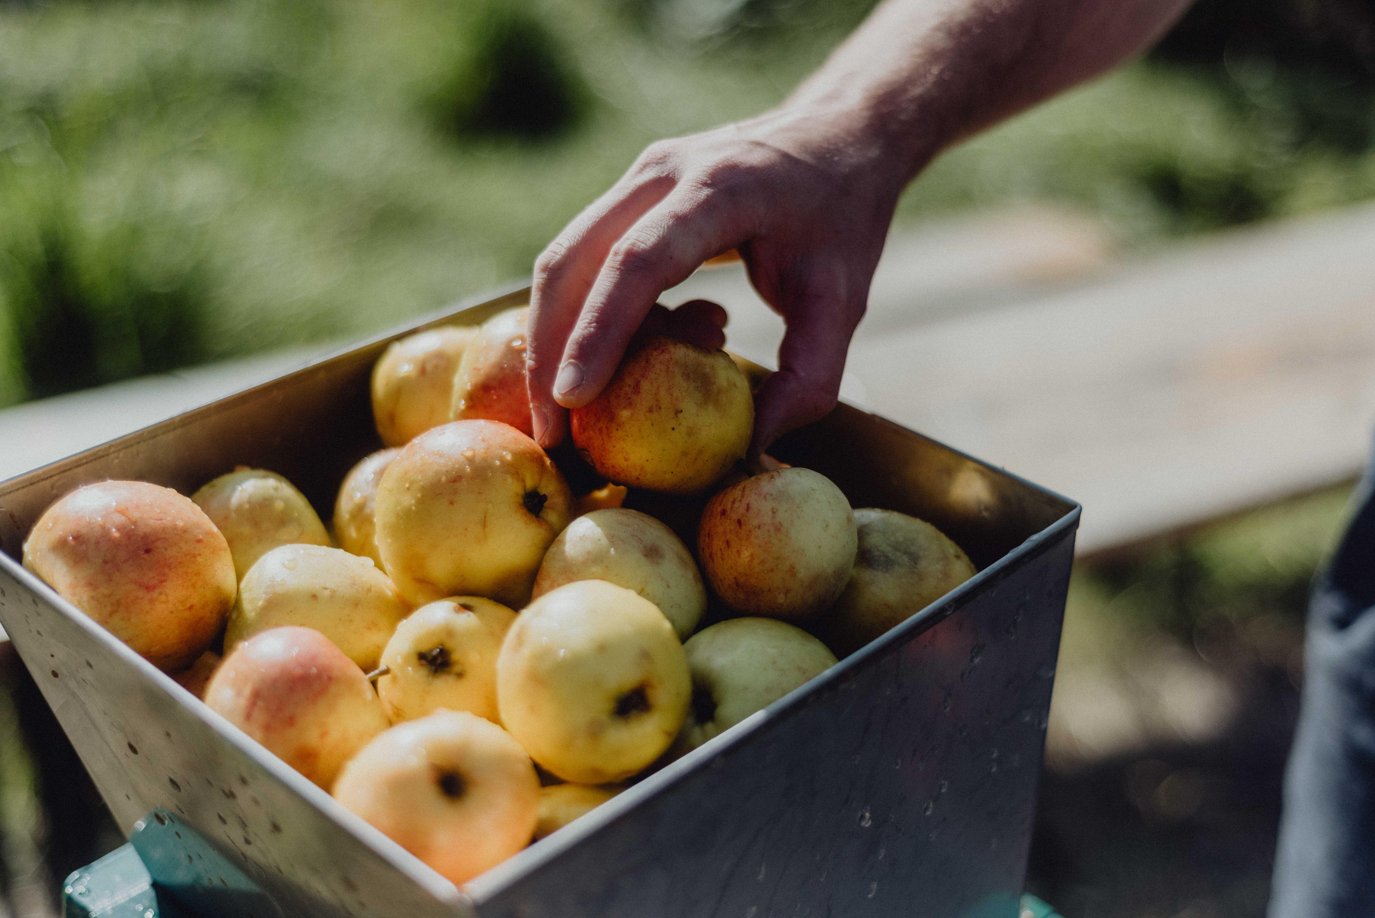

Entries have been reopened for CAMRA’s Pomona Award which champions and celebrates those who have gone above and beyond to promote real cider and perry.  Named after the Roman goddess of fruit trees, gardens, and orchards, the award is presented to a person, group, organisation, idea or concept (where a recipient can be identified) that has made an outstanding achievement, commitment, or contribution to the promotion of real cider or perry.  Last year’s winner was Adam Wells, author of the CAMRA book, Perry: A Drinker’s Guide. The book has gone on to win multiple awards.  Other previous winners include Elizabeth Pimblett, director of the Cider Museum in Hereford, Susanna Forbes co-founder of Little Pomona Cider in Herefordshire and James Finch, the Cider Critic.  Pomona Award Co-ordinator Andrea Briers said: “In the UK, we are blessed with some fantastic ciders and perries from independent producers. However, the industry is struggling to survive.  “Beautiful orchards are being torn down, not only erasing our stocks of ancient fruit trees, but devasting natural habitats for numerous species. Our independent cider and perry makers are finding it more and more difficult to get their amazing drinks in pubs, due to global corporate companies having a stranglehold on the access to market.  “Anyone who is working hard to highlight and protect the cider and perry industry or educate the public about these traditional drinks and their production deserves recognition. The Pomona Award does exactly that. I look forward to celebrating our cider and perry heroes later this year.”  More information, the nomination form and previous winners can be found here: camra.org.uk/awards/pomona-awards  The closing date for nominations is 1 August 2025. Worthy nominations received after this date may be considered for an award in May 2026.  The primary consideration is given to activities over the previous 12 months; however, ongoing work in this field can also be eligible. Nominations are sought annually, but the award will only be given in years when it is felt there is a suitable candidate.  Photo by Amelia Claudia