Monk has Faith in Damm deal

31/03/2025 by Timothy Hampson

Industry

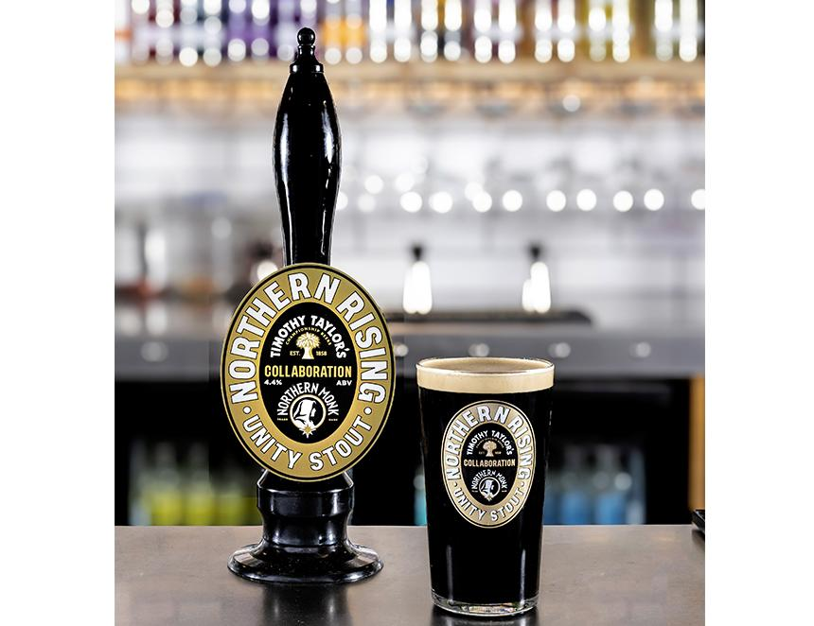

Spanish beer company Damm will distribute Northern Monk’s Faith and A Little Faith brands across the UK on-trade from May. The Spanish firm has entered an agreement with the Leeds-based craft brewer, which will enable Northern Monk to use Damm’s “extensive” on-trade distribution network. Northern Monk founder and MD Russell Bisset said the brewery would see a 20 per cent year-on-year expansion in its capacity in 2025, enabling it to produce an extra two million pints. Bisset said: “As one of the fastest growing beer brands in the off-trade, we are excited to join forces with Damm, a best-in-class partner, to accelerate our on-trade growth too, using this increased capacity to raise awareness of Northern Monk across the UK.” Last November, Northern Monk closed its equity crowdfunding campaign having smashed its initial £1m target. The money will be used to open a Northern Monk venue in London, upgrade the brewery’s original production site and taproom in Leeds, drive a commitment to reach net zero by 2030 and grow the brewer’s 114-strong workforce.