Perry well done

30/03/2025 by Matthew Rogers

Campaign

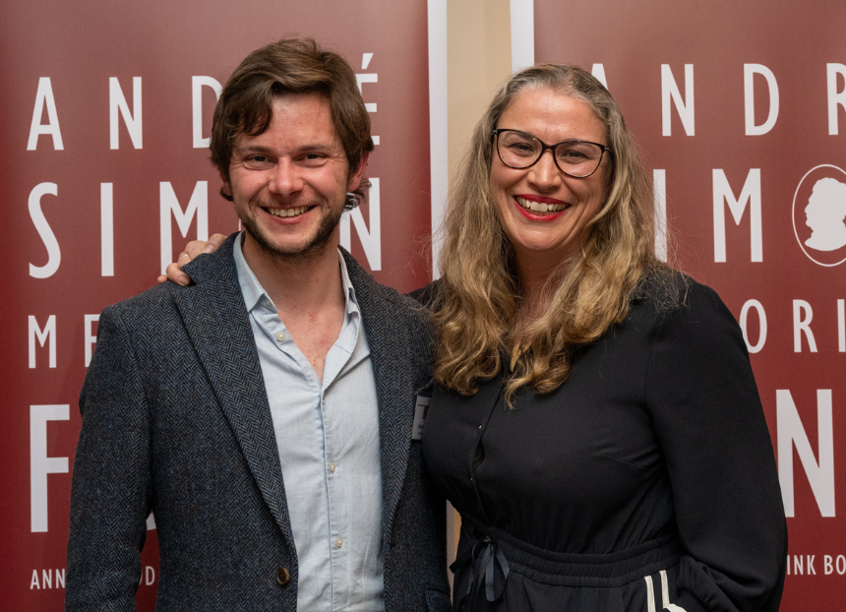

CAMRA’s Perry: A Drinker’s Guide by Adam Wells has won the Special Commendation prize at the André Simon Food and Drink Book Awards. Founded in 1978, the awards recognise the achievements of food and drink writers and are the longest continuous running prizes of their kind. Drink assessor Dawn Davies (pictured above with Adam) said: “I never thought I would pick up and enjoy a book about perry so much. Through this book I have found a new passion for a drink that was only vaguely on my radar. From production to the producers, this book has been written with humour and love, and even if perry wasn’t on your must-try list, by the time you get to the end of the book it will be.” Judges were looking for well-produced books with a substantial proportion of original research, high educational value and, most importantly, a pleasure to read. The book’s latest accolade comes soon after it claimed gold in the Susanna Forbes Award for Best Communication about Cider category at the Guild of British Beer Writers’ awards ceremony, plus author Adam taking home the Campaign’s annual Pomona Award. Perry: A Drinker’s Guide is the world’s first comprehensive guide to this often-overlooked drink. It describes the history of perry and how it is made, the varieties of pear, plus details the styles, regions and producers. Written by one of the UK’s leading voices on cider and perry, Adam is the founder-editor of Cider Review and co-host of the Cider Voice podcast Perry: A Drinker’s Guide is available to order from CAMRA’s online shop here. Photo: Hannah Maule-ffinch