Wheeling out the sexist tropes

29/03/2025 by Laura Hadland

Opinion

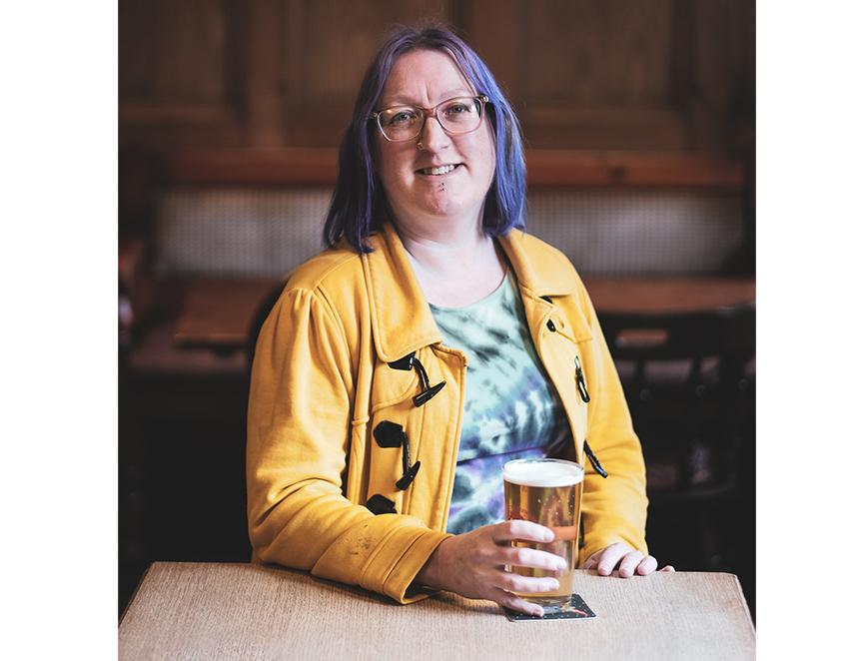

As some of you will know, I’ve just finished writing a book on beer festivals (available through CAMRA from 8 May). As a result, I’m naturally attuned to beer festival news. So it was hard to miss the recent debate surrounding this year’s St Albans Beer and Cider Festival. To commemorate 100 years since the opening of the Ballito Hosiery Mill, the organisers commissioned a logo design which features the silhouette of the factory, along with a “beer-drinking mascot”. This cartoon lady, after the style of Ballito’s 1950s hosiery advertisements sits bare-footed, holding a pint. Her skirt is ruched up to reveal her stocking tops. After accusations that this image is sexist on social media and in the local and national press, not to mention a detailed discussion on Discourse, the organisers have chosen to add a strapline to the logo – “celebrating the centenary of Ballito Hosiery Mill, 1925-1970” – to clarify their intentions. I should stress the issue has split opinion, with the logo finding many supporters as well as detractors. CAMRA HQ is satisfied the issue has been dealt with appropriately. Chairman Ash Corbett-Collins said: “We have been in discussions with the local CAMRA branch regarding its 2025 festival logo. This has now been updated to ensure the historic and local connection is clearer.” I have dedicated a chapter of my book to inclusivity at beer festivals. In the 1970s, private operators were running beer festivals where punters could have their photos taken with a topless model on their knee. One complained her bottom was “sore with pinching”. I write about how far we’ve come since then; including the banning of beers with discriminatory names or artwork from the Great British Beer Festival in 2019, and the important work that has been done to implement a festival code of conduct since 2022 to help make festivals more inclusive. I feel a bit disappointed that this logo has passed the acid test. I confess that the logo still very much “gives me the ick”, in the parlance of our times. Even with the strapline, this logo is just a pretty girl selling a beer festival to the casual viewer. The stocking tops on show beneath a hoicked-up skirt are not necessary for the nod to Ballito – you can easily indicate the presence of stockings by their seam alone. Festival sponsorship manager Emily Ryans describes the figure as “empowering”. Personally, I prefer to keep my stocking tops off display at a beer festival. I like to wear shoes too, given the option. I’m not the only one with concerns. Writer and journalist Melissa Cole has been calling out sexism in the industry for decades. She highlights the stocking tops and the line of the skirt along with the figure’s lack of eye contact, bare feet and lack of agency as “male gaze”. The male gaze began as a film theory, outlining how women were reduced to objects in Hollywood films because men controlled how they were made and made them to appeal to their own interests and values. The theory talks about women's bodies being stylised and denied realistic representations – an exaggerated version of reality. Much of the discussion surrounding the logo points to the fact that it is inspired by the historic branding. In fact, there are plenty of hosiery ads that are still doing the same thing today. Some show confident, athletic or professional women, but generally speaking they show their models scantily clad, looking and feeling sexy for their own benefit – it’s a key selling point for the products. But this logo is inviting people to attend a beer festival, not pick up a pair of nylons. A good parallel to this story is Castle Rock’s rebrand of Elsie Mo. Brewed since 1998, the beer originally featured a 1940s pin up, inspired by US aircraft nose art, on the pump clips. In 2018, it was decided that the sexualised presentation of Elsie Mo was “not acceptable in a culture that strives for, and celebrates, equality”. It was an autonomous decision made by the brewery, instigated by brand manager Liv Auckland and head of marketing Lewis Townsend. They were not taking action to address a backlash. They just felt it was the right thing to do. After an initial rebrand in 2014, they asked customers for their opinion and picked up that the character was still an issue. So, Elsie Mo became a pilot – with agency. Her smiling gaze meets yours as you look at the pump clip. The artwork was inspired by the women who took to the skies to deliver battle-ready planes to RAF pilots during WWII. A celebration of historical strong women. I hope the festival committee looks again at the St Albans logo. I can’t help but feel that if it were a pump clip, it wouldn’t pass muster at the Great British Beer Festival. Ballito has a marvellous back catalogue of adverts for inspiration that doesn’t let the male gaze dominate. We have come so far in making beer festivals more inclusive, and I don’t want to see the good folk at St Albans – one of the finest festivals in the land – taking steps backwards in stockinged feet.