When it rains, Greene King pours

28/03/2025 by Timothy Hampson

Industry

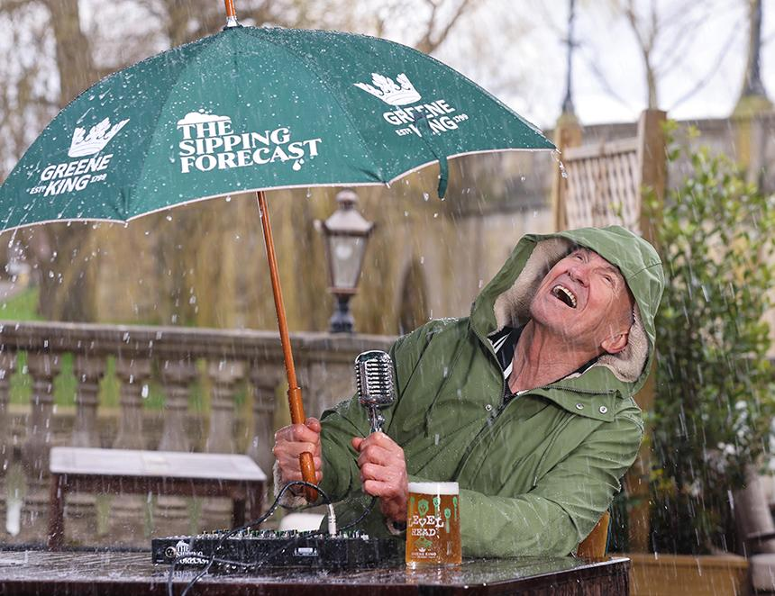

Greene King has revived its When it Rains, We Pour campaign, which will see the pub company and brewer give away up to 100,000 pints across the UK for 48 hours between 3-10 April. This is the second consecutive year the company’s pubs has run the campaign, with the aim of driving footfall and promoting its pub gardens this spring, rain or shine. The Sipping Forecast – fronted by TV star Larry Lamb of Gavin & Stacey and EastEnders fame – is a pub garden-based weather forecast, which will help viewers navigate the unpredictable British weather this spring. As part of the campaign, Greene King has installed rain detectors in six locations in its pubs across the UK. If a single drop of rain is detected at any one of the locations between 3-8 April, Greene King will activate a 48-hour pint giveaway. To launch the campaign, Lamb stars in a film that previews The Sipping Forecast, bringing to life moments of British pub garden behaviour. In the film, Lamb is seen battling wind and rain while being broadcast at the Boat House pub in Wallingford. He will go on to deliver a live Sipping Forecast at 12:48pm via Instagram on 3 April to offer an in-the-moment weather report live from a Greene King pub garden, paying close attention to the first drop of rainfall. The campaign is supported by customer research, which found nearly a third (31 per cent) of respondents say they’d dash inside from the pub garden at the first sign of bad weather. One in five (18 per cent) admit to wearing sunglasses and their winter coats at the same time to ensure they’re prepared for all weather conditions during the spring. Greene King MD Zoe Bowley said: “We are really happy to bring back our When It Rains campaign for the second year running, as well as collaborate with Larry Lamb to deliver the Sipping Forecast. “We wanted to celebrate our pub gardens as warm, welcoming and inclusive spaces where communities can gather with a good time almost guaranteed, whatever the weather. Even in the rain, we hope guests will be cheered to receive one of our free pints from 3 April.” Rain detectors have been installed in Greene King pubs in London, Glasgow, Birmingham, Leeds, Bristol and Wallingford.