Plan your spring festival trips now

27/03/2025 by George Robbins

Campaign

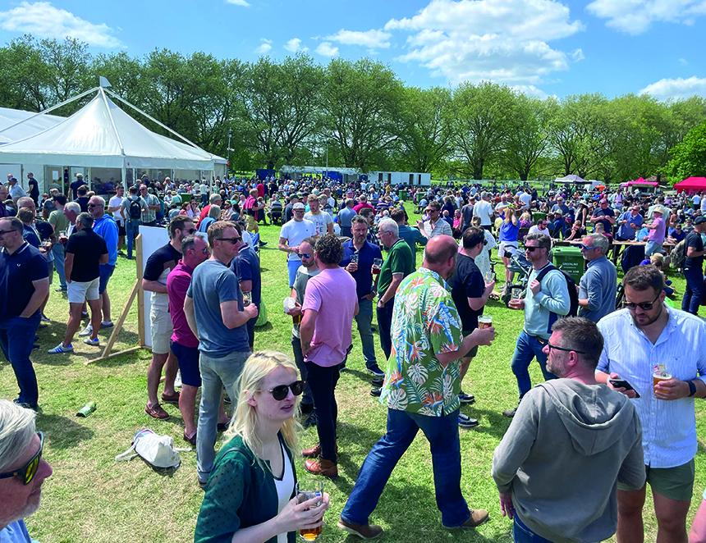

For your next festival trip look no further than the tempting list below. To see all upcoming CAMRA events visit the events webpage.   Burton and South Derbyshire Beer Festival, 27-29 March King Edward Place, Burton, East Staffordshire, DE14 2EB burtoncamra.wordpress.com/beer-festival   20th Maldon Beer and Cider Festival, 2-5 April Cygnet Room, Swan Hotel Bar & Grill, 73 High Street, Maldon, Essex, CM9 5EP maldonanddengiecamra.org.uk/MaldonBeerFestival   Larbert Real Ale and Cider Festival 4-5 April Dobbie Hall, Main Street, Stenhousemuir, Larbert, FK5 4BL  facebook.com/events/1368944747803999   Newcastle Beer and Cider Festival, 9-12 April Northumbria Students Union, Newcastle upon Tyne, Tyne and Wear, NE1 8SU nclbeerfest.uk   Isle of Man Beer and Cider Festival, 10-12 April Harris Promenade, Douglas, Isle of Man, IM1 2HP  iombeerfestival.com   47th Farnham Beerex, 10-12 April Farnham Maltings, Bridge Square, Farnham, GU9 7QR  farnhambeerex.org.uk/index.html   Oldham Beer and Cider Festival, 11-12 April Queen Elizabeth Hall, West Street, Oldham, OL1 1NL rob.camra.org.uk/viewnode.php?id=60320   Chippenham Beer Festival, 25-26 April Sadlers Mead, Chippenham, Wiltshire, SN15 3PA nwwiltscamra.org.uk/viewnode.php?id=177502   London Spring Cider Festival, 26 April Rocket Van Studios, 92 Brandon Street, Elephant & Castle, London, SE17 1AL sel.camra.org.uk/diary/festivals/   18th Bexley Beer Festival, 8-10 May Dartfordians Community Sports Club, War Memorial Club House, Bourne Road, Bexley, Kent, DA5 1LW bexley.camra.org.uk/beer_festival.html   Biggleswade Beer and Cider Festival, 8-10 May St Andrews Street, Biggleswade, England, SG18 8BA biggbeerfest.org   Maccelsfield Beer Festival, 9-10 May Macclesfield Rugby Club, Priory Park, Priory Lane, Macclesfield, Cheshire, SK10 4AF macclesfieldbeerfestival.org   33rd Yapton Beerex, 9-11 May Yapton and Ford Village Hall, Yapton, West Sussex, BN18 0ET westernsussex.camra.org.uk/viewnode.php?id=243311   Tredegar House Folk Festival Real Ale and Cider Bar, 9-11 May Tredegar House, Pencarn Way, Newport, Newport, NP10 8YW tredegarhousefestival.org.uk/   Clitheroe Beer Festival, 15-17 May St Michael & St John's Club, Lowergate, Clitheroe, BB7 1AG clitheroebeerfestival.co.uk/   2nd Dulwich Beer and Cider Festival, 22-24 May Dulwich Hamlet FC, Dog Kennel Hill, East Dulwich, London, SE22 8BD sel.camra.org.uk/diary/festivals/   Skipton Beer Festival, 22-24 May Town Hall, High Street, Skipton, North Yorkshire, BD23 1AH  skiptonbeerfestival.camra.org.uk   Lincoln Beer Festival, 22-24 May Southside, Colegrave Street, Lincoln, Lincolnshire, LN5 8DW lincoln.camra.org.uk/   38th Colchester Real Ale and Cider Festival, 28-31 May Colchester Arts Centre, Church Street, Colchester, Essex, CO1 1NF colchesterbeerfestivals.co.uk/   Thurrock Beer and Cider Festival 2025, 3-7 June Civic Hall Blackshots Lane, Grays, Essex, RM16 2JU thurrock.camra.org.uk/viewnode.php?id=242456   Braintree Real Ale Festival, 5-7 June Bocking Arts Theatre (formally Braintree Institute), Bocking End, Braintree, Essex, CM7 9AE braintreebeerfestival.co.uk/   Hitchin Beer and Cider Festival, 5-7 June Hitchin Rugby Club, Old Hale Way, Hitchin, SG5 1XL  hitchinbeerciderfestival.org.uk   Stratford-Upon-Avon Beer and Cider Festival, 6-7 June Stratford On Avon Racecourse, Luddington Road, Stratford-upon-Avon, CV37 9SE shakespeare.camra.org.uk/festival   CAMRA KESR Railway Real Ale & Cider Festival, 6-7 June Kent and East Sussex Railway, Tenterden, Kent, TN30 6HE afrm.camra.org.uk/viewnode.php?id=230145   Ale and Steam, 13-15 June Gloucestershire and Warwickshire Steam Railway, Winchcombe and Toddington Stations, Winchcombe, Gloucestershire, GL54 5DT gwsr.com/events/real-ale-festival-2   Stockport Beer and Cider Festival, 19-21 June Stockport Guidhall, 169-171 Wellington Road South, Stockport, Greater Manchester, SK1 3UA stockportfestival.org.uk/   27th South Downs Beer Festival, 20-21 June Lewes Town Hall Corn Exchange, Fisher Street, Lewes, Sussex, BN7 2QS brighton.camra.org.uk/   Leicester CAMRA Beer Festival, 26-28 June Corporation Road, Leicester, LE4 5PX leicester.camra.org.uk/festivals/   12th Rutland CAMRA Beer Festival, 27-29 June County Museum, Catmos Street, Oakham, Rutland, LE15 6HW rutland.camra.org.uk/viewnode.php?id=241929