Disappointing Spring Statement

26/03/2025 by WB Reporter

Campaign

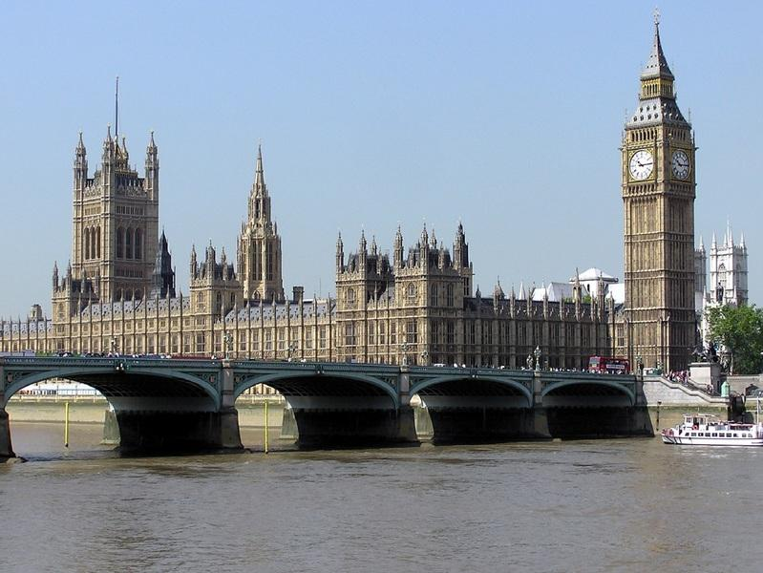

Following the chancellor’s Spring Statement, CAMRA national chairman Ash Corbett-Collins said: “Pub-goers are understandably worried about the future of community locals. Licensees will be hit by extra costs in the coming days from increased National Insurance contributions and a cut in support with business rates for pubs in England. “In light of these worries, it is disappointing that there weren’t any announcements in the Spring Statement to support pubs, breweries or consumers. Pub-goers and the people running pubs were crying out for the chancellor to think again on the employer National Insurance hike for pubs; to speed up the new, fairer system of business rates for pubs in England; for cuts to duty and VAT on beer and cider served in pubs. “CAMRA’s 145,000 members will continue to fight for better consumer choice and support for UK pubs and brewers leading up to the Autumn Budget.”