Three B’s grand milestone

26/03/2025 by Timothy Hampson

Pub

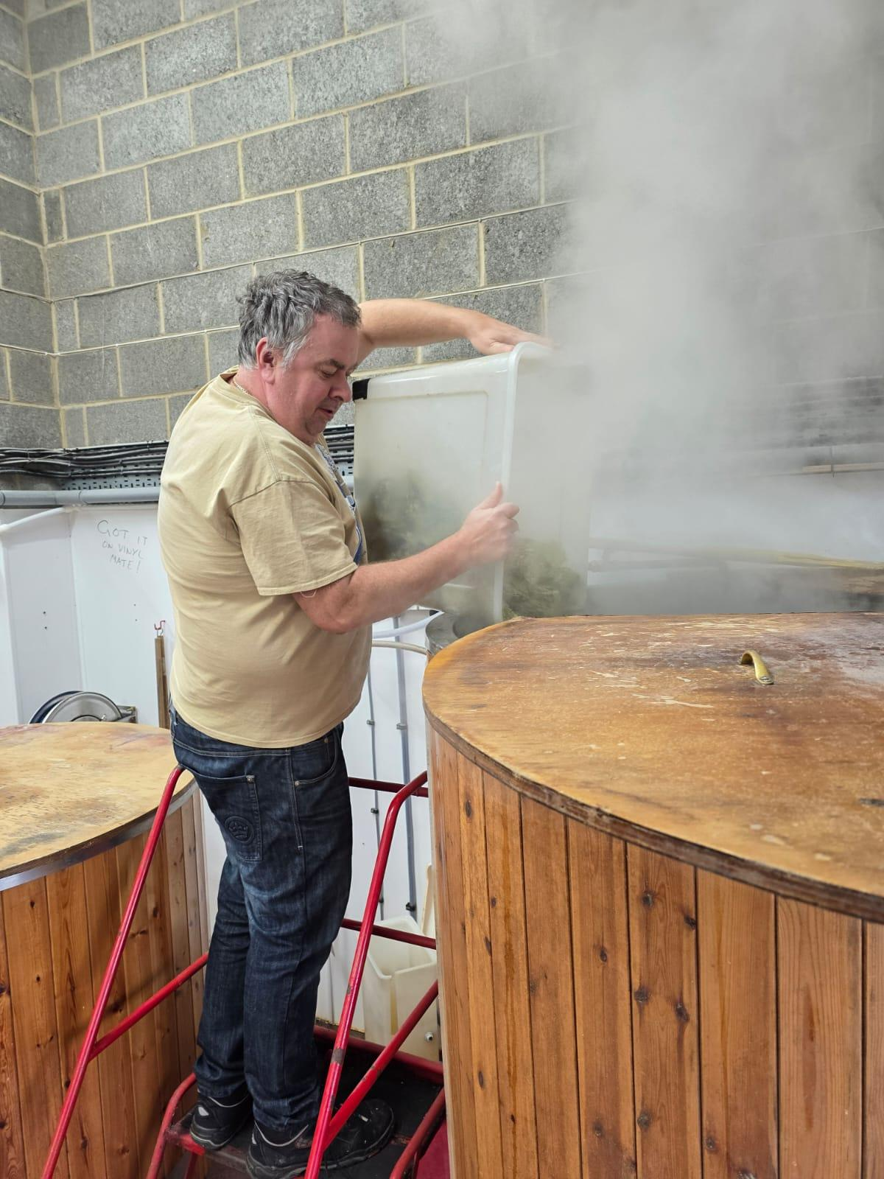

Award-winning Three B’s Micropub in Bridlington has served its 1,000th beer. The pub ensures three out of the four beers on tap has not been served before (the fourth is the ever-present Acorn Barnsley Bitter) and this week it’s raising a glass to its 1,000th brew. The beer, an intensively American-hopped beer (4.5 per cent ABV), was brewed at North Riding brewery in Snainton, North Yorkshire where Three B’s owner Mark Bates (pictured) assisted the production team. Mark said: “It was amazing to be entertained by our good friends at North Riding brewery, it was a very enjoyable and educational experience, and I thank them for allowing me to help with the production of the beer.”