Scottish brewers sweep the board
24/03/2025 by Timothy Hampson
Industry

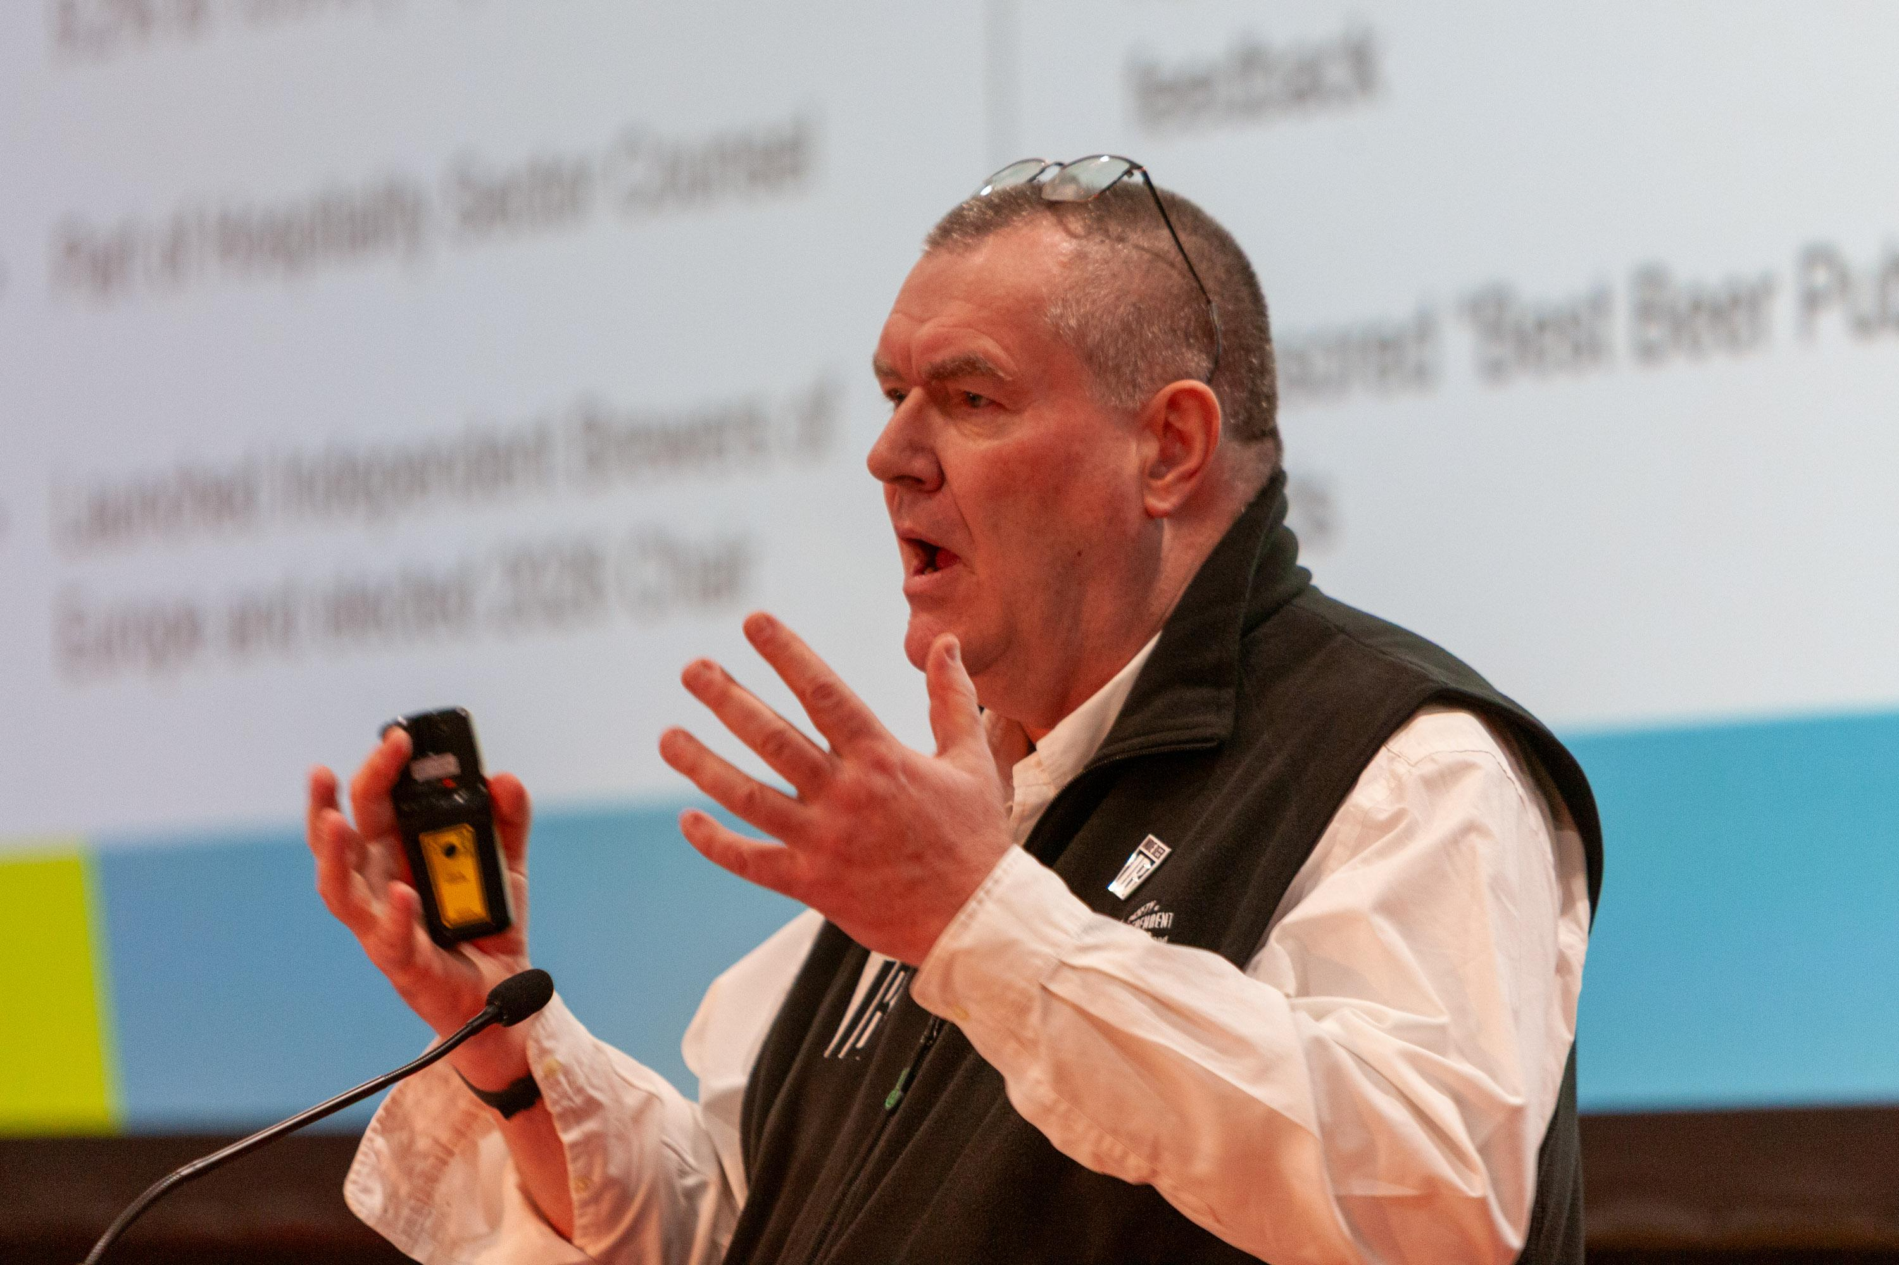

Scottish brewers took the top honours at the Society of Independent Brewers and Associates (SIBA) national beer awards in the cask, keg, and bottle/can competitions. Cross Borders Brewing was overall cask champion with its India Pale Ale (6 per cent ABV). Fyne Ales won the bottle/can contest with Mills & Hills Vintage (9.7 per cent), a barrel-aged imperial stout and Swannay took the keg beer crown with its Orkney Porter (9 per cent). Fyne Ales owner and SIBA Scotland regional director Jamie Delap said: “We’re absolutely delighted, there's so many fantastic beers here so to win a medal is always brilliant. “So the fact that judges have enjoyed what we do, we love it. We’re just so honoured. I think in Scotland we’re proud, we’ve got lots of brewers doing some really good things and this just validates that great work going on. So we’re delighted to win, really proud of everyone.” Judged by brewers and industry experts and organised by SIBA at its flagship BeerX UK event in Liverpool, the awards encompass a huge range of beer styles. SIBA chief executive Andy Slee (pictured) said: “These awards are 12 months in the making and given to only the UK’s very best beers. “Huge congratulations to all of this year’s medal winners and particularly our three overall champions, all hailing from Scotland for the first time in the competition’s history – there must be something in the water up there.”

