Seafood boil

23/03/2025 by Christian Gott

Uncategorised

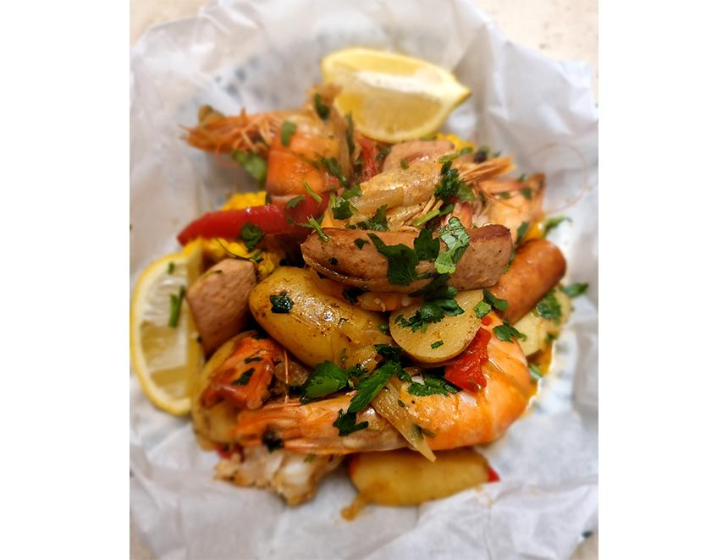

The recent spell of sunshine certainly seemed to put a smile on everyone’s faces and it got me thinking of one of my all-time top dishes to eat outside with a chilled bottle of beer or two. The seafood boil is an American favourite especially in Louisiana, New England and Maryland. Recipes differ from state to state, but the essentials are seafood such as crab and crayfish, potatoes and sweetcorn, cooked with a mix of herbs and spices. The dish is served on paper with extra spices and lemon, and you dig in with your fingers. In Maryland, the ingredients are often steamed rather than completely immersed and beer is often added to the cooking liquid. But the real secret to a great seafood boil is the blend of herbs and spices in the recipe. Many restaurants use J.O. No. 1 Brand Seafood Seasoning, whereas households tend to use the more readily available Old Bay blend. Both blends are heavily guarded secrets, but No. 1 is definitely heavier with the salt and chilli. You can buy Old Bay mix in most large supermarkets. When travelling in America, when I wasn’t eating BBQ food, seafood and steak, I would often grab the odd craft six-pack to take back to the next motel where I would be staying to sample. For this recipe, I wanted to find a UK-brewed version of the popular, easy-drinking, continental-style American amber lagers that will work both in the dish and to drink when eating it. Crumbs Brewing Bloomin’ Amber Lager is a smooth malty Vienna-style brew that fits the bill perfectly. Crumbs makes a range of beers using unsold bread in addition to Bloomin’ Amber, including a ruby ale made with rye and another lager made with left-over naan. Seafood and beer boil I like to parboil the sweetcorn and potatoes, so I don’t overcook the seafood. You can normally buy crab claws from a good fishmonger. Serve on a double thickness of waxed baking paper. 1 pack kielbasa sausage. If you cannot find kielbasa, use smoked pork sausage 800g baby potatoes washed and cut in half or quarters depending on size 4 corn on the cob each cut into thirds 8 crab claws 500g shell-on gambas or king prawns 150g salted Jersey butter at room temperature 440ml Crumbs Bloomin’ Amber Lager 6 large cloves of garlic, peeled and crushed 1 lemon cut into wedges 1 medium red chilli, finely chopped (optional) 1tbs Old Bay Seasoning 2tsp smoked paprika 1 small bunch flat parsley, washed and finely chopped Sea salt and freshly ground black pepper Cook the potatoes and the sweetcorn in boiling salted water for 10 minutes then drain and refresh in iced water. In a second large pan, melt the butter and gently fry the garlic and chilli without burning. Stir in the Old Bay Seasoning and paprika, then add the lager. Bring to a simmer. Add the seafood, sausage, potatoes, sweetcorn and half of the chopped parsley. Season generously and bring back to the boil. Add a tight-fitting lid and cook for 15 minutes. Carefully remove the lid and strain off the cooking liquid. Place the waxed paper into large serving bowls and spoon in the boil and garnish with the remaining chopped parsley and lemon before serving.