PUBlic Affairs round up – March

22/03/2025 by Tori Wood

Campaign

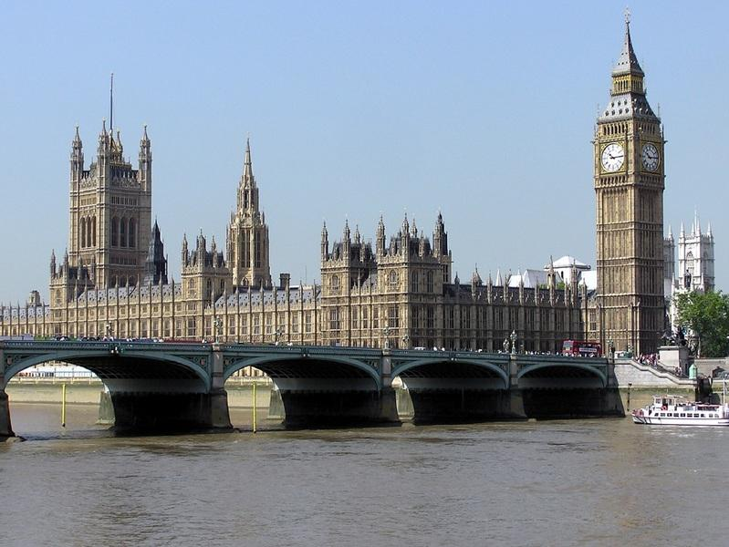

The PUBlic Affairs round up returns with the latest updates on how the Campaigns and Communications team has been working with members, branches and strategic committees to campaign for pubs, pints and people across Westminster, devolved parliaments and local government.  Westminster  All Party Parliamentary Group on Pubs The Inaugural General Meeting of the All Party Parliamentary Group on Pubs (APPG) was held in parliament on 11 February where the APPG was re-established, chair and vice chair positions elected, and CAMRA appointed as secretariat.   Charlotte Nichols MP (Labour, Warrington North) was elected as chair, Richard Holden (Conservative, Basildon & Billericay), Ben Maguire (Liberal Democrat, North Cornwall) and Blake Stephenson (Conservative, Mid Bedfordshire) vice chairs.  To kick off the newly appointed group, MPs have been invited to a brewery tour and beer tasting as the APPG’s first event in March.  Access to market review The team continues to engage with officials conducting the access to market review, with a particular focus on pushing for a meeting with the minister, Justin Madders MP.  High Street Rental Auctions The UK government’s High Street Rental Auctions scheme that allows local authorities to auction empty high-street premises went live on 2 December 2024.  A recent announcement made by the Ministry of Housing, Communities and Local Government introduces a further eight councils in England, bringing the overall total to 11, that can roll out the scheme in their areas.  The eight are: Barnsley, Broxtowe, Camden, Hillingdon, Lichfield, North Northamptonshire, North Somerset and Westminster.  The team is contacting the relevant local authority planning departments to urge protections are put in place for pubs, as well as providing resources for branches in these areas.  Minister Alex Norris answered a parliamentary question relating to High Street Rental Auctions asked on our behalf, where he stated there are adequate protections in the scheme for pubs.   The team will keep pushing ministers and councils to put in proper protections to make sure this scheme isn’t used as a loophole to bypass planning laws and see permanent conversions of pubs into housing or shops.  Planning protections [England] We are awaiting responses to letters we sent to ministers at the Ministry of Housing, Communities and Local Government about planning protections for pubs in January and February 2025.  The Mirror recently published a Your Pub Needs You campaign targeted at the UK government to implement funds and support for pubs and licensees, which CAMRA is supporting.  As part of this campaign, the team wrote a open letter to deputy prime minister Angela Rayner calling for better planning protection for pubs.   Other parliamentary questions have been asked on behalf of CAMRA including:  Q: To ask the secretary of state for Housing, Communities and Local Government, what assessment she has made of the potential merits of introducing a statutory duty on local planning authorities to remedy breaches of planning law for unlawful (a) demolition of public houses and (b) conversion of public houses to another use.  A: We have not made any assessment of the potential merits of introducing a statutory duty on local planning authorities to remedy breaches of planning law in relation to such matters. We continue to keep the operation of the current protections for public houses under review.  A Heritage Public Houses Bill has been introduced to parliament by Mike Wood MP (Conservative, South Staffordshire and Kingswinford) with the intent to provide additional protections for heritage pubs.   No time is to be allocated to debate this Bill, which limits chances to change the law, however, the team has contacted Mike Wood to offer support with the bill and wider pub planning protection campaigning in wake of the Crooked House destruction.  On 11 March 2024, the deputy prime minister introduced the Planning and Infrastructure Bill to reform the planning system, with a particular focus on large-scale developments and new towns.   The team has written to the deputy prime minister to ask that all new developments are required to include pubs as community facilities.    Handpump Hijack  In light of Carlsberg Britvic’s Fresh Ale concept, CAMRA continues to wait for a substantive response from West Northants Council’s Trading Standards Department  In a move to push the government to reform the Trading Standards regime to improve how issues like Fresh Ale are dealt with, CAMRA has had talks with consumer group Which?.  Deposit Return Scheme & Extended Producer Responsibility There are no new announcements or developments on packaging within the last month, either in relation to the England, Northern Ireland and Scotland Deposit Return Scheme or the Wales version.  A consultation on the operation of the Deposit Return Scheme in Wales is expected in the summer.  Industry bodies continue to discuss the challenges of the Extended Producer Responsibility policy and a lack of clarity and information and are lobbying ministers about the cost of the regulations for producers, pubs and the knock-on rise of costs for consumers.  Take-away sales and outdoor seating areas [England & Wales] The Covid-era regulations which allow pubs and clubs in England and Wales to sell off-sales and host outdoor seating areas on pavements without application to the licensing authority have now been revoked by the Home Office.  As per the government’s amended guidance to local authorities, businesses that currently offer these Covid-era regulations must now apply to amend licences and should be treated as a minor variation – which is easier and cheaper than a major change – if they plan to continue.     Scottish government and parliament   Cross-Party Group on Beer and Pubs (secretariat provided in part by CAMRA)  In April 2025 MSPs will be visiting breweries in Leith for a beer tasting where they will be networking and discussing issues independent breweries and consumers across Scotland are currently facing.  Scottish Pubs Code A wave of provisions in the Scottish Pubs Code will come into effect in April, with the delayed Market Rent Only provisions implemented in July.  The team continues to engage with the adjudicator and her office, which delivers regular updates on policies as the code is introduced.      Welsh government and Senedd Cymru  Cross-Party Group on Beer and Pubs (secretariat provided in part by CAMRA)  On 12 February, the Cross-Party Group met for a beer tasting from independent breweries across Wales, joined by Chris Charters (regional director of Wales), John Lamb (deputy regional director of Wales) and CAMRA Cardiff branch representatives.      Northern Ireland executive and assembly   Licensing Review The executive’s independent review of the licensing system was published in February. Ministers are due to respond to this review within six months.  The full report is available here.  The report recommends a wholesale reform of the licensing system as it confirms the surrender principle is “outdated”, recognises it “operates as a market barrier, limiting competition and driving up the cost of licences”, and must come to an end.    The report also states the surrender principle “has led to a decline in pubs while off-licence outlets (e.g. supermarkets and convenience stores) have increased”.  The team issued a press statement in response.  A series of engagements is taking place with political parties and MLAs about the report and its next steps.     Non-parliamentary  One Voice for Pubs & One Voice for Beer CAMRA chief executive Tom Stainer has been attending recent One Voice group meetings where industry organisations coordinate activities based on common concern issues.   A letter on business rates and National Insurance contributions has been sent to the chancellor, and Extended Producer Responsibility has been discussed.