From garden shed to Tractor Shed

21/03/2025 by Len Wainwright

Industry

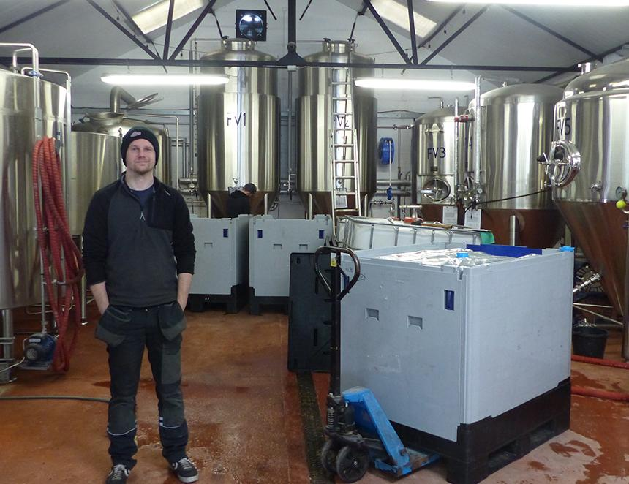

Crooked River brewery is to continue brewing Tractor Shed beers following the retirement of owner Graeme Mitchell in April, plus has launched its own cask range. Crooked River currently brews at Tractor Shed’s Workington site with restricted production to canned and keg beers to avoid direct competition with its host, but Graeme’s retirement has seen it launch its own cask line-up – a 3.4 per cent pale ale, 4.2 per cent golden ale, 4.2 per cent bitter and 4.8 per cent stout. Crooked River co-founder Alan Fitton-Crellin (pictured) has nearly a decade of experience brewing at Tractor Shed where he played a key role in contract brewing. This experience sparked his ambition to create his own range of craft beers. In 2022, Alan partnered with Phil Scholey, a sales professional and graphic designer, and began brewing small-batch beers in the former’s garden shed. Starting with just 50 litres per week, they purchased a small brew kit and canning machine, with Phil designing the labels and marketing resources. The beers quickly found a home in businesses across Cumbria, but the long-term vision was to establish their own brewery and taproom. The closure of Cockermouth’s Jennings brewery in autumn 2022 provided the catalyst to take the next step. Alan and Phil initially sought premises in the town but encountered planning restrictions. Realising the need to increase production, they approached Tractor Shed owner Graeme and secured an agreement to contract brew on-site. This allowed them to dramatically increase capacity, producing up to 1,000 litres per batch and expanding their reach across Cumbria and the Lake District. The beers gained a following and in 2023 and 2024, Crooked River hosted social events at Cockermouth Cricket Club, combining its craft beers with street food and live music. Meanwhile, the search for a taproom continued and in autumn 2024, they secured premises in Packhorse Court, Keswick.  Crooked River has ambitious plans to expand its hospitality presence in West Cumbria and is in discussions with the new owners of Jennings over joint ventures in 2025. Len Wainwright is a member of West Cumbria CAMRA