CAMRA Pub Heritage Group update – February

19/03/2025 by Tom Chapman

Campaign

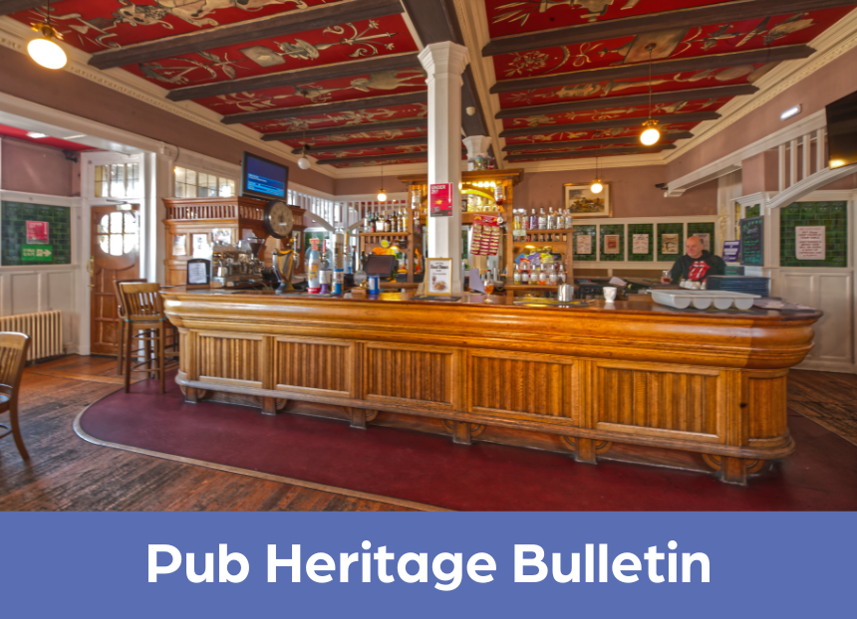

CAMRA’s Pub Heritage Group shares news and updates about pubs with historically significant interiors across the UK. For further news, see the Pub Heritage webpage here. Three Star Heritage Pubs Prestoungrange Gothenburg, Prestonpans, Edinburgh & The Lothians This superb Arts and Crafts-style pub (above), built in 1908, sadly closed at the end of January following the licensee quitting. The owner, Dr Gordon Prestoungrange, believes the pub is not viable due to recent increased costs associated with the industry. He is now seeking ideas from the local community for alternative uses and called a public meeting to discuss its future. The unusual name of the pub originates from the Swedish Gothenburg system, in which the manager makes no profit from alcoholic drinks, but only from food and soft drinks. It is one of only four Scottish pubs that still runs on the Gothenburg system. Find out more about the public meeting on the East Lothian Courier website here.

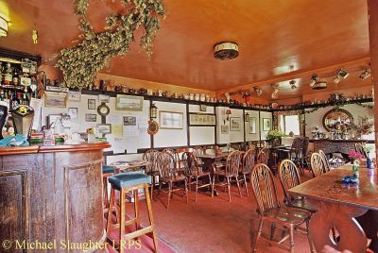

Brown Jug, Broadstairs, Kent (above) The Brown Jug, owned by artist Tracey Emin, has unfortunately had retrospective planning permission (first lodged in June 2023) granted for change of use. The Pub Heritage Group was not surprised of the result given the dilapidated state of the building making its viability as a pub questionable, coupled with a lack of local clamour over its loss. More information on the pub's conversion can be found on the Isle of Thanet website here.

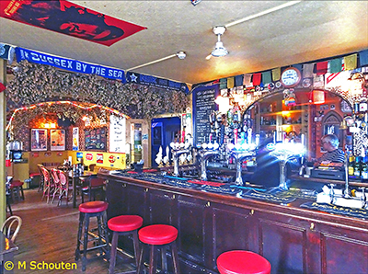

Prince Albert, Brighton, East Sussex (above) The Pub Heritage Group reported in November 2023 a planning application to develop an adjoining building next door to the live music pub had been made. The concern was noise complaints could follow, threatening the Prince Albert’s future. Thankfully, the application, which included Airbnb rooms was turned down by the council. However, the applicant has now gained permission on appeal with a modified proposal that only includes office use. Further information can be found on the BBC News website here.

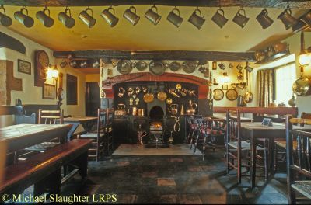

Olde Gate Inne, Brassington, Derbyshire (above) Shannon Lyons, who is just 20, has become the licensee of the Olde Gate. The Olde Gate has an interior relatively unchanged since 1874 and is recommended by beer writer Roger Protz as “Simply the perfect winter pub, you won’t find a cosier place in the country”. Find out more about one of Derbyshire’s youngest licensees on the Derby Telegraph website here.

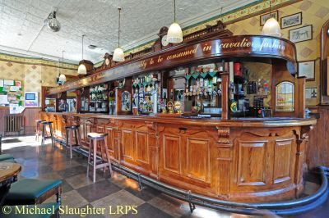

White Swan, Birmingham, West Midlands (above) The White Swan closed on 17 January. The Pub Heritage Group last covered it in February 2024, when the pub changed ownership and a planning application to develop the upper floors was submitted (while retaining the ground floor public house). The Pub Heritage Group believes the latest closure could be linked to the planning application, with the possibility of works due to start soon. Birmingham CAMRA branch is trying to find out more information, and the Pub Heritage Group would welcome anymore news.   Two Star Heritage Pubs

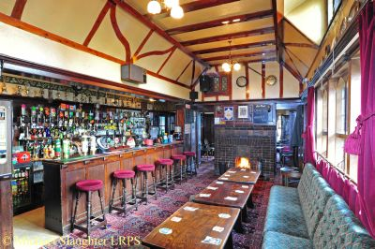

Gate House, Norwich, Norfolk (above) The Pub Heritage Group last reported on the Gatehouse in April 2024 when the Asset of Community Value (ACV) had been re-instated following the pub’s closure. The Gatehouse Community Hub has registered as a Community Benefit Society and is looking to raise money to buy the pub, which is now on the market through Brown’s of Norwich. Find more information about the campaign on the Norwich Evening News website here.

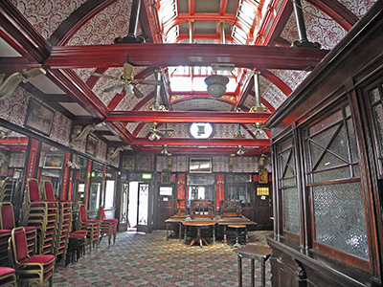

Denmark Arms, East Ham, Central London East (above) The Denmark Arms closed at the end of January and the freehold is now for sale with an asking price of £1.25m. The pub was built in the late 19th century with a major extension in 1903 and is worth visiting to view the impressive first-floor, former billiard room with glazed skylights. Find more information on the Rightmove website here.

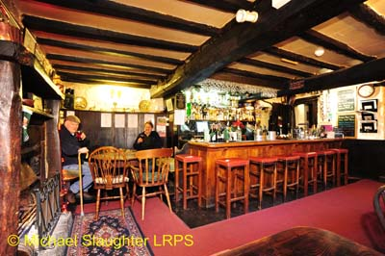

Oxenham Arms, South Zeal, Devon (above) The picturesque Oxenham Arms on the edge of Dartmoor is up for sale with an asking price of £1.4m. Owners Simon and Lyn Powell are retiring after 13 years running the thriving pub, which functions as a hotel, restaurant and bar. The ancient building was originally monastical, later becoming a manor house, and becoming an inn by the 16th century. The traditional public bar was last altered in the 1960s, and in the small rear lounge can be found the South Zeal Menhir – a 5,000-year-old megalith set into the rear lounge wall. The pub remains open. Find out more about the sale on the Bettesworths website here.   One Star Heritage Pubs

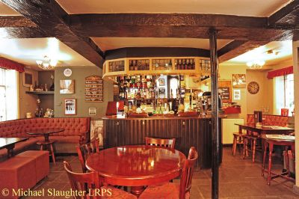

Royal Oak, Chesterfield, Derbyshire (above) Having been closed for three years, the Pub Heritage Group is pleased to report the Royal Oak has been sold by Stonegate with the new owner due to reopen the pub in April. For more detail see the Chesterfield News website here.

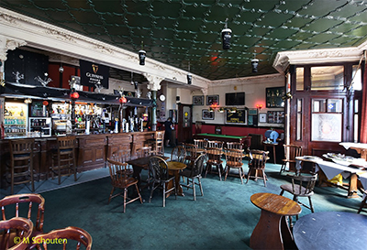

King’s Arms, Eastbourne, East Sussex (above) The Pub Heritage Group reported in February that a planning application had been submitted to turn the ground floor of the listed Kings Arms into apartments. The pub suffered an arson attack on the night of 2 February. No casualties have been reported, but it is unclear if the interior has been damaged and if so, how badly. The Pub Heritage Group would welcome further news. Read more about the arson on the Argus website here.

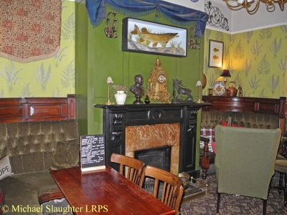

Peacock Hotel, Nottingham, Nottinghamshire (above) The Pub Heritage Group last reported on the Peacock in February 2023 when it reopened following a £250,000 refurbishment by owner Heineken Star Pubs & Bars with manager Ben Bronson at the helm. Ben has now decided to move on due to Star changing the dynamic of the pub, with more emphasis on sports TV and cheaper brands, which he sees as moving away from the inclusive community ethos of the pub he had fostered during his time there. The pub remains open with new management. More information can be found on the Nottinghamshire Live website here.

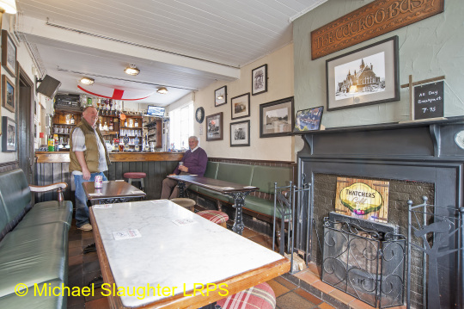

Cuckoo Bush Inn, Gotham, Nottinghamshire (above) The Cuckoo Bush Inn is closed with a sign advertising for new tenants with a promise of “refurbishment planned”. The unspoilt public bar remains currently unaltered, but the Pub Heritage Group would welcome any updates. If you have any news for CAMRA’s Heritage Pubs team, send to: info@pubheritage.camra.org.uk. If you wish to receive the bulletins directly, sign up by sending an email to bulletin@pubheritage.camra.org.uk with the word “subscribe” as the subject or “unsubscribe” if you wish to stop receiving bulletins. Photos by Michael Slaughter and Michael Schouten