Freedom Toast’s new deal

18/03/2025 by Timothy Hampson

Industry

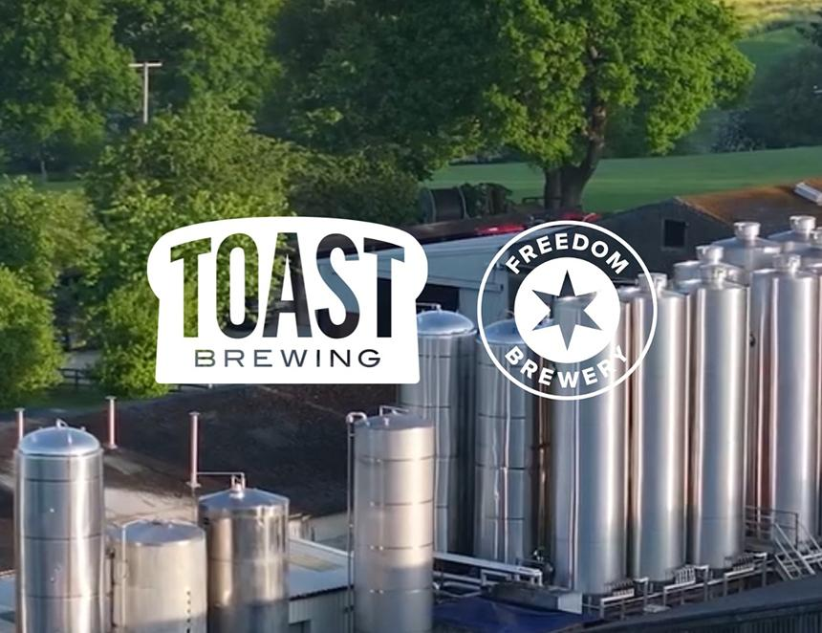

Toast Brewing and Freedom brewery have joined forces to ensure the survival of their beers. Under the licensing agreement, Freedom will exclusively brew and sell the Toast beers nationwide from May with the latter retaining ownership of its brand. Toast has been brewing with surplus bakery bread to replace malted barley, which not only makes good use of the UK’s most commonly wasted food, but it also uses less malt. Freedom has spent nearly three decades honing its skills making unpasteurised lagers. Freedom’s commitment to low-temperature fermentation and long maturation results in naturally carbonated, unpasteurised lagers that burst with delicate, refined flavours. Toast co-founders, Rob Wilson and Louisa Ziane, will continue to lead the beer brand. They will also continue to advocate wider adoption of the circular economy in the beer industry through projects with Toast. Rob said: “We’re delighted to be working with Freedom brewery to support the growth of the Toast brand. While it’s a challenging time for the brewing sector, with many businesses falling into administration or being bought into larger groups under value, our businesses are in a strong position. “With rising costs and restrictive access to market, this partnership brings operational and commercial efficiencies that strengthen us both. Our shared belief in beer that does good has seen us work together before, and this new relationship will mean we can create even better beer and deliver more impact.”