12 Irish stouts to say sláinte to this St Patrick’s Day!

17/03/2025 by Tori Wood

Campaign

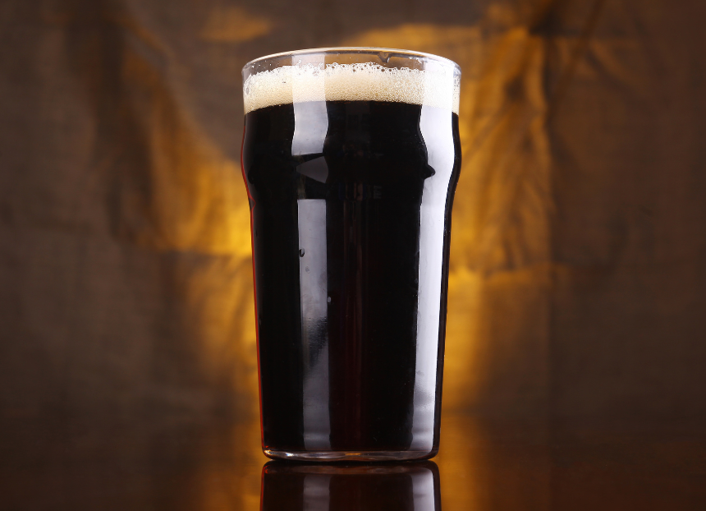

CAMRA has compiled a list of 12 stouts produced by some of the best independent brewers Ireland has to offer to celebrate St Patrick’s Day.  These can be found in cask, keg, can or bottle, and will go down a treat this St Patrick’s Day!  From catching the gingerbread man to a family run, history-inspired brewery, read on to find your next favourite Irish stout. Sláinte!  Ulster Black (5 per cent) Brehon Brewhouse, County Monaghan Opened in 2014, this brewery was inspired by the history of its landscape and was founded by dairy farmer Seamus McMahon who wanted to diversify his homestead.  With a toasted-malt aroma and dark chocolate and coffee flavours, Ulster Black is filled with light detailing of bitter hops. Pair this full-bodied stout with red or smoked meat and heavy stews. Available in can, bottle, and keg.  Flat Black Coffee Stout (Bailies Collab) (5.6 per cent) Bullhouse Brew Co, Belfast  Inspired by great tasting beer on a road trip around the West Coast of the US, Bullhouse opened in 2011 after homebrewing on a farm outside of Belfast for four years and is now a firm favourite in the east of the city.  In collaboration with Bailies Coffee Roasters, its expertly roasted Salvadorian La Guachaca beans infuse this beer with intense aromas of dark chocolate, dried mango and hazelnut. A full-bodied stout with a velvety mouthfeel and lingering coffee finish. Available in can and keg.  Belfast Black (4.2 per cent)  Whitewater brewery, Castlewellan, County Down  Established in 1996 on a fifth-generation family farm amid the spectacular Mourne Mountain range in the north of Ireland, Whitewater is now the biggest independent brewery there.   Belfast Black is made with roasted barley, rolled oats, chocolate and black malts combined to produce this traditional Irish stout, balanced perfectly with a gentle coffee aroma and rich hop flavours. Available in bottle, cask and keg.  Can't Catch Me Gingerbread Stout (6 per cent)  Heaney brewery, County Derry, Londonderry Founded in 2014, this brewery is based on a family farm where there has been generations of harvest and inspiration.  Can’t Catch Me is a fourth version of Heaney’s Gingerbread Stout. Brewed with fresh ginger and cinnamon, this stout has an indulgent biscuit body with layers of caramel that brings a sweet finish. Available in can and keg.  Utopian Stout (8 per cent) Lacada brewery, Portrush, County Antrim     A community owned co-operative brewery based on the world-famous north coast of Ireland.    Its Utopian Stout is an award-winning, full-bodied, medium-dry stout with a silky mouthfeel, complemented with a warm roasted malt aroma and dark chocolate and coffee notes. Available in bottle, cask and keg. Once in a Lifetime (5 per cent) Our brewery, Randalstown, County Antrim   Opened in 2022, Our brewery specialises in fermentation projects, exploring historical techniques with modern equipment to create unique beers for consumers.  Described as silky smooth with complex flavours of coffee, dark fruits, burnt caramel and toffee, this stout has a sensory-rich mouthfeel with roasted malts balancing the smoothness of oats to bring a depth of flavour. Available in can and keg. Oatmeal Stout (5.5 per cent)  Rough Brothers, Derry, Londonderry  Established in 2018, this small batch brewery incorporates microbrewery equipment and technology to offer a range of bespoke beers.  Filled with bold flavours of dark chocolate, liquorice and black coffee, this stout has added oatmeal for extra body. Brewed with seven types of malt and oatmeal, why not pair this full-flavoured stout with a Sunday roast? Available in cask, keg and bottle.  Spectre (4.1 per cent)  Mourne Mountains, Warrenpoint, County Down Founded in 2015 in the foothills of the Mourne Mountains, the brewery produces a diverse range of beers and uses whole leaf hops from around the world.  This dry, dark brew has a roasted barley, espresso and dark-chocolate aroma with a perfectly balanced roasted bitterness and smooth dry finish. Available in cask, keg and bottle.  Black (4.5 per cent) McCrackens brewery, Portadown, County Armagh   Established in 2018 with two beers and a dream, this award-winning brewery produces unfiltered and naturally conditioned beers and has recently expanded its team and beer range.  This award-winning black Irish stout is full-bodied and robust in flavour, complemented by Nugget and East Kent Golding hops. A combination of kilned malted barley and oats gives this stout its jet-black colour and smooth mouthfeel. Available in can.  Gift Imperial Stout (8.8 per cent) Boundary Brewing, Belfast   This co-operative brewery was founded in 2014 and is shaped and run by its own members to produce beers inspired by Belgian and US styles.  This luxurious and complex imperial stout is built on a robust malt foundation of Heidelberg pilsner, Munich, flaked and malted oats, and a blend of chocolate malts. Rich layers of flavour include dark chocolate, roasted coffee and caramelised sweetness. Available in keg and can.   1689 (9 per cent) Walled City, Derry, Londonderry   Walled City’s brewery was founded in 2015 and opened Derry's first taproom in 2022 with 15 beer taps – the largest offering in the city.  This imperial stout based on a recipe found in a 17th-century diary from the siege of Derry. Exclusively available in the Walled City Taproom, it was claimed to cure “toothache, heartache and scurvy”.   Winterland (5.3 per cent)  Kinnegar brewery, Letterkenny, County Donegal In 2013 Kinnegar opened in north-east Donegal, but after rapid growth and success, the team expanded and relocated to a larger production facility near Letterkenny in 2017.  This seasonal special has a deep, rich and exotic ability to light up cold, dark nights. Filled with deep, roasted-malt flavours, smooth cocoa richness, and a subtle, salted finish that lingers on the palate. Available in can.  To find more brews to try this St Patrick’s Day, check out CAMRA NI member Quare Swally blogger’s guide There’s more to Irish stout than just Guinness’ on Facebook.