Halfway goes all in to help community

16/03/2025 by Timothy Hampson

Pub

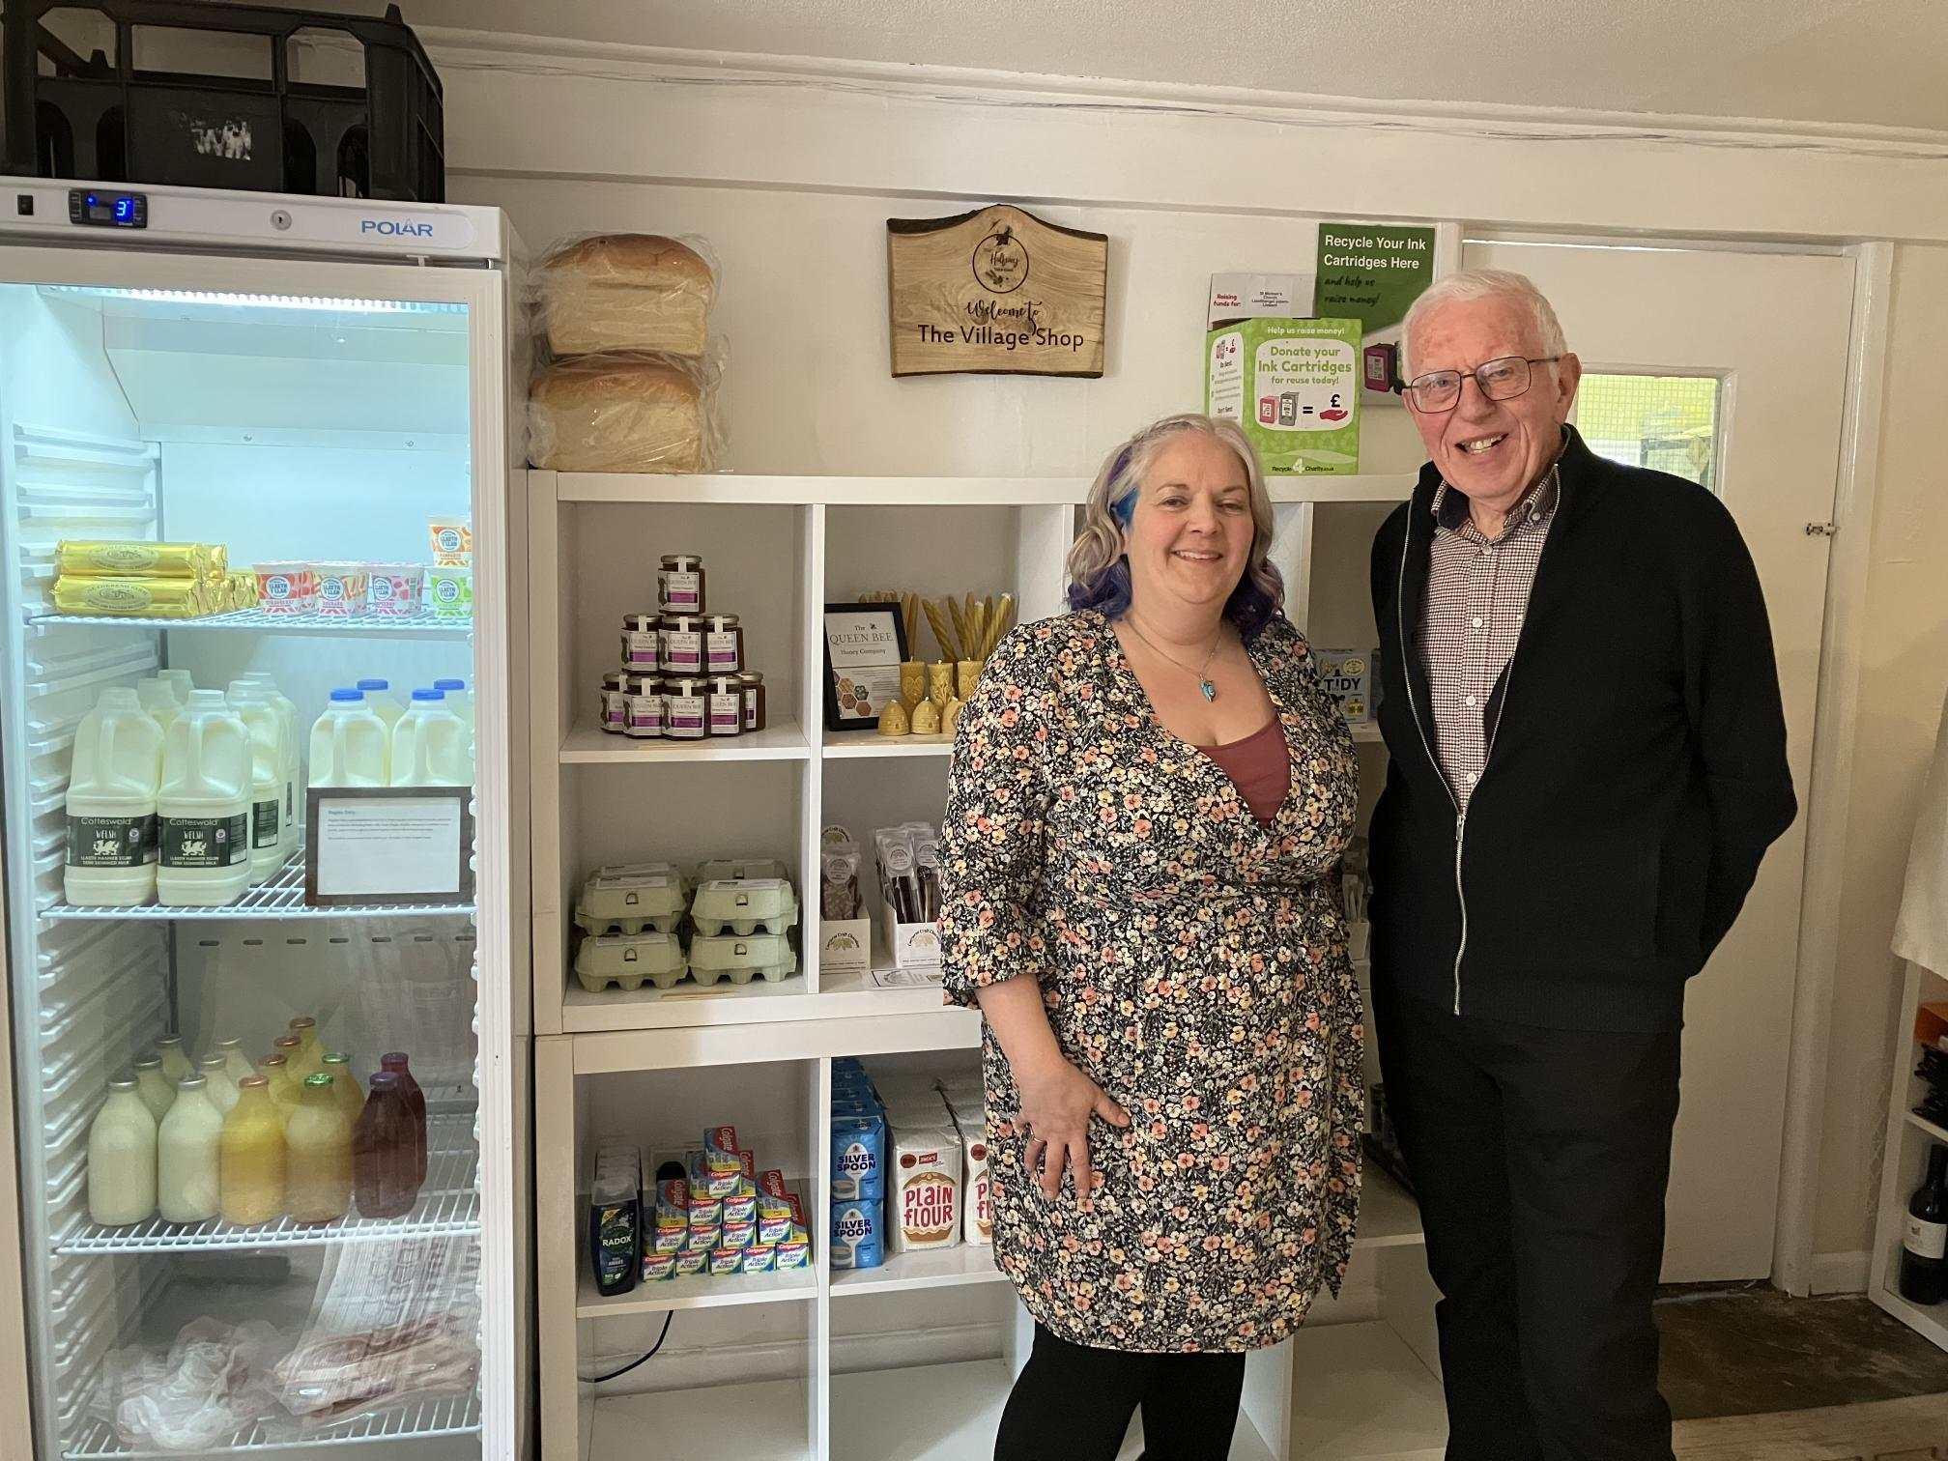

Licensees Rhiannon Metters and Jason James are making it their mission to support people in the isolated farming community of Tal-y-coed, Monmouthshire. Their pub, the Halfway, is the hub of this rural community where many people, including farmers, live and work alone, with little opportunity for social interaction. The area has a population of around 730 and limited services with no local shop or public transport links to nearby more populated areas. The nearest supermarket is more than a 20-minute drive and the road can be closed in bad weather. The couple contacted Pub is The Hub for help and advice in order to tackle the lack of services and activities for people nearby. Help and a Community Services Fund grant from Pub is The Hub were provided to help with the opening of a village store and community marquee. Pub is The Hub is a not-for-profit organisation that helps locals diversify and provide essential services. It has supported a number of projects in rural areas across Wales after receiving £25,000 from the Royal Countryside Fund. The Halfway has launched a store in the pub, which stocks a range of essentials. There are plans to move this into an outbuilding for more space and stock. A marquee has also been erected, which is being used as a community hub. It is the centre of a range of community events and is being used as the base for the new local produce market. The village shop will also be used to provide opportunities to create partnerships with schools and youth service providers to ensure young people are given an insight into local produce and how the shop can help to support the rural economy. The Halfway has also been using a craft box, supplied by Pub is The Hub in partnership with charity Creative Lives, to help engage people in more creative activities. Rhiannon has been using the craft box to help engage families with the pub and support younger visitors, as well as encouraging older customers to get creative. The boxes feature drawing materials including paper, pens, charcoal and pastels plus watercolour and acrylic paints alongside origami kits and air-drying clay. Rhiannon said: “We are in an isolated rural community with the pub being the social hub. It is so important we support local people ensuring they are not feeling isolated and alone. We are very passionate about making sure this is a pub for everyone in the area. “The village store here, in this isolated rural area, is such a support for people in the community with the marquee enabling us to run more community events supporting both local people and suppliers.” “The craft box offers a great way to encourage conversation over a shared activity. It’s helped me to further create a place where the community can come together and using creativity to do this works so well.” Pub is The Hub regional advisor Roger Belle added: “These publicans are the real heroes of this local community and have made the pub the hub of this rural village. “Offering these services and activities to support people in this area of Wales is proving to be a lifeline to overcome social isolation and loneliness.” Pictured, from left, Rhiannon and Roger