Interested in shaping debate at CAMRA Conference? Apply to join Conference Procedures Committee!

14/03/2025 by WB Reporter

Campaign

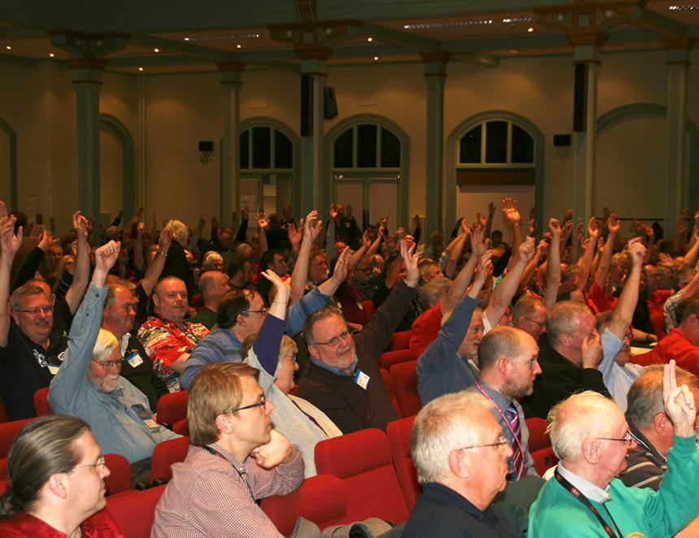

Conference Procedures Committee is seeking applications to join the committee for the one-year 2025/26 term.  Following the annual election, one nomination was received for two two-year vacancies and one one-year vacancy on the committee. Royce Hunt has been returned to the committee for a two-year term and Emily Ryans was co-opted to fill the other two-year term. There is now a vacancy for the coming year.  Interested CAMRA members are now being asked to apply for the vacancy on the committee, which plays an important role in CAMRA’s policy-making process.  If you are a die-hard Conference-goer with an interest in helping members propose and debate policy, this could be the volunteering opportunity for you. Members of CPC are expected to attend CAMRA Conference, helping the chairman to apply the Standing Orders and make important decisions in the run-up to Conference, including:  providing drafting advice for members, branches and committees considering submitting motions for debate

setting the Order Paper (motions for debate) and the Standing Orders (rules for how debate at Conference is run)

hearing appeals on rejected motions and receiving and assessing Emergency Motions and Amendments to motions.   To apply send a supporting statement of no more than 300 words to cpcsecretary@camra.org.uk, detailing why you want to join the committee and any relevant experience. The committee will consider applications and make a decision following the 2025 Conference in Torquay.  More information on CPC, including its full remit, is on the CAMRA website at camra.org.uk/cpc