New brew’s on target

14/03/2025 by Timothy Hampson

Industry

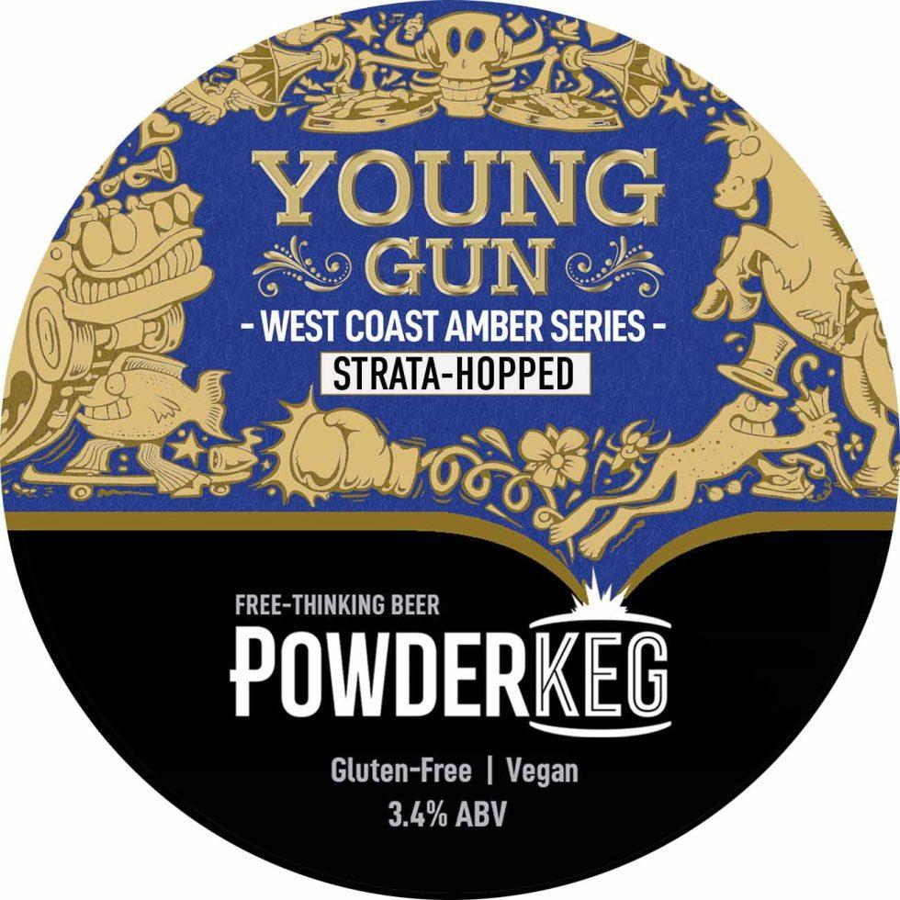

Devon's Powderkeg brewery has added the first of many new beers planned for 2025 to its range – Young Gun. The 3.4 per cent beer starts a series of amber ales “from when the West Coast was the wild, new frontier of craft brewing”. Powderkeg owner and head brewer John Magill said: “We have a history with this style – it’s one we keep coming back to. “It started with 6ixes & 7evens way back in 2016. Last time we brewed it, in 2023, it was crowned the best Indie Amber Ale in the UK. “Then last year we did a limited-edition brew called Simcoe Pleasures that sold out in a matter of weeks, and we remembered how much we – and everyone else – loves a West Coast amber. “It’s that perfect mix of modern and trad brewing, and it has a lovely balance between the malt and hops. “So, we thought we’d do a run of ambers, but to keep exploring the frontier we’ll be using a series of newly released, often still-experimental hops. “These will all be sourced from growers out there on the West Coast of America, some of the varieties are so new they don’t even have a name yet and are still identified by an ID code. “The first in the edition is Strata (or X-331 as it was known until relatively recently), a hop that brings tropical fruit and a shot of classic US dankness to a prominent malt base. “We have corralled all the flavour into a session-strength beer, for a beautifully rounded finish. This will be the perfect offering for all those venues looking for a craft cask beer to complement the more traditional ales on their handpulls. “It’s a more modern style and a more interesting beer, but it still has a very broad appeal because of that amber colour and full bodied maltiness. “We’ll only produce one batch with each hop variety, so you will need to be quick on the draw to get supplies in. “For people of a certain age, Young Gun comes with a guaranteed Bon Jovi earworm. You may consider this a gift or a curse. We like to think it’s a good thing. There has certainly been a lot of Blaze of Glory karaoke at the brewery over the past few weeks.”