Find out about Finnish beer

13/03/2025 by Timothy Hampson

Industry

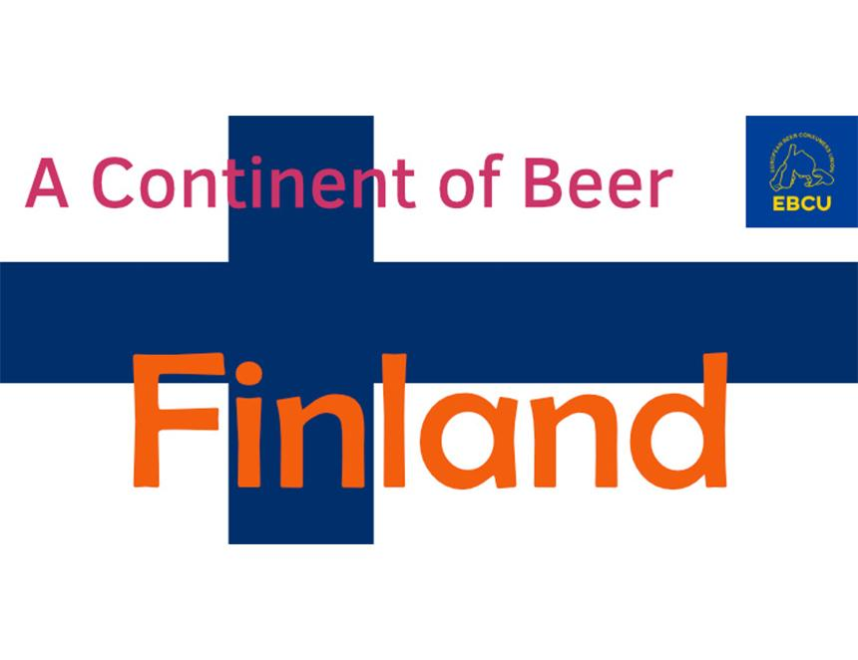

Tickets are now available for a European Beer Consumers' Union (EBCU) webinar, part of its Continent of Beer series. A Continent of Beer – Finland will be held at 20:00 CET on Monday 21 April. The presenter Anikó Lehtinen will describe Finnish beer culture, travel destinations, tap rooms and beer restaurants. Lehtinen is a beer journalist, judge, sommelier and president of the Finnish Beer Association. She is responsible for beer education at Laurea Applied Science University. She brews with students and has written two books about beer and two about beer tourism. One of her favourite subjects is the combination of beer and food, and she is writing her doctoral dissertation at the University of Helsinki on the history of brewing. Tickets can be booked here.