Eyes on the prize in Leeds

12/03/2025 by Timothy Hampson

Industry

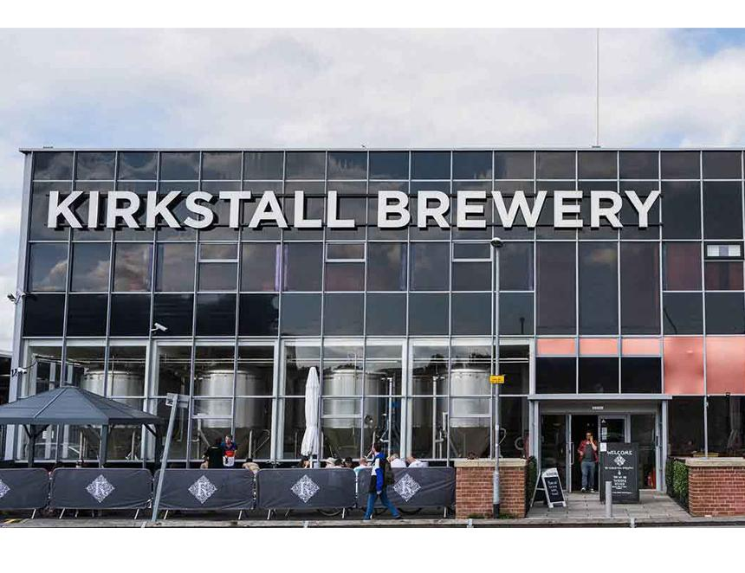

A Leeds brewery is hosting a beer festival “like no other” in collaboration with more than 30 breweries from across the country. Kirkstall’s Great Exhibition of Prize Ales is taking place at its Kirkstall Road site on Saturday 27 May. Promising a celebration of prize ales, the event will showcase the history of brewing – with live music, street food and a wide range of beers. The brewery has challenged breweries across the UK to dig deep into their local history and exhibit one or more beers that provide a link to the past. Breweries have been booked by invitation only and will be pouring everything from classic bitters and export pale ales, to milds, porters, barley wines, oak-aged stock ales and imperial stouts. Breweries confirmed include local Horsforth, North Brewing Co and Northern Monk, as well as others from across the country, and a panel of judges will award medals for the best. Guests can expect to be transported back in time and taste beers recreated from recipes decades or even hundreds of years old. Kirkstall’s brand manager Chris Hall said: “Now in our third year, we’re delighted to continue to bring something unique to the beer scene. The Great Exhibition of Prize Ales is about celebrating a history of innovation, flavour and skill that is all-too-often overlooked. “Times continue to be tough for our industry, so we are proud to present the very best of brewing talent in the UK rising to the challenge and delivering another exceptional experience. This is the beer festival that brewers tell me they book time off to attend, and frankly there is no higher compliment.” Tickets are now available with early bird pricing available for a limited time here.