Better together collab brew

11/03/2025 by Timothy Hampson

Industry

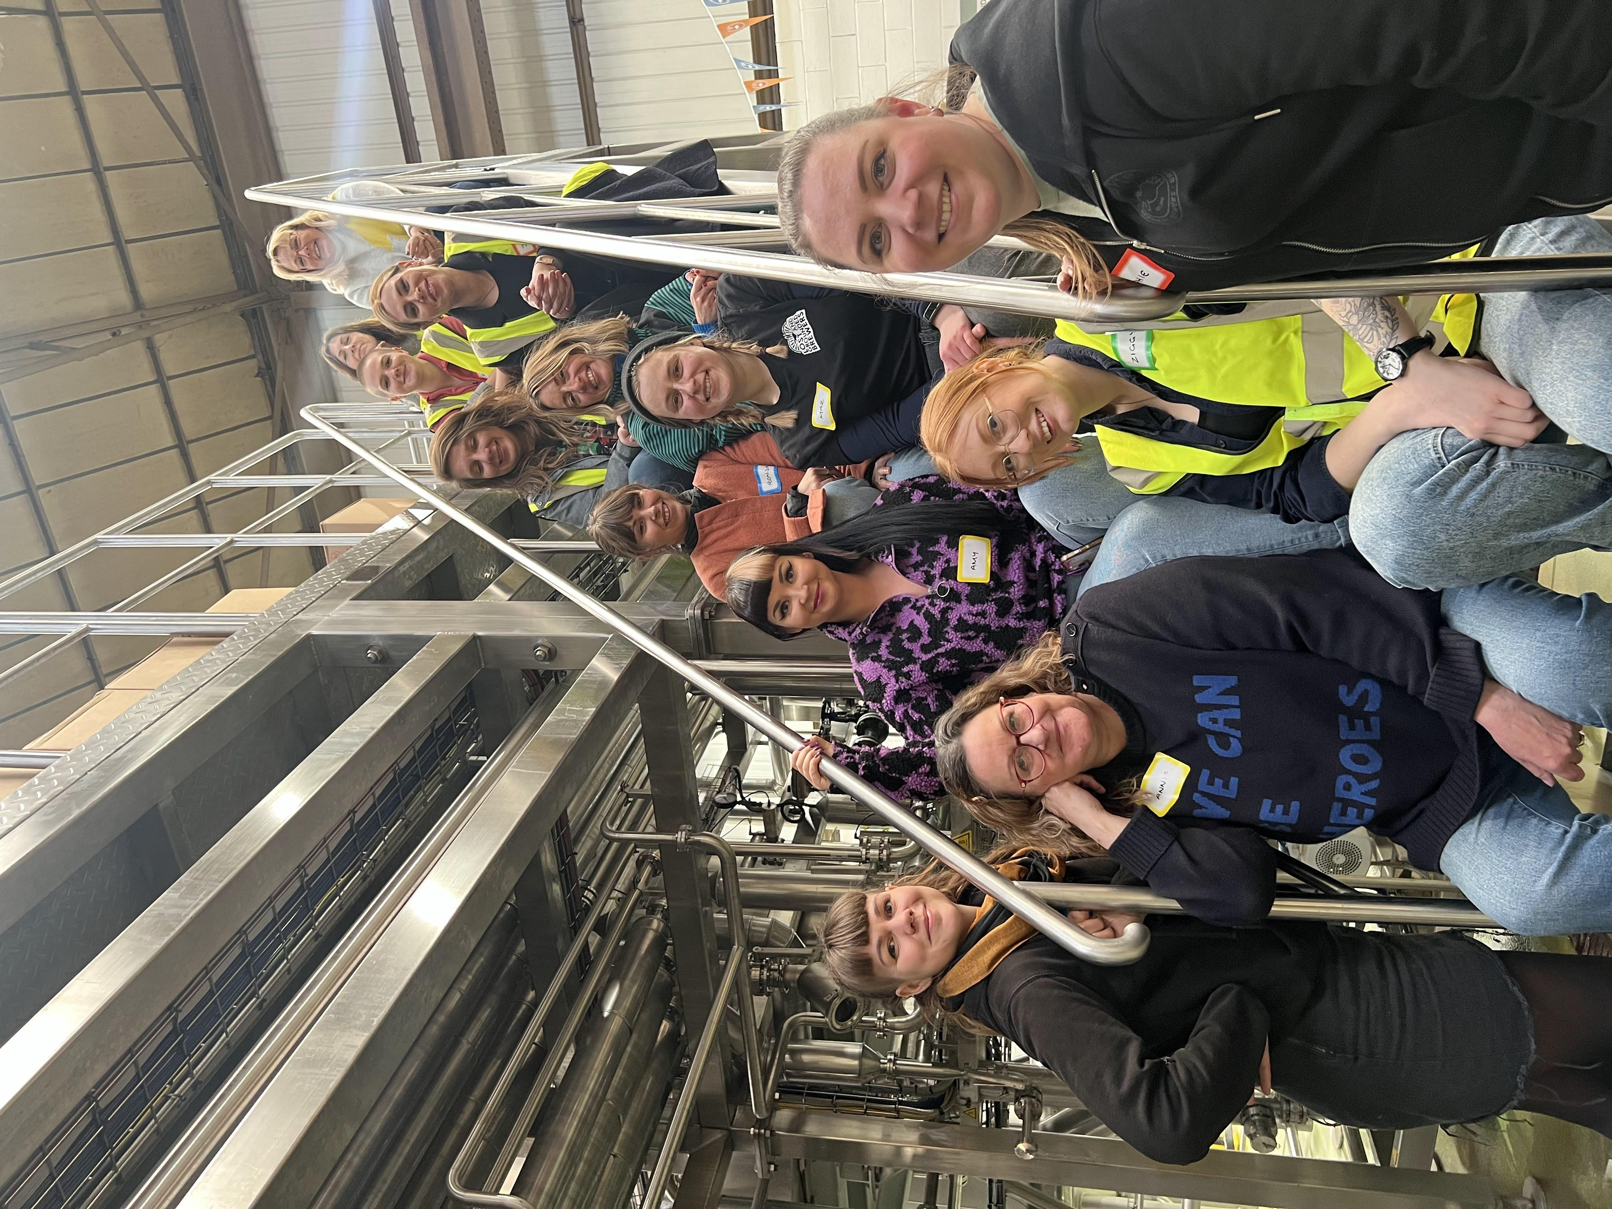

Bristol’s Lost and Grounded brewers’ latest beer is Together Sounds Better, a 3.2 per cent blackcurrant Berliner-style weisse, brewed with and for the women who make the beer industry special. Since 2014, International Women’s Collaboration Brew Day (IWCBD) has been used as an opportunity to bring women from all corners of the beer and hospitality industry together to create beers, with the goal of uniting them and raising money for their causes. Once a women-dominated profession, they now represent roughly 30 per cent of those employed in the beer industry, with only three per cent being brewers. Lost and Grounded wanted to celebrate the women who pour its beer every day and do it despite frequent challenges and stigmas. So, this year it threw open the doors of its brewery and welcomed a group of women (above) who work in the beer and hospitality industry to prove one thing – women belong in beer. Co-founder Annie Clements said: “It was such a huge opportunity to meet with our peers and discuss our issues and achievements. We continue to strive for a more inclusive world, and not only champion women in our workplace, but highlight atrocities against women across the globe. “We have a new revolution of women making some serious waves throughout the brewing world. Over the past decade, there’s been a steady increase in the number of women working in brewing. I’m certainly excited to be right here, right now, working among talented women across varying roles locally, nationally to globally.” Brought together under the banner of this year’s theme Unite Society, the fruit of their labour has the signature tartness of a traditional Berliner weisse, coupled with the distinctive colour and tang of blackcurrant, this is a beer with a big character, and a bite to make you sit up and take notice. It is more than a beer with a message, it is also one with a purpose. Each year, IWCBD organisers ask participating breweries to nominate a cause that will benefit women in their community. This year, 10p from the sale of each can of Together Sounds Better will be donated to Womankind, a Bristol-based charity that offers counselling, helpline support and befriending schemes for women.