Creating demand for cask scoops top club crown

10/03/2025 by Timothy Hampson

Campaign

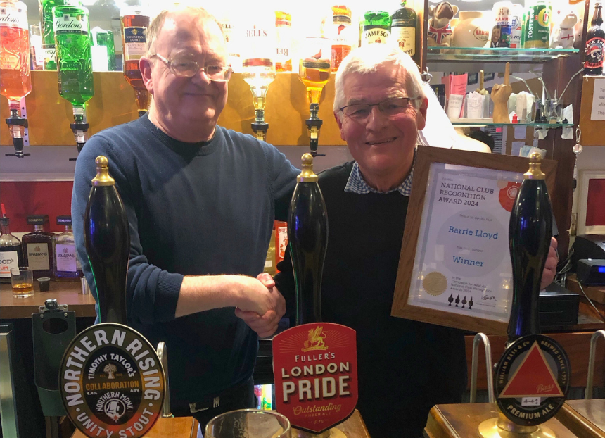

A commitment to providing a great choice of cask beers has seen Barrie Lloyd scoop CAMRA’s Club Recognition Award. Barrie is Royston Social Club’s secretary in St Albans where his dedication and hard work means there is a wider choice of cask beer in an area which is less populated with pubs. He was nominated for creating a desire and demand for quality beers within its membership. The transformation from an establishment that solely offered mainstream keg products to a club providing a rotating selection of well-maintained cask beers from both from national and independent local brewers, has meant that it is now a mainstay in CAMRA’s Good Beer Guide. The Royston Social Club has been awarded the South Hertfordshire Branch Club of the Year on three occasions since 2021. Barrie said: “Thank you to everyone at CAMRA for nominating us for this award which I am most honoured to receive on behalf of the Royston Club team.  “It is so gratifying that the hard work put in by everyone at the club has been recognised. Thank you also to our loyal members who I know will be proud to hear of this news.” South Hertfordshire branch chair Ian Boyd said: “Since taking over as secretary of the club a few years ago, Barrie has transformed it from a completely non-real ale establishment into a multi award-winning club which has recently installed a fourth handpump. “He hasn’t simply put ales on but has created the demand for them too, actively encouraging keg drinkers to give them a try and ensuring they are kept in top condition. Our congratulations to Barrie for this well-deserved award.” Club Recognition Award co-ordinator Phil Gregg said: “This year, there was a clear winner, despite tough competition for the crown. Barrie Lloyd and his mission to transform the Royston Social Club into a haven for cask and his endeavour to promote the wonders of cask beer to the local community should rightfully be celebrated.” Pictured: Ian Boyd (left) with Barrie Lloyd (right)