Can beer break Britain?

09/03/2025 by John Cryne

Opinion

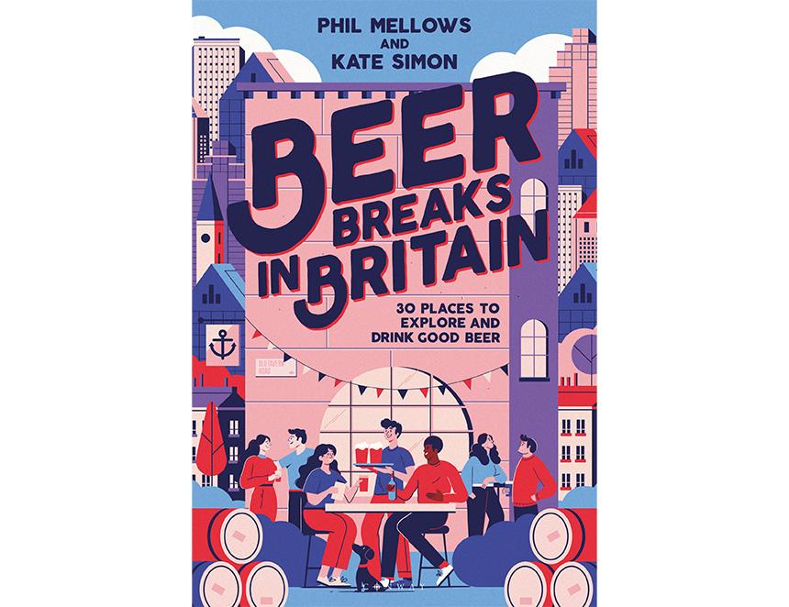

Well, according to something called an AI Overview (thanks Mr Google), the answer is “Beer is part of the British culture and economy, and it's unlikely to break Britain. In fact, the British are known for their love of ale and beer”. To demonstrate this, Phil Mellows and Kate Simon have published a book which “joins the dots between beer and travel” in Britain. I first met Phil more than 30 years ago. I had just taken on the role of CAMRA national chairman and he was a journalist on the Morning Advertiser (MA). It is fair to say that at that time relations between CAMRA and the MA were somewhat strained. The use of the term “real ale” in the MA was verboten, indeed he was told not to give CAMRA any positive publicity or in fact mention it at all if possible. Not sure how he managed to interview me. Well, times have changed and it’s great to see a publication which joins together the great places you can find to drink beer in this country and the great places you can visit “in between pints (or halves, or thirds)”. So what sort of bang do you get for you bucks with Beer Breaks in Britain? The publication will take you to 30 locations covering England, Scotland and Wales  – not quite John O’Groats to Land’s End but plenty to keep you occupied. The book is split into eight sections and there is not space here to cover them all but, for an example, let’s go to the North West which itself is split into four areas – Lake District, Manchester, Liverpool and Chester. I will be going to Scotland later in the year so thought the Lake District would be a good place to break the journey. But now I have to make a hard choice – do I go for Kendal, Ambleside or Grasmere? The only way to make such a hard choice is to read the book and find the watering holes that meet your expectations – be it traditional pubs, bars, brewery taprooms or micropubs. They locate the places and things you want to see and do – “to find out about the area’s history and its natural and built attractions”. Then to add further value to your research you will find places to stay – and yes, you guessed it – those places are where you can get a good drop of beer. Thanks to Phil and Kate for the considerable research they have done to put together this valuable addition to our library, linking beer and travel in Britain, suggesting places to visit and drink which you may not have previously considered. The hard work has been done for you in this book. Beer Breaks in Britain, £20 published by Bloomsbury and can be bought here.