Brewer’s refurbished tap opens

07/03/2025 by Timothy Hampson

Industry

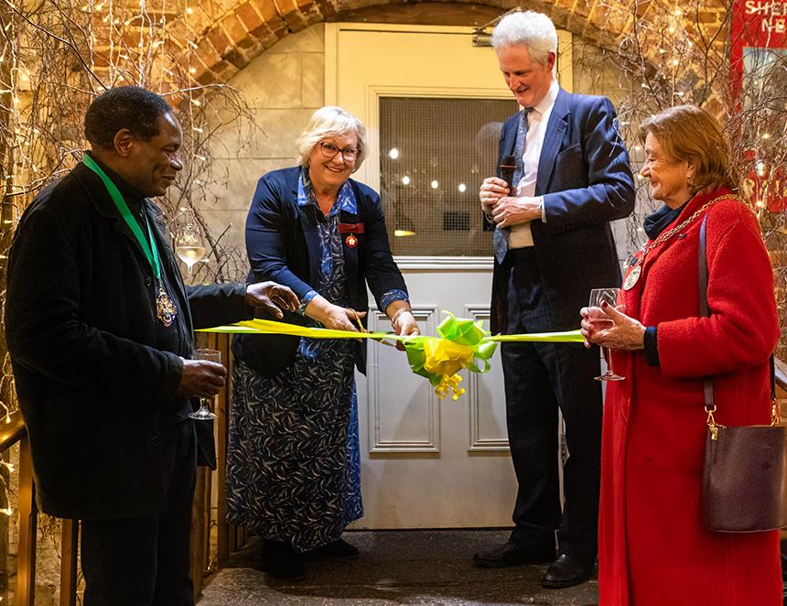

Surrey-based Hogs Back brewery has celebrated the official opening of its Tap Room following a two-month renovation. Based in the village of Tongham, the Tap Room is housed in the old hop-drying kiln in this traditional hop-growing region of Surrey. The renovation was part funded by a grant secured through the Rural Prosperity Fund, courtesy of Surrey County Council. Deputy lieutenant of Surrey Caroline Breckell opened the refurbished tap, which includes a larger bar supported on recycled wooden beer casks, replaced stone and wooden flooring plus new chairs, tables and sofas. Hogs Back MD Miles Chesterman said: “The tap is an integral part of our future growth plans here in Tongham.  “We’re delighted to have secured the funding, which means we can invest in the highest quality and standards. “Bringing like-minded people together in a relaxed and comfortable environment, where they can drink the freshest beer straight from the cellar is very special and we want to continue that tradition.” Pictured, from left, Farnham mayor Brodie Mauluka, Caroline Breckell, Hogs Back executive chairman Rupert Thompson and Guilford mayor Sallie Barker. Credit: Jon Hawkins, Surrey Hills Photography