Spring cask special doubles up

06/03/2025 by Timothy Hampson

Industry

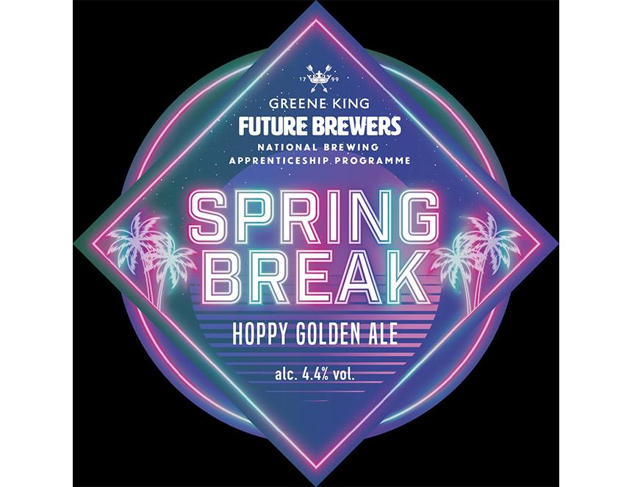

Greene King’s latest seasonal cask beer, Spring Break, has been designed to suit the arrival of brighter weather and it will also switch roles for St George’s Day. The 4.4 per cent ABV golden ale was originally created by two apprentices studying at the University of Nottingham’s brewing programme in 2022 and has aromas of peach, lychee, and tropical fruit flavours. Spring Break will also be dubbed George & the Flagon for St George’s Day. Greene King brand manager Amina Ali said: “We are proud to have worked with the National Brewing Apprenticeship Programme for a number of years and Spring Break has been one of the great successes. “Spring Break is a fruity golden ale that complements the spring weather as we transition from the darker, stronger cask ales we’ve had in the winter. “Our seasonal beers are there to support our permanent cask range, offering styles and flavours that are ideal for the time of year and also themed to celebrate special moments in pubs.” Ali added: “We created the George & the Flagon pump clip to offer flexibility for pubs so they can celebrate a national day but also have a beer that can be enjoyed over a longer period with interchangeable branding.” The Fresh Cask Releases calendar includes 15 limited-edition beers throughout the year to celebrate the seasons, sporting occasions and collaborations with other brewers.