Government help needed to boost low-alcohol beers

05/03/2025 by Timothy Hampson

Industry

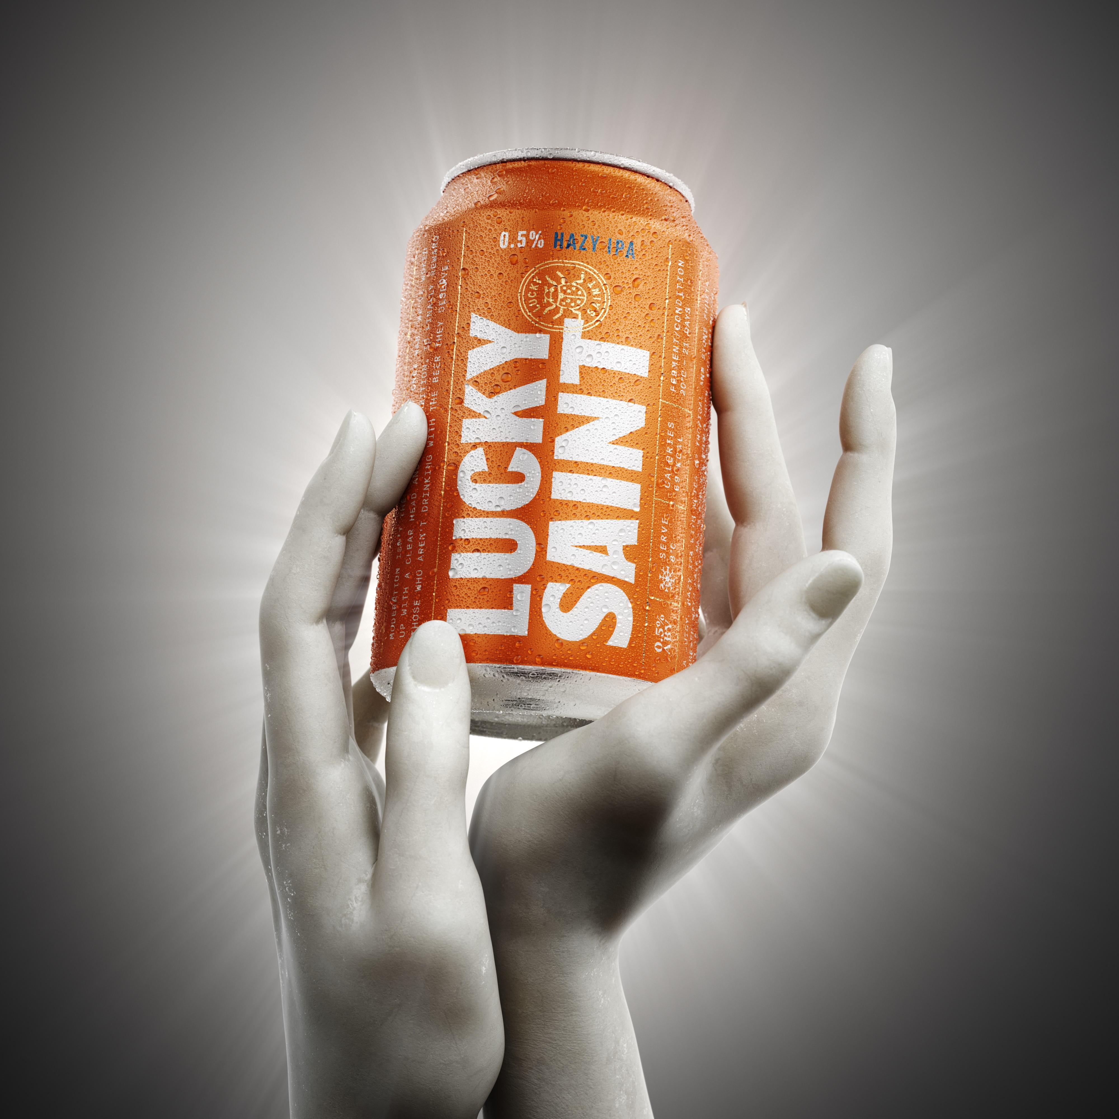

The British Beer and Pub Association (BBPA) is calling on the government to align existing no and low-thresholds with those of other nations following data which revealed more than 120m pints of the brews were drunk in 2023, with figures looking set to rise by another 20 million in 2024. BBPA data showed no and low-alcohol beer in December 2023 accounted for 12 per cent of all pub sales for that year, up from 11 per cent in 2022.  With no and low-options growing in popularity, the BBPA believes it is important the government takes meaningful steps to address the disparity in UK descriptors compared to other markets.  BBPA CEO Emma McClarkin said: “Whether someone is choosing moderation, keeping pace with many festivities or just doesn’t drink alcohol, these sales show brewers and pubs are catering to all. “With the popularity of no and low increasing, we stand ready to support the government in taking the necessary steps to align our no and low-alcohol descriptors with other markets. This important move would allow the category to continue to flourish, benefit the consumer, and allow the pub to continue being a home away from home.”  In the UK, the threshold for alcohol free is 0.05 per cent ABV, while many other nations define it as 0.5 per cent. Aligning the thresholds will provide a level of fairness for UK brewers and will help to contribute towards the government’s commitment to drive growth which will boost the UK economy. Taking this step will raise awareness of the no and low-options, support innovation, and provide even greater choice to consumers, the BBPA said. Luke Boase, founder of non-alcoholic brewer Lucky Saint, said: “There is an exciting opportunity for the government to support consumers in understanding no and low-drinks, and that will create a hugely positive impact on the health of the nation. “Clear descriptors that align with other markets will help unlock availability, raise awareness and drive consumption of alcohol-free drinks across the country.” The no and low-category continues to grow at a rapid rate year-on-year with 86 per cent of pubs now serving a no and low-option, with eight per cent serving it on draught, up from just two in 2019. This is compared to 77.8 and 1.7 per cent respectively in 2019.