Northern Ireland licensing law stifling pubs and breweries

04/03/2025 by Timothy Hampson

Campaign

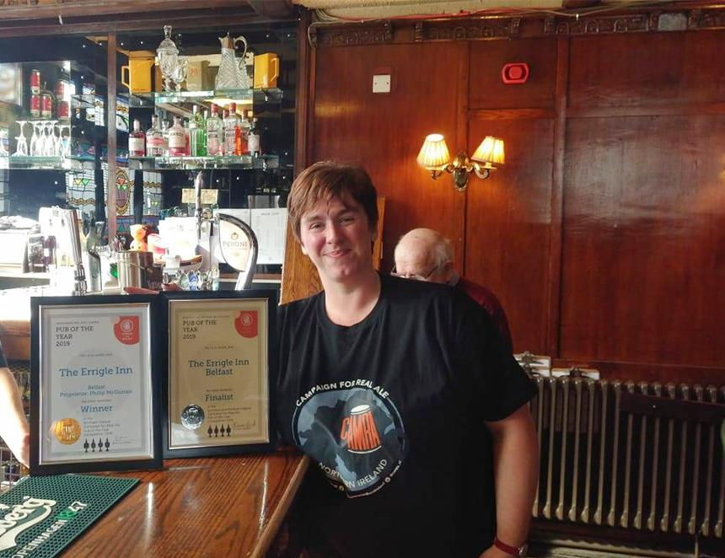

The rules for licensing the sale of alcohol in Northern Ireland are allowing established businesses to restrict competition and risk stifling innovation, a major independent review has concluded. It found “deep-seated problems” with the current system’s design, operation and enforcement and has put forward a set of recommendations for change. One of the report’s authors Dr James Nicholls said there are “many great pubs in Northern Ireland, but the sector is in long-term decline”. Commenting on the publication of the Northern Ireland Executive’s independent review of the alcohol licensing system carried out by the University of Stirling, CAMRA NI chair Ruth Sloan (pictured), said it confirms the Campaign’s position. She said: “This independent review confirms what we have all known for years – that our outdated licensing system, where no new licences have been created since 1902, is a huge barrier to keeping community pubs in rural areas alive and thriving, to opening new pubs, to supporting local breweries and to providing more choice for locals and tourists alike. “As seen by the recent Lidl Dundonald licence fiasco, it is extortionately expensive and almost impossible to open a new pub. “Not only does this stop new, diverse and interesting pubs, micropubs and brewery taprooms opening across the province, it also means people are more likely to drink cheap supermarket alcohol at home instead of encouraging drinking in the safe, regulated setting of a pub. “The review’s recommendation to end the current system and make it easier to open a new pub – with measures to address the financial impact on any existing pub licence holders – could be a big improvement to the current system. “But we have serious concerns that the recommendations of a per capita limit on the number of licences would continue to incentivise against small community pubs and again create artificial limits to competition. “The global brewing businesses that dominate the beer and pub market here should have nothing to fear from allowing new pubs to open and local, independent breweries to thrive – just like they do in other parts of these islands and across Europe where the choice of beer and a range of diverse, specialist pubs and micropubs are thriving. “We now need to make sure the executive and MLAs from all parties give their backing to dragging our licensing laws into the 21st century so that locals and tourists alike can benefit from a better choice of pubs and brewery taprooms showcasing locally produced beer and cider – not just a limited range of bigger pubs serving the same old beers from global brands.” The minister for communities has six months to respond to the report and recommend steps.