Members’ Weekend 2025 – Conference motions published

03/03/2025 by Ellie Hudspith

Campaign

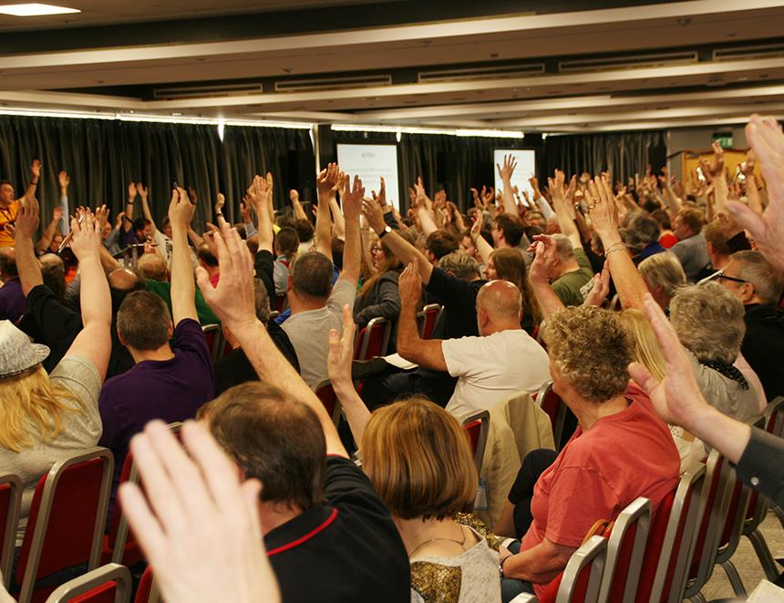

Ahead of CAMRA’s Members’ Weekend in Torquay, the Order Paper and other Conference information has been published. Conference Procedures Committee met on Monday 10 February to set motions for debate.   Order Paper (motions for debate) Motion 1 This Conference agrees to adopt the Policy Documents presented for adoption at Conference 2025, subject to any amendments to policy decided at this Conference.  National Executive    Motion 2 This Conference agrees the Annual Membership Subscription rates will increase by £3.50 from 1 July 2025 to the following:  Single membership (British Isles and Overseas) Direct Debit £34 Non-Direct Debit £36

Single concessionary membership (British Isles) Direct Debit £25.50 Non-Direct Debit £27.50

Joint membership (British Isles and Overseas) Direct Debit £42 Non-Direct Debit £44

Joint concessionary membership (British Isles) Direct Debit £33.50 Non-Direct Debit £35.50  National Executive    Motion 3 This Conference agrees that UK beer lovers have been badly let down by the lack of leadership and imagination shown by the multinational brewers and large property firms that, between them, control the UK beer trade.  Conference therefore instructs the National Executive to ensure that all relevant CAMRA publications and communications pledge preferential support to beer producers and suppliers that are independent of the influence of the multinational brewers, and to make the case persistently for this stance.    Real Ale, Cider and Perry Campaigns Committee    Motion 4 This Conference instructs the National Executive to establish a self-funding opt-in Beer Group for members, to study and discuss all aspects of beer, viewed from the consumer perspective. The group should be of interest to consumers and the wider beer and pub trade.  Real Ale, Cider and Perry Campaigns Committee    Motion 5 This Conference instructs the National Executive to investigate the logistics and funding of a specialist training course about the nature of beer in all its forms, the structure and ownership of the UK brewing industry and retail beer trade, the nature of real cider, and an introduction to the UK club trade, viewed from the consumer perspective.  This should be self-funding and open to all.    Real Ale, Cider and Perry Campaigns Committee    Motion 6 This Conference instructs branches to use the National Beer Scoring System as a significant factor when determining which pubs are considered for inclusion in the Good Beer Guide, from the 2027 edition onwards.  Commercial Committee    Motion 7 This Conference instructs the National Executive to reduce the number of pubs in the Good Beer Guide from the 2027 edition onwards, to ensure only quality pubs are featured.  Commercial Committee    Motion 8 This Conference agrees the National Executive should take steps to ensure complaints and disciplinary processes and procedures, as well as the Code of Conduct, are clear and easily accessible to all members. The distinction between complaints and disciplinary matters must be clarified, particularly at what stage a complaint might become a disciplinary matter that needs escalating. At all times Branches and Regions to have autonomy, with Regional Director guidance, to deal with issues locally in the first instance and determine whether and when a complaint needs to be escalated. Branches and Regions to be empowered to impose commensurate penalties at a local level, but within the relevant guidelines, and as agreed with the Regional Director.  Bradford    Motion 9 This Conference instructs the National Executive to publish the final submissions for all National, Regional and Branch festival business plans, with confirmation as to whether these were approved or rejected (with reasons provided where appropriate), on an appropriate part of the CAMRA website accessible to members.  Bradford    Amendments and Emergency Motions Members can now submit amendments to motions on the Order Paper for consideration by Conference Procedures Committee.      Amendments will only be accepted during debate at Conference in exceptional circumstances.     Emergency Motions are defined as those where the situation requiring the motion arose after the deadline for submission or ordinary motions (for 2025 Conference, Friday 7 February) and could not have been anticipated before the deadline.    Both Amendments and Emergency Motions should be submitted for consideration at the Conference Procedures Committee meeting on the eve of Conference, which takes place on 11-13 April in the Riviera Centre, Torquay.      Where possible, please submit these in advance of the meeting to Ellie Hudspith, secretary to Conference Procedures Committee on cpcsecretary@camra.org.uk     All the information above is on the Conference Procedures Committee page on the CAMRA website (member login required): camra.org.uk/cpc       Discussion threads for each of the motions on the Order Paper have been set up on Discourse, CAMRA’s online discussion forum.      Want to take part in CAMRA’s Conference but haven’t registered yet? You can find out about the weekend and register to attend here.