New CAMRA homebrewing book

02/03/2025 by Timothy Hampson

Campaign

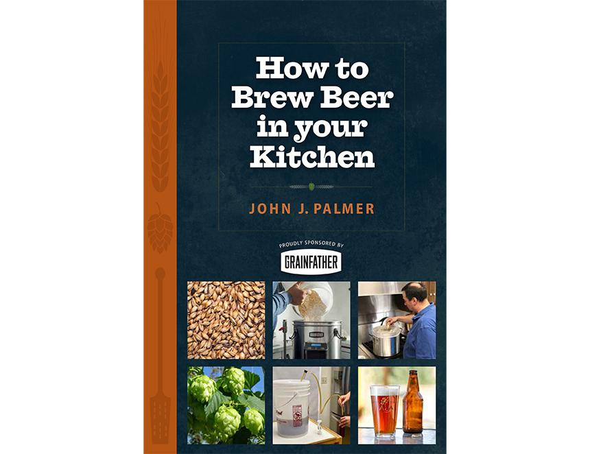

CAMRA’s latest book How to Brew Beer in your Kitchen by acclaimed homebrewing author John J Palmer is now on sale. Designed to demystify the brewing process, Palmer has created a step-by-step journey into beer production in the comfort of your kitchen, welcoming anyone who wishes to make their own beer with minimal fuss. Illustrated in full colour, this easy-to-follow guide is dotted with beer recipes including some that are bound to add new styles and flavours to the palate. Palmer is the bestselling author of How to Brew: Everything You Need to Know to Brew Great Beer Every Time, co-author of both Brewing Classic Styles, and Water: A Comprehensive Guide for Brewers from Brewers Publications. This book is proudly sponsored by Grainfather, producer of intuitively designed homebrewing systems and equipment. Readers can now order How to Brew Beer in your Kitchen here. Find more books published by CAMRA here.