Sheps keeps it simple

28/02/2025 by Timothy Hampson

Industry

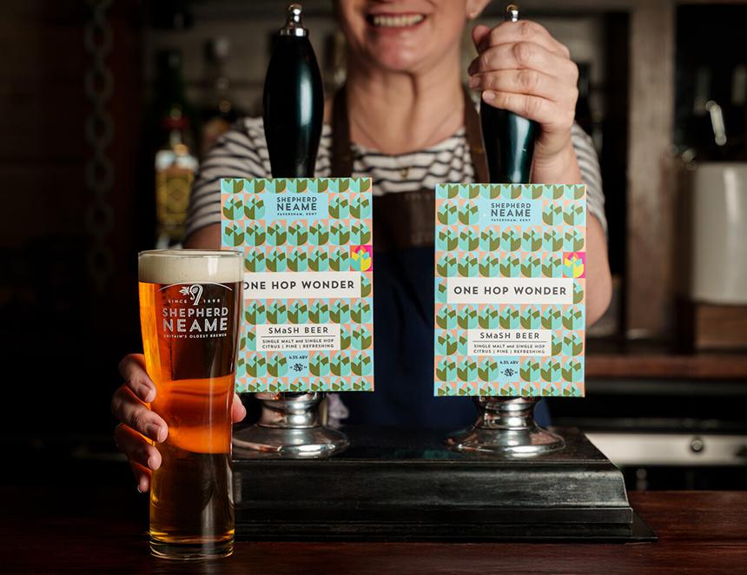

Shepherd Neame is not over complicating things with its latest limited-edition beer, which uses a single malt and a single hop. One Hop Wonder (4.5 per cent ABV) uses lager malt and the UK Chinook hop, which is a new variety for the Faversham-based brewer. The combination has produced a fruity, floral tasting, full-bodied brew, which is a light, pale straw colour. It is the latest offering from Shep’s Cask Club, a range of limited-edition cask beers. The UK Chinook variety is sourced locally from English Hop, based in Tunbridge Wells. Shep's technical brewer Danielle Whelan said: “We chose our ingredients to focus on the aroma and flavour of the hops, with the lager malt allowing as much of a blank canvas as we can give the beer to showcase the UK Chinook hops. “We are really pleased with the finished result and have had great feedback from everyone who has tried it so far.” One Hop Wonder is now available at selected Shepherd Neame pubs and hotels across London and the South East. Find out more here.