Screen stars join Cask Club

27/02/2025 by Timothy Hampson

Industry

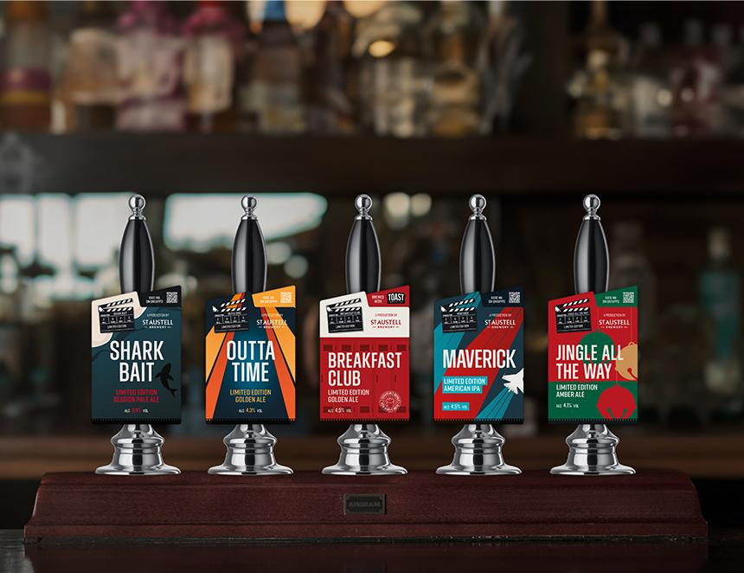

St Austell brewery is launching five limited-edition cask beers for 2025, all with a film theme. Shark Bait, Outta Time, Breakfast Club, Maverick, and Jingle All the Way are the star-studded line-up, which is set to take centre stage in the brewery’s estate across the West Country, plus independent pubs throughout the UK. The beers form part of St Austell’s Cask Club series, which sees its brewers bring brews to life in its small-batch brewery. Shark Bait is light and zesty with passionfruit and stone fruit flavours. Available from 3 March, expect a clean, crisp, and fruity 3.9 per cent ABV session pale ale that’s good to enjoy on dry land. Outta Time is a 4.3 per cent golden ale, featuring a mix of floral, herbal, and tropical hop flavours, which come together with sweet, oaty malt. It will be on sale from 6 March. On bars from 30 June will be Breakfast Club (4.5 per cent), a collaboration between St Austell and Toast Brewing, a London-based brewery that uses surplus bakery bread to brew its beers. The fresh and fruity golden ale has been made with British Harlequin and Jester hops alongside Toast’s surplus breadcrumbs. Orange, hops, and honey combine in Maverick which will land on bars from 1 September. Pale and full-bodied, this 4.5 per cent American IPA is brewed with Amarillo, Citra, and Cascade hops. The final beer will be Jingle All the Way (on sale from 17 November) which aims to be a festive favourite. The 4.1 per cent amber ale has a rich aroma of piney hops and raisin, toffee, and malt notes. It has a deep and bittersweet finish, plus uses British Challenger and Goldings hops. St Austell brewing director Georgina Young said: “This exclusive line pays tribute to legendary movies, blending storytelling with great flavours for an immersive drinking experience. Whether you’re a fan of action-packed thrillers or timeless classics, there’s a brew that should capture everyone.”