Plan your next festival trip

26/02/2025 by George Robbins

Campaign

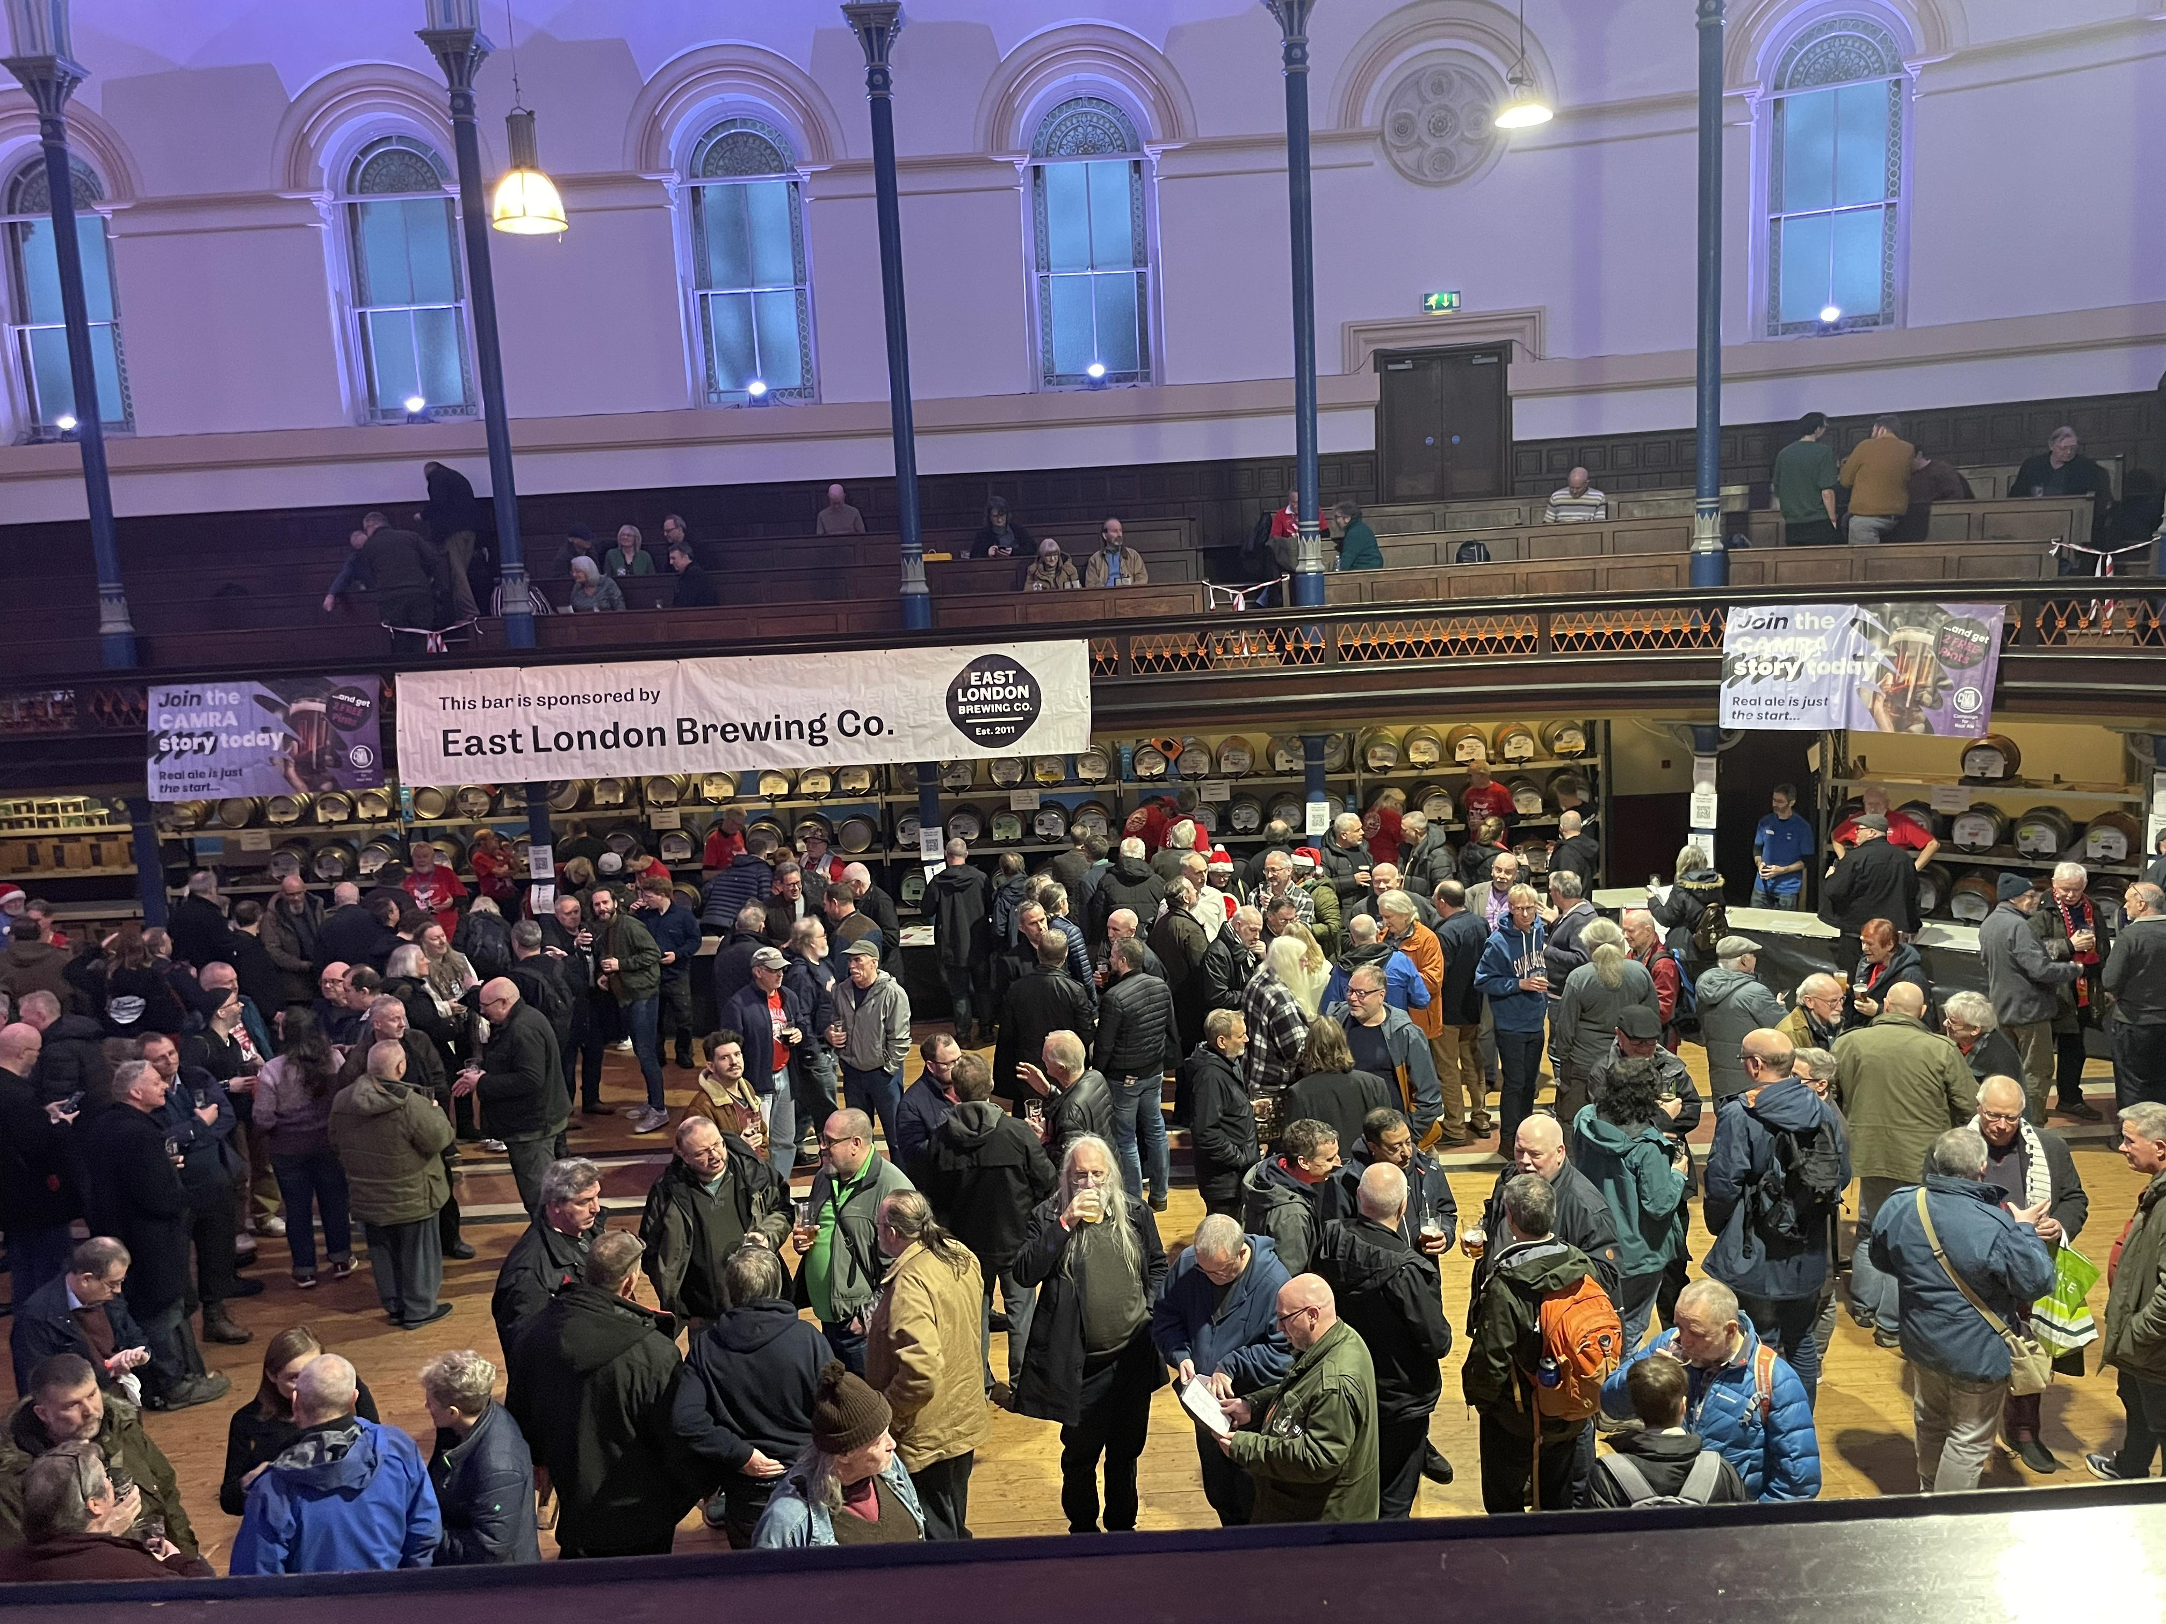

For your next festival trip look no further than the tempting list below. To see all upcoming CAMRA events visit the Events webpage.   48th Loughborough Beer Festival, 6-8 March  Polish Club, True Lovers’ Walk, Loughborough, LE11 3DB  loughboroughcamra.co.uk/beer-festivals/48th-loughborough-beer-festival    Chester Beer Festival, 14-15 March  Northgate Street, Chester, CH1 2HJ  westcheshire.camra.org.uk/viewnode.php?id=230888    Scarborough Beer and Cider Festival, 20-23 March Dean Road, Scarborough, North Yorkshire, YO12 7QS scarborough.camra.org.uk   Burton and South Derbyshire Beer Festival, 27-29 March  King Edward Place, Burton, DE14 2EB  burtoncamra.wordpress.com/beer-festival    20th Maldon Beer and Cider Festival, 2-5 April Cygnet Room, Swan Hotel Bar & Grill, 73 High Street, Maldon, Essex, CM9 5EP maldonanddengiecamra.org.uk/MaldonBeerFestival   Newcastle Beer and Cider Festival, 9-12 April Northumbria Students Union, Newcastle upon Tyne, Tyne and Wear, NE1 8SU nclbeerfest.uk   47th Farnham BEEREX, 10-12 April Farnham Maltings, Bridge Square, Farnham, GU9 7QR  farnhambeerex.org.uk/index.html   Oldham Beer and Cider Festival, 11-12 April Queen Elizabeth Hall, West Street, Oldham, OL1 1NL rob.camra.org.uk/viewnode.php?id=60320   Chippenham Beer Festival, 25-26 April Sadlers Mead, Chippenham, Wiltshire, SN15 3PA nwwiltscamra.org.uk/viewnode.php?id=177502   London Spring Cider Festival, 26 April Rocket Van Studios, 92 Brandon Street, Elephant & Castle, London, SE17 1AL sel.camra.org.uk/diary/festivals/   18th Bexley Beer Festival, 8-10 May Dartfordians Community Sports Club, War Memorial Club House, Bourne Road, Bexley, Kent, DA5 1LW bexley.camra.org.uk/beer_festival.html   Biggleswade Beer and Cider Festival, 8-10 May St Andrews Street, Biggleswade, England, SG18 8BA biggbeerfest.org   33rd Yapton Beerex, 9-11 May Yapton & Ford Village Hall, Yapton, West Sussex, BN18 0ET camra.org.uk/event/33rd-yapton-beerex-81956   2nd Dulwich Beer and Cider Festival, 22-24 May Dulwich Hamlet FC, Dog Kennel Hill, East Dulwich, London, SE22 8BD sel.camra.org.uk/diary/festivals/   Lincoln Beer Festival, 22-24 May Southside, Colegrave Street, Lincoln, Lincolnshire, LN5 8DW lincoln.camra.org.uk/