UK brewery numbers continue to decline

25/02/2025 by Timothy Hampson

Industry

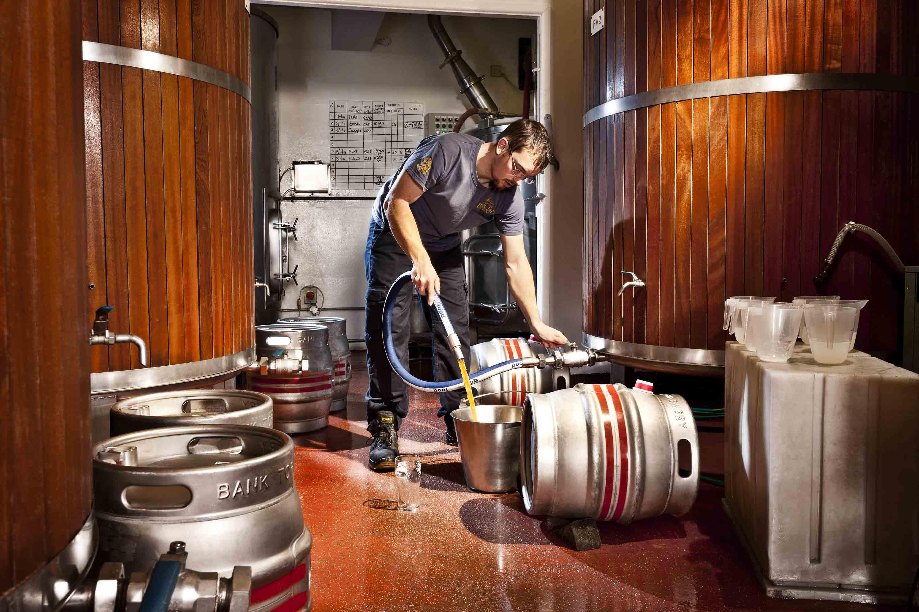

The UK had 100 fewer breweries last month compared to January last year with each quarter of 2024 showing a negative net closure rate, despite reports of strong demand for beer from independent breweries. The figures, released by the Society of Independent Brewers and Associates (SIBA) UK Brewery Tracker which considers all openings and closures to give the net number of breweries, shows the UK total now stands at 1,715 compared to 1,815 at the start of 2024. The drop in overall brewery numbers over the last 12 months is much higher than in recent years – at the start of 2023 the total was 1,828, dropping by just 8 overall to 1,815 in January 2024. SIBA said legacy Covid debt, restricted access to market via pubs, and tight margins are all factors in the rise in closures. SIBA chief executive Andy Slee said: “The consumer appetite for independent beer is high and our indications suggest volumes for independent beer at the end of 2024 were up on 2023. The issue for small independent breweries is lack of access to market and rising costs, making it incredibly difficult to remain profitable. “Speaking to many indie brewers who have closed their doors over the last 12 months it is a very similar story; they can’t sell into enough of their local pubs and make enough of a profit to remain viable. “Given the demand for independent beer isn’t being met locally you have to wonder whether more local beer in community pubs would help pub closure rates as well.” Looking at the quarterly closure rates offers a small glimmer of hope, with the fourth quarter of 2024 showing a slowing of the closure rate to minus 24 across the UK, compared to a minus 27 in the third quarter up to the end of September, minus 29 in Q2 and an even larger 38 net loss in Q1. Slee said: “As we begin 2025 our hope is that the dial continues to turn in the right direction and we see stable or even growing brewery numbers in the UK; however this will not happen without greater support from government for the hugely valued indie brewers all across the UK.” Wales has also had a positive year as it was the only place where brewery numbers are in modest growth and an overall net brewery number of 97 at the start of 2025, compared to 96 at the start of 2024. The average closure rate across the UK was around five per cent which shows that, while Northern Ireland had a relatively small shift in its net number down just six in percentage terms, this was by far the highest, accounting for more than 20 per cent of the overall number. Areas with a higher density of breweries such as the South East had a much bigger drop in numbers but a percentage drop of around 7 per cent, very similar to the similarly sized Midlands.