 Manchester pubs unite to save historic youth club

24/02/2025 by Timothy Hampson

Industry

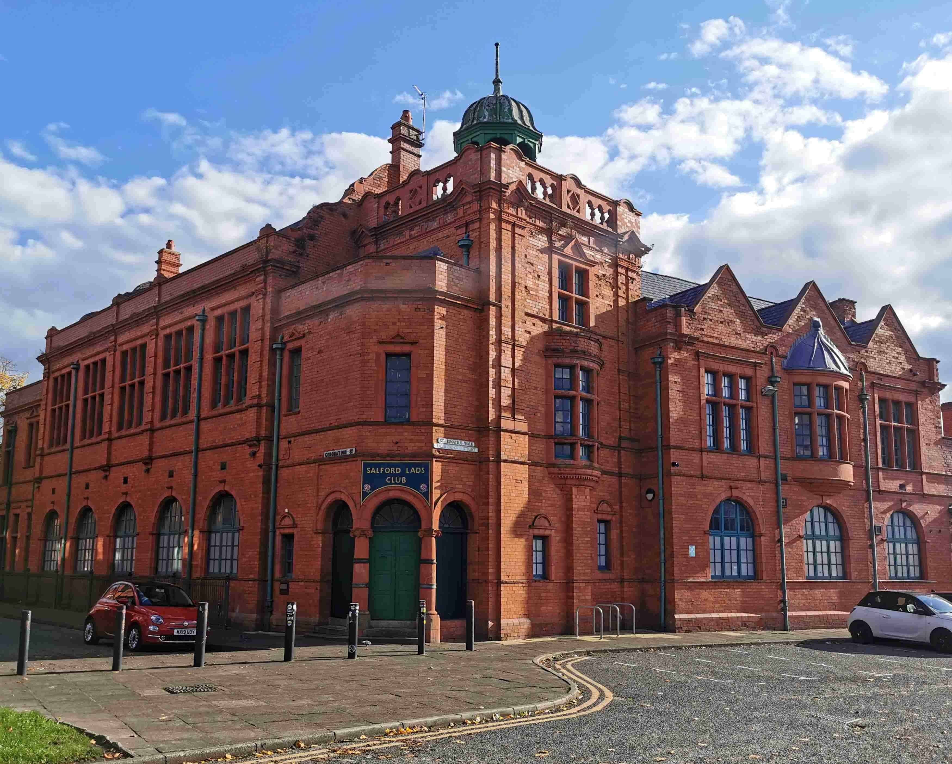

Pubs in the North West are coming to the aid of a Northern institution with the launch of a fundraiser for the Salford Lads and Girls Club (pictured). The 120-year-old club, which gained global recognition after being on the cover of an album by The Smiths, was recently saved from closure following a campaign supported by local music legends including Smiths lead singer Morrissey and the Hollies’ Graham Nash. However, money is urgently needed for ongoing maintenance of the grade II-listed Edwardian building and 39 Joseph Holt pubs pubs in the area now plan to raise funds for the club. Holts director of pubs Mark Norbury said:  “At Joseph Holt we very much focus on being a resource for the community in terms of the activities or events we hold as well as providing a warm and welcoming space. “It’s an ethos which very much chimes with the work of Salford Lads Club which provides a lifeline and programme of activities for youngsters from some of the areas most deprived communities. So when we heard the club was in need we were determined to help.” The organisation was initially founded as a club for boys, but is now open to all young people. Officially opened in 1904 by scout movement founder Robert Baden-Powell, the building retains many of its original fittings. Money raised by Joseph Holt will go towards a Salford Lads and Girls Club Legacy Fund, which will be invested into a permanent trust, to help to secure its future survival. Nowbury said: "As a Manchester Institution, Salford Lads Club has been at the heart of local life since 1903 and was nearly lost in 2024 due to rising costs. “As a 175-year-old business ourselves, we really want to support their legacy fund and help raise £10,000 to protect this much-loved heritage and grassroots supporter club" Club head of youth operations Laura Slingsby said “We are incredibly grateful to Joseph Holt for launching this fundraising campaign, which will help us continue our work and secure the club’s future for generations to come. “The connection between Salford Lads Club and Manchester’s brewing heritage makes this partnership even more special, and we encourage everyone to support this campaign. “Every donation makes a real difference in keeping our doors open and our legacy alive to brighten young lives and make good citizens.”