Brewer’s goulash

23/02/2025 by Christian Gott

Uncategorised

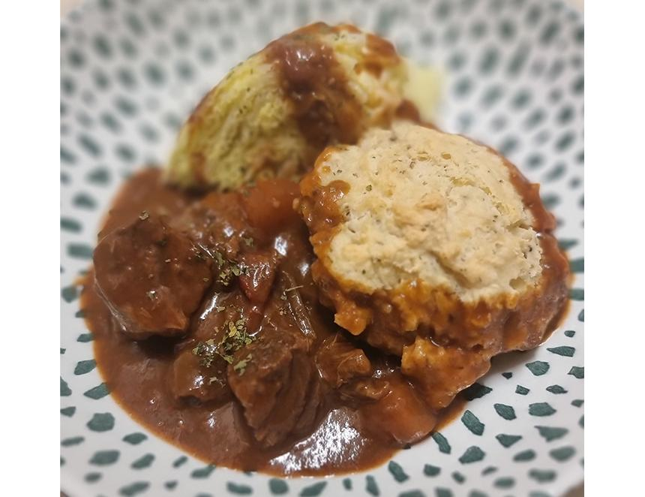

Fans of history will be well aware of the shifting state of borders and allegiances across Central Europe. Kingdoms, states and principalities came and went, but one of the most important countries was the Austro-Hungarian Empire. Actually, it was two countries with one ruler, the Emperor of Austria and the King of Hungary. Seriously chef, what has this got to do with cooking? Today’s recipe was thought to have originated with Hungarian shepherds and is now their national dish. However, from experience, I can tell you today that both the Austrians and Hungarians believe that only they make the authentic version. In fact, there are more recipes for goulash than you can imagine. Almost every village has its own version. There are soup-like dishes and more substantial stews and casseroles. They can be made with beef, pork or mutton and served with noodles, bread or dumplings. The completed dish can be garnished with sauerkraut, sour cream, fried egg or sausage and pickles. The common link is paprika, a sweet pungent spice made from capsicum peppers. Paprika gives goulash its distinctive depth of flavour and colour. There is a long common heritage between goulash and beer. There is a version called drayman’s goulash, which would fuel the hungry hard-working beer delivery men. My recipe is a version of brewer’s goulash which, as you can imagine, contains beer in the list of ingredients. My choice is traditional Bavarian-style Helles brewed by Braybrooke Beer Co, near Market Harborough. The team specialises in full-flavoured lagers and its Helles is made with Pilsner and Munich malts and Hallertau Tradition hops. It balances a malty sweetness with light, hoppy bitterness and is great in the recipe and also to drink while you are eating it! Brewer’s goulash 700g beef shin, cut into chunks 330ml Braybrooke Helles Lager 3 onions, peeled and thinly sliced 3 large carrots, peeled and cut into chunks 100g lard 50g plain flour 3 cloves garlic, peeled and crushed 3tbs (heaped) Hungarian sweet paprika 2tbs tomato puree 1tsp caraway seeds 1tsp (heaped) marjoram Sea salt and freshly ground black pepper Preheat your oven to 300F/150C/Gas Mark 2. Melt half the lard in a large, heavy-bottomed frying pan and slowly cook the onions until they are caramelised and brown. This adds a great base level of flavour to the finished dish. When cooked, transfer the onions to a casserole dish. Fry the beef in batches in the remaining lard until brown and transfer to the casserole. Add the garlic and flour to the pan and make a roux. Add the paprika and the beer and turn down the heat. Mix thoroughly, scraping the bottom of the pan, and transfer to the casserole. Add the remaining ingredients with enough beef stock or water to ensure everything is covered and add a lid. Place in the centre of the oven and cook for 2.5 hours. Remove halfway through cooking and stir. Take the goulash out of the oven and check if the meat is tender. If not, return to the oven for another 15 minutes or until cooked. Correct the seasoning and serve with freshly baked bread or dumplings.