Pressure grows to save Ivy

19/02/2025 by Timothy Hampson

Pub

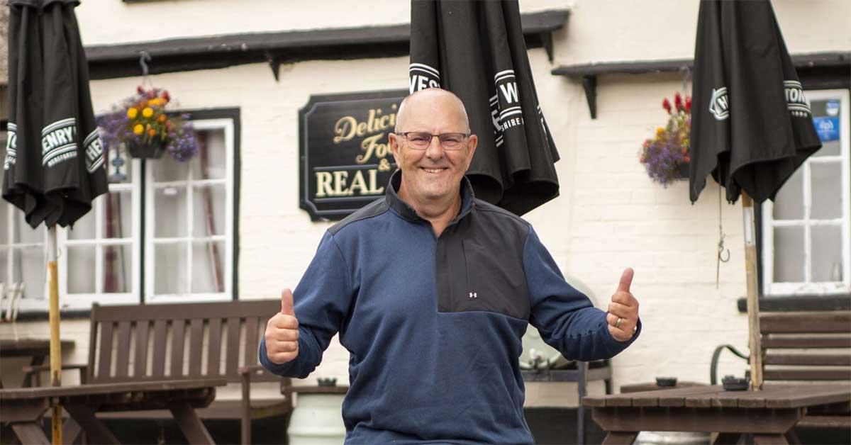

A community is rallying round to save the picturesque Ivy Inn at Heddington, which has been closed for months after current owner Wadworth Brewery put it up for sale in May 2024. The 17th-century, thatched-roofed inn is loved by people throughout the county and a group called Friends of The Ivy was quickly set up to save it. The pub is listed as an Asset of Community Value until 2029, and the group has a share scheme ready to go, but it needs to strike a deal with Wadworth over the sale before it is launched, and negotiations are ongoing. The Friends need to overcome several hurdles, not least the government decision to halt the Community Ownership Fund, a scheme which matched the amount communities raise to save their pubs. Friends chairman Dr Paul Moyle-Harris (pictured) said: “The government’s decision to end the Community Ownership Fund is a big blow, making life far harder for us and for other groups trying to save community pubs. “In many cases the fund provided half the cost to buy these pubs and turn them into real community hubs and we know of a couple that received £200,000 to £300,000 under the scheme which has been an absolute gamechanger for them. “That kind of money would, more or less, buy the pub and then we could concentrate solely on the renovation so it’s a big loss, but we have a never-say-die spirit here in Wiltshire and will battle on through. There are only 400 community pubs in the country, it’s clear people love them as the heartbeat of their communities and it’s vital they are saved. “When we did a survey in 2024 about saving the pub we had an 87 per cent response rate which is, in itself, phenomenal but 91 per cent who responded said they rated a village pub as important or very important and half of them said they wanted to see live music in the Ivy once it’s reopened. “The government can still help community pubs in other ways, such as not charging alcohol duty on pubs owned and run by the community or not implementing the National Insurance rate rises in them. These pubs are owned by the people for the people which is why our slogan is real ales, real community, real Wiltshire.” The pub needs major renovation including rewiring, new plumbing and significant work on the drains and damp-proofing along with improvements to the kitchen and toilets. It will mean an investment of more than £225,000 once the pub is bought. The Friends is now setting up a Seed Enterprise Investment Scheme via HMRC. Under this, people who invest £10,000 or more will get a 50 per cent reduction in their tax bill the same year. That means if they buy shares worth £10,000 in the pub, they’ll get £5,000 off their tax bill. Other tax incentives could then follow. People investing under £10,000 will be eligible for a 33 per cent tax rebate under the similar Enterprise Investment Scheme. The Friends plan to run the pub as a café during the day – possibly as a franchise by popular cafés in neighbouring villages – to entice groups in, such as toddler-and-baby gatherings. It also aims to have a farm shop on-site but with a difference, as all produce will be in a refrigerated vending machine in a purpose-built wooden cabin and include sausages, bacon, bread and cheese – all the essentials so villagers don’t have to make car journeys to the shops. Moyle-Harris added: “We’re a very committed community group poised and ready for action to not only save the Ivy but to turn it into something special. Going back in time, it had a phenomenal reputation throughout Wiltshire, so much so that people travelled from Salisbury and Bath and had to book a month in advance for Sunday lunch. “We are here to reinstate that reputation and restore the Ivy as a destination pub for people from across Wiltshire and further afield. It’s set in brilliant countryside surrounded by walks and cycle rides. It’s the perfect place for the quintessential English pub.” The interior will reflect the pub’s proud heritage and will be expanded with what is now the licensee’s front room transformed into a snug. “There is a great deal of enthusiasm to save the Ivy and turn it into the very epicentre of the community but, ultimately, we will need money to do it. “We know it will take time to save the Ivy, but we are determined to see it through and know it will be well worth all the time and effort in the end.” For the latest information and how you can help go here.