New chance to join Women In Beer mentor programme

18/02/2025 by Timothy Hampson

Industry

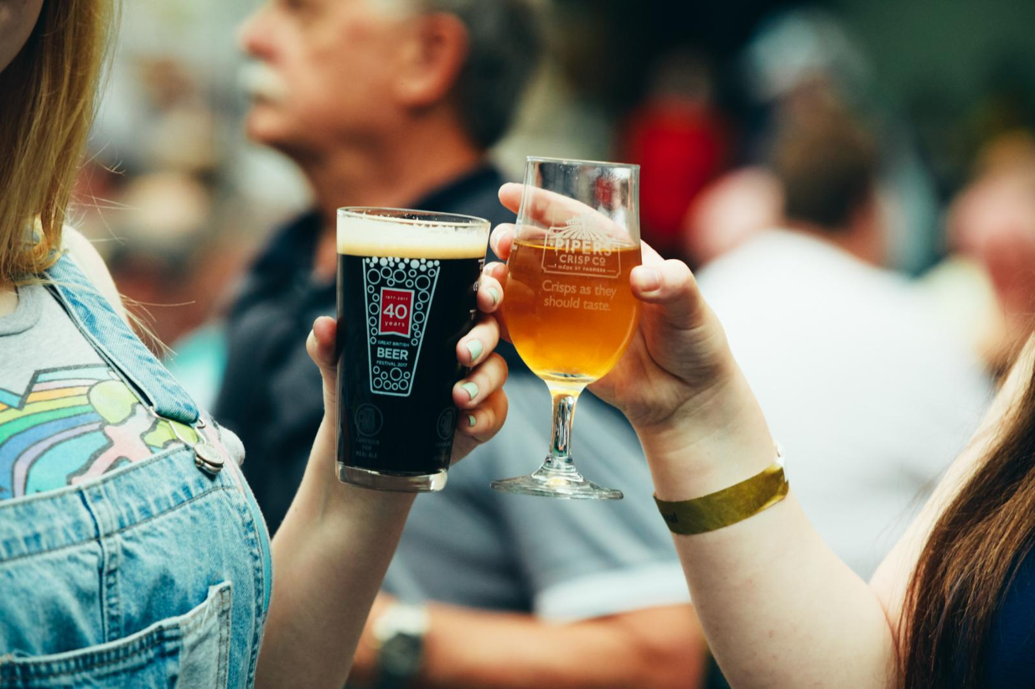

Women in Beer is opening eight spaces in the third intake of its mentor programme until 9 March. The successful women-identifying individuals based in the UK will be paired with one of the Women in Beer mentors, plus have the chance to join the previous participants' WhatsApp group, as well as access networking events throughout the year. The latest cohort will also have a chance to get their WSET Qualification Level 1 in Beer as part of the programme. Women in Beer founder Amelie Tassin said: “We wanted to offer a comprehensive programme for our mentees, combining personal advice, learning and networking. “We are very proud to count WSET as our education partner for the second year, adding a qualification that will give our mentees more confidence in their everyday life. “We are very proud that 100 per cent of the mentees who took the exam last year got their qualification and believe that it is an essential part of the programme.” Sponsor’s Simpsons Malt will also welcome the mentees at its maltings in Berwick-upon-Tweed. Simpson marketing director Richard Simpson said: “As a business, we’re always keen to support projects that promote learning and development with the brewing industry and, in its first year, the Women in Beer mentorship programme did just that. “As a result, we're delighted to be sponsoring this initiative again in 2025, and we hope the mentees all enjoy being part of another successful programme.” This year will see the launch of Women in Beer’s networking events across the UK as well as the first edition of the Women in Beer Awards. Open to all women working in the industry across the UK, the awards recognise exceptional achievements from women in fields including brewing, marketing, and communication. To apply go here.