Beer key part of city rebrand

17/02/2025 by Dave Pickersgill

Industry

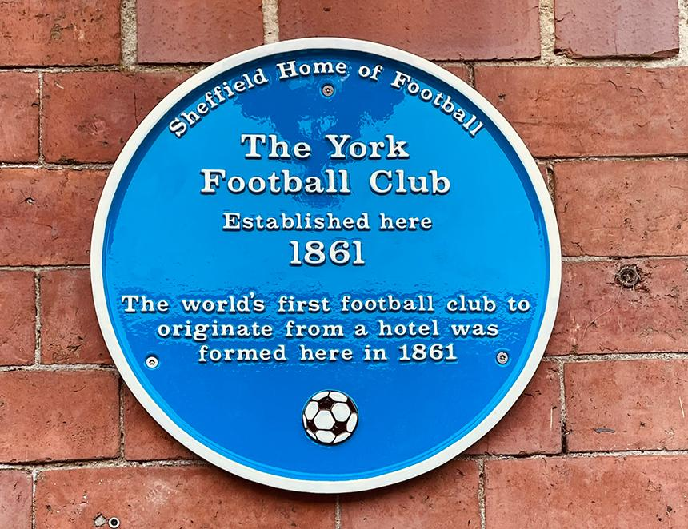

Sheffield City Council (SCC) hopes rebranding will improve the perception of the city, including its role in craft brewing, and boost both economic growth and tourism. The SCC Economic Development and Skills Policy Committee recently heard that the Sheffield Inspires brand would ensure the city was recognised as “one of the UK's top five most attractive cities for trade, tourism and talent”. The City Brand Development Work report highlights the impact Sheffield has had on the world, from the city’s importance in the birth of both electronic music and football, to its place as a craft beer developer and world-renowned climbing centre. The report emphasises that a stronger city brand can bring significant benefits, supporting investment, visitor numbers, and business growth. Sheffield and District CAMRA is pleased to note the emphasis on craft beer. It has been promoting beer tourism for many years through its Steel City Beer Festival (SCBF), pub walks and publications. Both Sheffield Beer Week and SCBF have a significant positive tourism impact on the city. These activities not only support both the local independent breweries and pubs but also help to bring more money into the city than the annual two-week World Snooker Championship. Allied with Sheffield Home of Football (SHoF), the city has two unique selling points which bring in thousands of visitors. There is an increasing link between SHoF and indie beer, as Little Mesters brew the SHoF-branded beers. There are also many connections between the early years of Sheffield rules football and local pubs. One of the SHoF series of football-related blue plaques was recently unveiled at the York Hotel (above). The first pub-based team in the world is also local. The report emphasises that Sheffield’s brand perception directly impacts its economic prospects. A unified and well-promoted city brand can unlock significant benefits. Sheffield CAMRA anticipates local breweries and pubs will take their full part in promoting these benefits. Image: Dave Pickersgill