Trigger warning: sexual violence and rape

16/02/2025 by Laura Hadland

Opinion

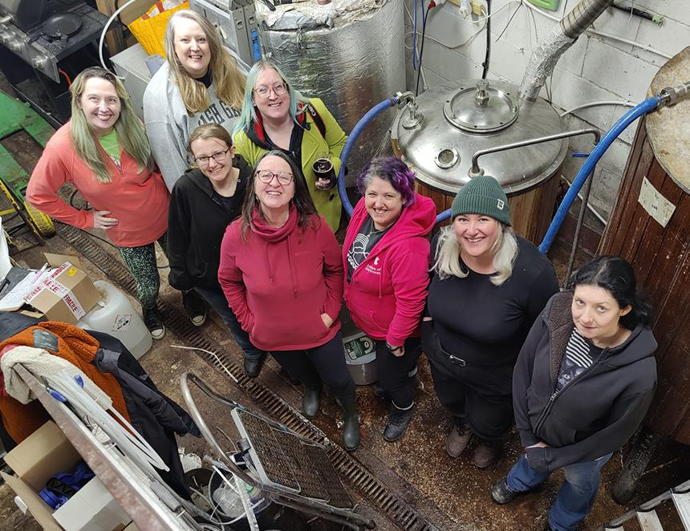

International Women’s Collaboration Brew Day (IWCBD) has been taking place since 2014. Women come together to brew a beer for release on International Women’s Day, 8 March, or do the brewing on that day. I am keen to participate whenever I can, as we celebrate women in the beer industry and also raise funds for women’s charities. This year, I think the brew day I attended is particularly important. I went to Tom’s Tap and Brewhouse in Crewe on a grey, drizzly Friday to brew with the Ladies of Darkness – a stout-loving women’s beer group which meets at the taproom regularly. They are local women who have come together over a shared interest. This year they are doing something a bit special – a parti-gyle. This meant a long brew day with two runs on the grain. The end result will be a small amount of strong beer, and a larger amount of a weaker brew. The worts have been treated differently so they will have their own flavours at the end even though they come from the same base. It was a brilliant day. The laughter didn’t stop flowing. The Ladies of Darkness are intelligent, witty and not afraid to hold back with their welcome or their opinions. They are fantastic company, and you can see why the group thrives. The shared passion for the beers they had designed was evident and everyone got stuck into the brewing process. Even me. I pulled my shoulder stirring the mash. I obviously need to do it more often. But more than that, it was the little touches I noticed. Regardless of experience or ability, it was common to see folk checking in on each other and helping their friends if it was needed. Even our delicious home-made chilli lunch was welcoming to all as it was vegan-friendly, gluten- and lactose-free. It’s the way society should be, but so often isn’t. The reason this particular brew day was so special is the names they have given the beers. LoD founder member Louise Lucas said: “We are brewing a sticky toffee pudding imperial stout called Women of a Certain Age. We are parti-gyling it with a custard stout called Shame must Change Sides.” The first is a response to Gregg Wallace hitting back at the accusations of inappropriate behaviour levelled against him. He dismissed his accusers as a handful of middle-class women of a certain age. This prompted justifiable anger – do women of a certain age not get to complain if they are treated inappropriately? “As women of certain ages,” Louise said, “many of us have experienced all sorts of things and the name is intended to start those conversations and bring that into beer.” The second name, I think, is significantly more provocative. It refers to Gisèle Pelicot’s own words in court after her indescribable ordeal at the hands of her husband and some 50 other men who embarked upon a decade of rape and sexual violence against her. I asked Louise how she thought a beer called Shame Must Change Sides might make men who saw it feel. “I don’t care,” she replied, without hesitation. “I hope it makes them think, since women have got to think about this stuff all the time. We have to think about our safety, about sexual predators and how we manage that, particularly going into male spaces. So, if it makes a man feel a little bit uncomfortable in a pub, then that feels like a really good thing, because there’s a lot of pubs I’ve been into and been made to feel uncomfortable on many occasions.” Because of this, I believe that the beers brewed by the Ladies of Darkness mark a huge step change in the potential of IWCBD. It has always been a serious movement, never tokenistic, but it is my expectation that this beer will make some people, mainly men, feel uneasy. That discomfort reminds us of the difficult conversations that society needs to have. Women are right to demand freedom from the fear and reality of rape and abuse. Men have a role to play to act as allies for women and call out inappropriate behaviour in their friends, sons and brothers when they see it. It was not Gisèle Pelicot who had committed a crime, but her husband, Dominique. By waiving her right to anonymity at Dominique’s trial, she showed us all that the shame was not hers. I hope that seeing a beer with such a powerful name, evoking Gisèle’s words, will be a first step on the road to making the world a safer place for our friends and daughters. Ten pence from each pint sold will be donated to local Crewe charity Survive, which supports survivors of abuse. That’s a small, but important, step in itself. These two beers, made from the same grain go together hand in hand. That is symbolic of women standing together to shout out that sexual discrimination and abuse is not acceptable. I leave the final word to Louise. “Feminism is still needed. We see stuff happening around the world where women’s rights are being stripped away, where queer people are being persecuted. All of the institutionalised and systemic oppression that’s going on and still we’re told that it isn’t really happening. It’s important that we’re having these conversations and making it visible.” Find International Women’s Collaboration Brew Day information here. To make a donation to Crewe charity Survive go here. Pictured: Ladies of Darkness at Tom’s Tap and Brewhouse in Crewe