PUBlic Affairs round up – February

15/02/2025 by Tori Wood

Campaign

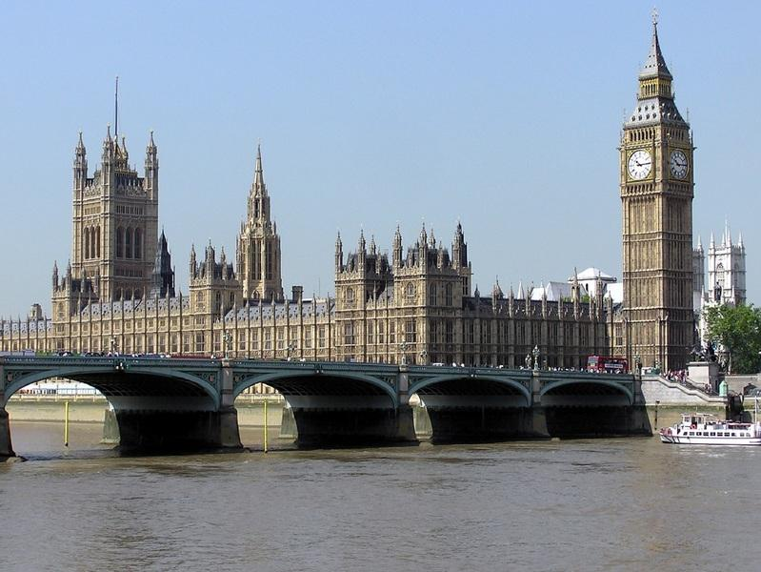

The regular PUBlic Affairs round-up returns with the Campaigns and Communications team’s latest campaigning for pubs, pints and people across Westminster, devolved parliaments and local government.  Westminster  All Party Parliamentary Group on Pubs An All Party Parliamentary Group (APPG) meeting on pubs took place in parliament on 11 February.   The team is re-establishing the APPG, a forum for cross-party work and campaigning on issues affecting pubs, consumers and independent brewers and cider makers.  Charlotte Nichols MP (Labour, Warrington North) will chair the APPG with CAMRA as secretariat.  Access to market review  The access to market review has gained positive media coverage on Politics North (North East and Cumbria) and the BBC. The coverage came after Julie Minns MP of Carlisle led an adjournment debate on the Pubs Code and provision of guest beers.  Hight Street Rental Auctions Since the High Street Rental Auctions scheme, which could see vacant pub premises leased with or without their fittings and fixtures, was implemented on 2 December 2024, branches have been monitoring the impact.  No vacant pub premises leased via the scheme have been reported or received.  A parliamentary question on pub protection in the High Street Rental Auctions scheme has been asked on CAMRA’s behalf: “To ask the secretary of state for Housing, Communities and Local Government, what steps she is taking to prevent the permanent conversion of public houses to other uses through the High Street Rental Auctions scheme.” The team is waiting for a reply. Planning protections [England] While awaiting a follow-up meeting to discuss pub planning protections with civil servants, parliamentary questions have been submitted on behalf of CAMRA for the attention of ministers, special advisors and civil servants.  CAMRA is waiting for responses to the following:  “To ask the secretary of state for Housing, Communities and Local Government, how many public houses have been unlawfully (a) converted to another use and (b) demolished since 2017.”  “To ask the secretary of state for Housing, Communities and Local Government, what assessment she has made of the potential merits of introducing a statutory duty on local planning authorities to remedy breaches of planning law for unlawful (a) demolition of public houses and (b) conversion of public houses to another use.”   In light of the owner’s appeal against South Staffordshire Council’s enforcement notice of the Crooked House in Himley, which caught fire and then was demolished as a result in 2023, CAMRA issued a press statement in response.  Handpump Hijack West Northants Council has been asked for an update on its Trading Standards investigation into Fresh Ale. Its response will determine how CAMRA navigates this campaign.  As West Northants Council’s Primary Agreement provides advice to Carlsberg Britvic’s UK operations, its response will determine CAMRA’s approach with other Trading Standards departments, particularly if they are in favour of Carlsberg Britvic’s Fresh Ale.  Deposit Return Scheme The Department for Environment, Food and Rural Affairs’ Drink Industry Forum met on 21 January where MPs agreed on legislation relating to a Deposit Return Scheme for drinks containers in England, Scotland and Northern Ireland.  The legislation determines when the scheme will operate, the types of containers, and definitions of drinks producers, importers and retailers.  The Deposit Management Organisation will set deposit levels, labels, interact with similar schemes, set producer fees, calculate handing costs for return points and exemption return points.  The following developments will include:  – product lines with less than 5,000 units placed on the market across the UK per annum will be exempt from specific Deposit Return Scheme obligations, such as the requirement to pay fees, apply deposits, and carry DRS labelling – requirement for retailers to operate a takeback service for drinks containers sold online from day one. This could impact independent and specialist online retailers which would have to find a method of accepting containers back in order to be recycled, and issue deposits accordingly – hospitality venues will not be required to host a return point for containers to be recycled at but will be able to host one voluntarily.   A transcript of the debate that took place in parliament is available here.  The government opened applications for a Deposit Management Organisation to administer the scheme. Applications closed on 3 February, and an appointment will be made in April 2025.  The Deposit Management Organisation will be granted 12 months to set the scheme up, followed by a further 18 months for industry implemented changes. The scheme will commence in October 2027.  The UK government has been in discussion with the Welsh government about its participation in the same scheme as England, Northern Ireland and Scotland.  Packaging Extended Producer Responsibility (EPR) scheme  The EPR scheme will require producers to fund reduction, recycling and the reuse of packaging in all UK nations.  Pack UK is the scheme administrator which has a remit to deliver reductions in unnecessary packaging, additional recyclable packaging, more efficient and effective management of packaging waste by councils, and more better-quality recycled content packaging available to industry.  The scheme will be implemented later this year.  Scottish government and parliament  Cross-Party Group on Beer and Pubs (secretariat service provided in part by CAMRA) At the group’s AGM in January, Craig Hoy (Conservative, South Scotland region) and Paul Sweeney (Labour, Glasgow region) were re-elected as convenor and deputy convenor.  CAMRA, the Society of Independent Brewers and Associates (SIBA) and the Westminster Parliamentary Beer Group were jointly reappointed as secretariat.  Minister for business Richard Lochhead MSP has been invited to discuss recommendations for the CPG’s report What Does Brand Scotland Mean for the Scottish Beer and Pub Sector?  Finally, the CPG will visit independent breweries in Leith in April 2025 which will have the opportunity to discuss brewery and consumer issues with MSPs.  Scottish Pubs Code Stuart McMahon attended the Scottish Pubs Code adjudicator’s stakeholder round table in Edinburgh on 15 January.  Discussions on how CAMRA can assist the adjudicator in publicising the code, and help tied tenants make use of the new guest beer right were had.   The right will be implemented in April 2025, and SIBA is creating a free tool to assist licensees access qualifying beer from an independent producer as their guest beer.  Welsh government and Senedd Cymru  The Welsh government’s draft Budget, that was published in December, proposed a continuation of a 40 per cent business rates relief into 2025/26.  The team issued a press statement on the need for fundamental reform of the business rates systems.  The final Welsh Budget will be published later this month.  Ministerial meeting Ash Corbett-Collins (CAMRA national chairman) and Ellie Hudspith (CAMRA senior campaigns and communications manager) met with Welsh government minister for Economy and Planning Rebecca Evans MS to discuss CAMRA’s campaigning asks on pub planning protections and business rates.  Planning laws remain intact, but the team will create a programme of work to influence MSs and party manifestos ahead of the 2026 Senedd elections.  Northern Ireland executive and assembly  Licensing review The team continues to await a response from them since the independent review of the licensing system was handed to the executive.